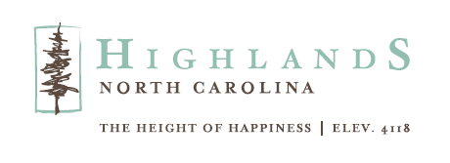
RIBBON CUTTING SCHEDULED FOR SUNCOAST EQUITY MANAGEMENT’S HIGHLANDS OFFICE
HIGHLANDS, NC, June 27, 2024 – The Highlands Chamber of Commerce will host a traditional ribbon cutting ceremony at Suncoast Equity Management. The event is free and open to the public and will take place on Wednesday, July 17 with a reception starting at 4pm and ribbon cutting at 4:30pm at 431 N. 4th Street, Highlands.

Founded in 1997, Suncoast Equity Management LLC takes a boutique approach, working with an exclusive group of clients to ensure they can best serve every family, business, and organization with which they partner.

“Our decision to open an office in Highlands was influenced by several factors,” says Don Jowdy, Founder and Chief Investment Officer, Suncoast Equity Management. “First, many of our clients' own homes in the area, and we wanted to offer them exceptional service while they enjoy the mountain lifestyle. Second, after personally experiencing the beauty and charm of Highlands, we knew it was a place we wanted to be.”

"We are delighted to celebrate the opening of Suncoast Equity Management's new office in Highlands," says Kaye McHan, Executive Director of the Highlands Chamber of Commerce/Visit Highlands, NC. "Our community greatly values personalized investment management services, and we are pleased to welcome a provider dedicated to meeting this need for our residents."

Suncoast Equity Management also has offices in Tampa and Sanibel, Florida. For more information about their services visit their website www.suncoastequity.com.

To learn more about the Highlands Chamber of Commerce/Visit Highlands, NC call 828-526-5841 or go to their website www.highlandschamber.org.
###
About the Highlands Chamber of Commerce/Visit Highlands, NC:
Formed in 1931 to serve as the voice of business, the Highlands Chamber of Commerce has grown to provide services and support to businesses, residents and visitors. Hosting various events and programs throughout the year, including the Plateau Pick-Up, Leadership Highlands, Business After Hours, Outdoor Concert Series, and July 4th Fireworks and an array of holiday and winter festivities, the Chamber strives to make Highlands, NC a better place to live, visit and conduct business.

MEDIA CONTACT: Johanna Fein
Marketing and Communications Director
communications@highlandschamber.org
828-526-5841

