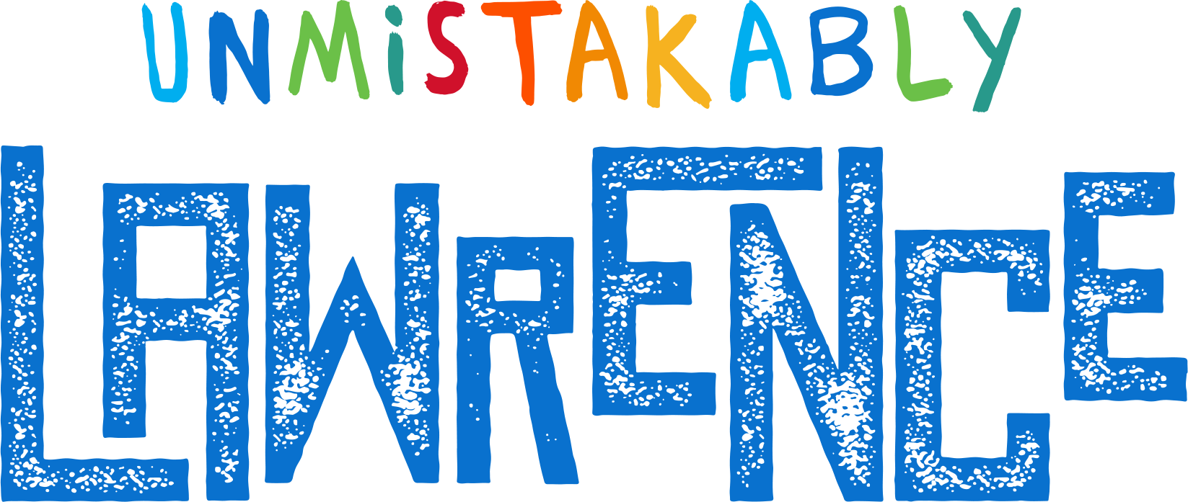

|  |  |  |  |  |  |  |  |  |  |
| --- | --- | --- | --- | --- | --- | --- | --- | --- | --- |
| |  |  | | --- | --- | | Contact | Allison Calvin | | Email | allison@explorelawrence.com | | Website | Unmistakablylawrence.com | |  |  | | FOR IMMEDIATE RELEASESeptember 9, 2024 |

EXPLORE LAWRENCE announces winners of the first annual hospitality awards

Lawrence, KS, September 9, 2024– eXplore Lawrence is happy to announce the winners of the first annual eXplore Lawrence Hospitality Awards.

eXplore Lawrence hosted the 2024 Annual Tourism Summit on Thursday, September 5th 2024. Over 100 attendees heard from Misty Heggeness (Swiftynomics), Bridgette Jobe (Kansas Tourism), and Nathan Hermiston (Visit KC on 2026 World Cup).

Kim Anspach, Executive Director of eXplore Lawrence, hosted the first annual eXplore Lawrence Hospitality Awards. We also welcome the CEO and Founder of Bandwango, Mo Parikh and COO Jay Alson, about the newly launch Burger Battle passport using the Bandwango platform.

The winners of the 2024 eXplore Lawrence Hospitality Awards are the following:  
 Au Marche, Hospitality Partner of the Year  
 Jeff Boeve, Hotel Employee of the Year  
 Lawrence PRIDE Parade and Party, Event of the Year  
 Mike Logan, Tourism Champion

To view the winners and photos from the event, [visit the Tourism Summit website](https://www.explorelawrence.com/partnership/tourism-summit/).

# # #

eXplore Lawrence represents the travel and tourism industry for Lawrence and Douglas County, Kansas. We are dedicated to creating economic development by attracting visitors, conventions and events to our city.

If you would like more information about this topic, please contact Allison Calvin at (785) 856-5284 or email at allison@explorelawrence.com.