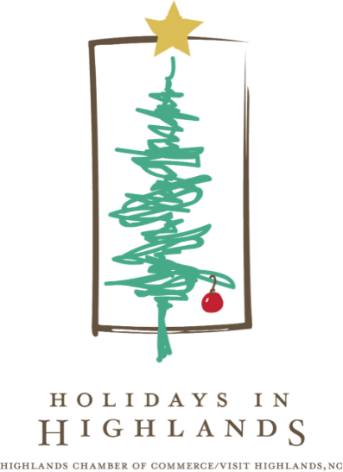

**THE HOLIDAYS IN HIGHLANDS – THERE IS NOTHING COZIER**  
*The holidays are a time to gather amid the warm glow of twinkling lights,*   
*filled with a festive spirit, to celebrate cherished traditions.*

HIGHLANDS, N.C., October 14, 2024 … The Highlands Chamber of Commerce/Visit Highlands, NC has an exciting lineup of holiday events in store. The schedule boasts a diverse range of activities, including:

**Ice Skating in Park – Thur., Nov. 21, 3:30-8pm in Kelsey-Hutchinson Founders Park**

The Highlands Parks and Recreation-managed Ice Skating in the Park kicks off Thursday, November 21 and runs through early March, weather permitting. The hours are Thursdays, 3:30-8pm, Fridays, 3:30–10pm, Saturdays, 1–10pm, Sundays, 1–5pm. Thanksgiving Week: 11/25-11/27, 1-8pm, Closed Thanksgiving Day, 11/29-11/30 1-10pm, 12/1, 1-5pm. Christmas Break: 12/23, 1-8pm, 12/24, 1-5pm, Closed Christmas Day, 12/26, 1-8pm, 12/27-12/28 1-10pm, 12/29, 1-5pm, 12/30, 1-8pm, 12/31, 1pm-1am, 1/1, 1-8pm. The price is only $8, with or without skates. Coffee and hot chocolate are available for purchase.

**Light Up the Park – Sat., Nov. 30, 6-8pm in Kelsey-Hutchinson Founders Park**

Anticipation will fill the mountain air as the community gathers in the park to enjoy treats and a program that includes live music and carols led by the Foxfire Boys, a display of children’s artwork and a reading of the Christmas story. Then, Santa arrives atop a firetruck to usher in the lighting of the park and Main Street. Watch the park come alive with thousands of holiday lights that will remain throughout the season, along with ice skating and photo-op fun.

-more-

2-2-2

**Santa in the Park – Sat., Dec 7, Sat., Dec. 14, Sat. Dec. 21 and Tues. Dec. 24 in Kelsey-Hutchinson Founders Park**

Santa Claus himself will make special appearances on Saturdays in the park to listen to the wishes of children, both young and young at heart. On Christmas Eve, Tuesday, December 24, Santa is extremely busy prepping for gift delivery so appointments are required and can be booked at www.highlandschamber.org/event/santa-in-the-park/1306/ Additionally, he will make periodic visits to collect letters placed in a designated mailbox within the park.

**Highlands Christmas Parade – Sat., Dec. 7, 10am–12pm along Main Street**

As part of this longstanding tradition, expect to witness a delightful procession along Main Street featuring marching bands, llamas, camels, imaginative floats, and, of course, the star of the show, Santa Claus. Those who wish to participate in the parade must submit a completed application to the Highlands Chamber of Commerce/Visit Highlands, NC no later than 12 noon on Nov. 15. To apply and for more information, email events@highlandschamber.org or call 828-526-5841.

**Lighting of the Menorah – Weds., Dec. 25, 5:30pm, Kelsey-Hutchinson Founders Park**

Hanukkah is an eight-day winter festival of lights, celebrated to mark the triumph of light over darkness. One candle of the giant menorah will be lit on the first night of Hanukkah and an additional candle each successive night. This will be done until the eighth night when the Menorah is fully illuminated.

For more information about the Holidays in Highlands, call the Highlands, NC Welcome Center at 828-526-2112 or visit www.visithighlandsnc.com.

###

**About the Highlands Chamber of Commerce/Visit Highlands, NC:**

Formed in 1931 to serve as the voice of business, the Highlands Chamber of Commerce has grown to provide services and support to businesses, residents and visitors. Hosting various events and programs throughout the year, including the Plateau Pick-Up, Leadership Highlands, Business After Hours, Outdoor Concert Series, and July 4th Fireworks and an array of holiday and winter festivities, the Chamber strives to make Highlands, NC a better place to live, visit and conduct business.

**MEDIA CONTACT:** Johanna Fein   
 Marketing & Communications Director   
 communications@highlandschamber.org   
 828-526-5841