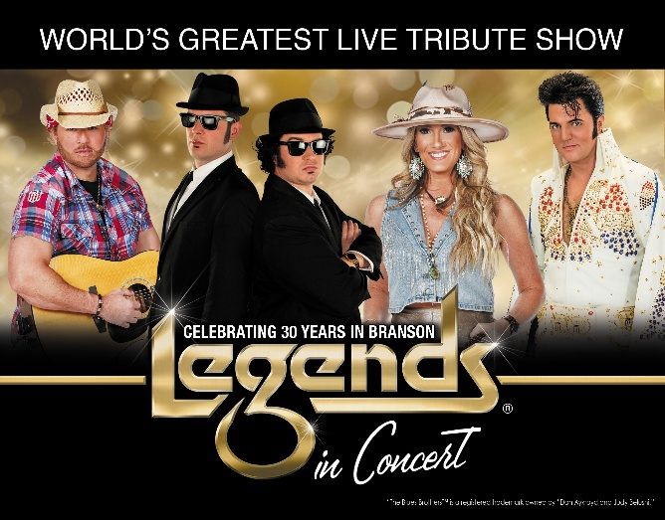

Legends in Concert
Pepsi Legends Theater 1600 W 76 Country Blvd. Branson, MO 65616

FOR IMMEDIATE RELEASE
February 4, 2026
Branson, Missouri
Contact: Jill Heppner jill.heppner@legendsinconcert.com

LEGENDS IN CONCERT ANNOUNCES 2026 SPRING LINEUP
Legends in Concert proudly returns for the 2026 season, marking an exciting milestone—30 years in Branson!
The spring season at the Pepsi Legends Theater will feature tributes to The Blues Brothers™, Lainey Wilson, Toby Keith, and Elvis Presley from February 6–April 7. The lineup continues April 9–May 24, 2026, with tributes to Pat Benatar, Shania Twain, The Blues Brothers™, and Elvis Presley.
“As Legends in Concert celebrates 30 years in Branson, we are honored to reflect on three decades of partnership with this remarkable community. This milestone underscores our longstanding commitment to delivering exceptional live entertainment and preserving the legacy of the world’s most iconic performers. We look forward to continuing this tradition of excellence for many years to come,” said Jeannie Horton, General Manager.
Legends in Concert will be celebrating Area Appreciation for their spring lineup February 13-28, 2026.
Guests can enjoy performances at 3 p.m. or 8 p.m. at the Pepsi Legends Theater, located at 1600 West 76 Country Blvd. Beer and wine service is available. For tickets and additional information, call 417-339-3003 or visit www.legendsinconcert.com/branson.

About Legends in Concert and the Pepsi Legends Theater: Legends in Concert is a live musical celebration featuring the world’s greatest celebrity tribute artists. In addition to Legends in Concert’s year-round exclusive marketplace residency of over 250 performances annually, Pepsi Legends Theater is also home to the year-round award winning SIX Show, Cassandre, the annual Branson Elvis Festival, and exclusive Branson seasonal performances. Affirming Legends in Concert’s commitment to sustainability, the property boasts Liberty Utilities only EV Charging Station located at a theater in the greater Branson, MO marketplace and 900 brand new custom luxury theater seats. In addition to Branson, Legends in Concert produces shows year-round in such markets as Myrtle Beach, SC, in Waikiki at the Royal Hawaiian Theater, on the high seas aboard the Norwegian PEARL, and seasonally in Niagara Falls, Long Island, Melbourne, Australia, and a dozen other markets. For more information: www.legendsinconcert.com/locations/branson-mo
“The Blues Brothers™ is a registered trademark owned by “Dan Aykroyd and Judy Belushi” Lineup is subject to change.

