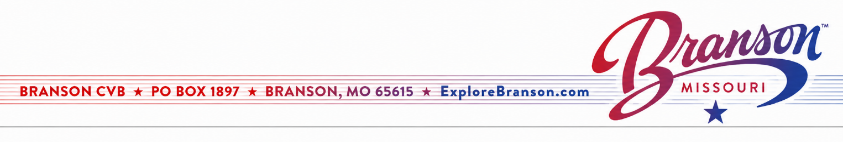
Sports Committee Meeting Minutes
Branson Chamber/CVB - Silver Dollar City Room
Wednesday, August 19th

Call to Order / Introductions - Given by Caylen Cantrell
- Meeting was called to order. Kristina is out due to surgery. Natalie is no longer serving as the co-chair, as she is no longer with Silver Dollar City.

Explore Branson Sports Updates – Given by Stewart Grimm
- July Event Updates: 9 events were supported by Explore Branson, with 12 additional events taking place in the area.
- The American Junior Golf Association (AJGA) is exploring potential new venues for future tournaments. There have been positive conversations between AJGA and Point Royale.
- The Babe Ruth/Cal Ripken organization is hoping to bring a softball World Series to Branson. The organization also has a new headquarters office inside Ballparks of America.
- Cowboy Rumble has new ownership under 3STEP Sports.
Explore Branson Sports Department Updates – Given by Stewart Grimm
- Sports Destination Management (SDM) has an upcoming fishing feature and digital banner campaign that is now live on SportsDestinations.com.
- Stewart will be attending an XTERRA event in New Mexico from October 7–11 to assist with planning and logistics for XTERRA’s Elite event, scheduled to take place in Branson in April 2027.
- Stewart conducted a site visit with a prospective event organizer to explore the possibility of hosting a Women’s 5K/Half Marathon/Conference/Fun Run in Branson during the fall of 2027.
- Planning and destination support continue for the first AKC Fast CAT Invitational, taking place September 18–21 at Sycamore Creek Ranch. Assistance has included lodging questions, Branson attractions, the Explore Branson Sports Athlete Program, and promotion of public participation opportunities, including:
- The Star-Spangled Scurry – FIT DOG WALK: A $20 walk benefiting the United States War Dogs Association and open to anyone with a dog.
- Open Fast CAT: Scheduled for Thursday in September, with 640 available runs. All dogs are welcome to participate, with a $35 entry fee. Open CAT is scheduled for September 18–20.
- Vendor Marketplace: A vendor marketplace will be located on the lower FAST CAT field, providing an enhanced event experience for participants and spectators.
- Next conferences:
-Connect Sports (August 24th through 28th)
-Relationship (September 21st through 24th )
-TEAMs (October 26th through 30th)

Venue & Facility Committee Member Updates – Led by Stewart Grimm
- Branson RecPlex – Updates given by Josh Aubin
- The RecPlex had a very busy and successful summer. Next year, USSSA will host events for three consecutive weeks. Special Olympics held its first softball game at the RecPlex on August 15. The organization hopes to expand its events in the coming years. Great progress continues with the development of mountain bike trails behind the facility.
- Ballparks of America
- No updates given.
- Branson Convention Center – Updates given by Jordan Cannefax
- NuWay Combat (wrestling) went very well. Their new owners, 3STEP, would like to continue bringing the event back to Branson. MoNASP is also returning. Chewjitsu Open also took place at the Convention Center during the second quarter.
- Table Rock Lake State Park – Updates given by Caylen Cantrell
- XTERRA will be coming to Branson in April 2027, with logistics already in motion. The Corps of Engineers and Table Rock State Park approved the addition of eight new cabins.

2026 Sports Committee Meeting Dates – Given by Caylen Cantrell
- Next meeting: Wednesday, November 18th at 3:30pm

