Happy Earth Day! Ways to Explore, Give Back, and Contribute to our Earth!

Earth Day is an important celebration of the tiny blue and green planet that we all call home. I like to think of Earth Day as the Earth’s “birthday,” or a day to focus on just how much the Earth means to us.

Here are some ways you can celebrate Earth Day here in Rockford!

- Explore some of our beautiful natural areas:
  - Throughout the Rockford region, we have prairies, woodland areas, ponds, cliffs, creeks, rivers, and so much natural beauty to explore! Here are some of my favorite places:
    - Severson Dells Nature Center: a nature education center, home to the dolomite cliff Dells! Severson Dells offers free Adventure Packs full of tools to explore the outdoors!
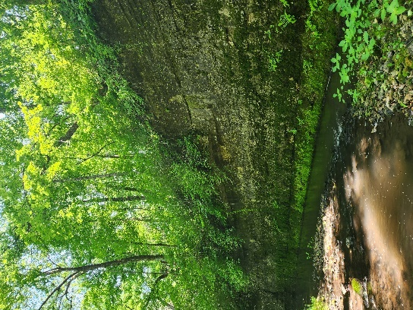
The Dells of Severson Dells, photographed by Andrea Wallace Noble on June 8, 2023 at Severson Dells

    - Rockford Park District’s Atwood Park: with trails to explore and a Birds of Prey exhibit, this is a go-to spot to explore by biking or hiking!
    - Natural Land Institute’s Carl & Myrna Nygren Wetland Preserve: a beautiful wetland great for spotting birds and experiencing wildlife!
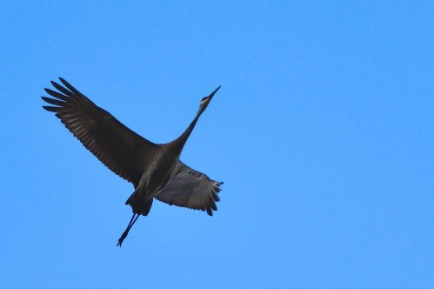
Sandhill Crane, photographed by Ashlyn Rogers on April 30, 2022 at Nygren Wetland Preserve
    - Forest Preserves of Winnebago County’s Hononegah Forest Preserve: the oldest forest preserve in Winnebago County, this is a great place for views of the river, picnicking or camping!
    - Nature at the Confluence: a beautiful confluence of the Rock River and Turtle Creek, with great trails and learning gardens!
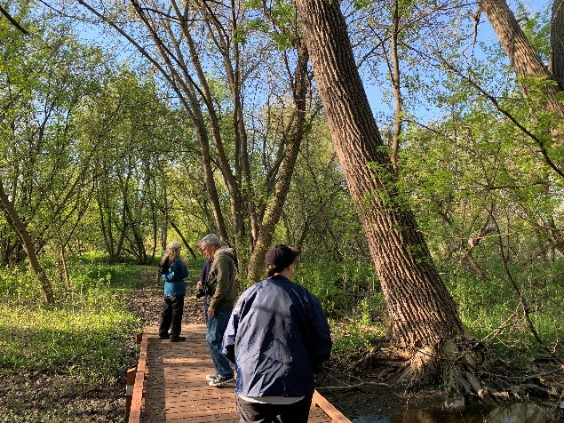
A footbridge along the Rock River Birding & Hiking Trail at Nature at the Confluence, photographed by Julie Uram in Spring 2023

- Give back to the Earth:
  - While visiting some of the places listed above, help us keep these area’s clean by picking up litter.
  - Visit some local shops contributing to the wellness of our planet:
    - Earth Zero Waste: A great place to find eco-friendly daily use items like laundry soap, tooth paste, and much more!
    - Rockford Art Deli: This local t-shirt shop has made many eco-friendly changes to the way clothing is produced! (and offers some pretty great Rockford gear)
    - Thrift Stores! Rockford has so many thrift stores! From clothing to furniture to books, you can find so many hidden gems that re-home items that might otherwise be thrown away
  - Make some eco-friendly changes at home or work!
    - Wild Ones Rock River Valley is a local non-profit focused on the benefits of native plants. They have tons of great, native flowers and trees that are not only beautiful, but also great for our local biodiversity. They also offer a native plant sale each spring! Hurry, orders are due April 26!
    - Owls Roost Farm offers composting for homes and businesses. Composting is a great way to return nutrients back to the soil instead of trapping it in the landfill.

- Contribute to local research through the City Nature Challenge!
  - City Nature Challenge is a global citizen science competition to photograph as much wildlife as possible between April 26th - 29th. The local Rock River Valley team joins over 400 cities around the globe in getting outside, exploring nature, and documenting biodiversity for science! Whether you join one of the many guided hikes or explore independently, anyone can participate by snapping some photos during the event and uploading them to the iNaturalist app.
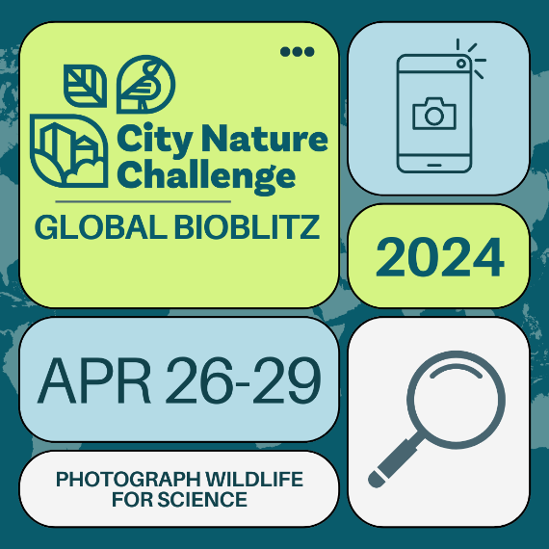
  - The local City Nature Challenge Rock River Valley team is organized by Severson Dells Nature Center with partners across northern Illinois. For more information, reach out to Liz at liz@seversondells.org
  - City Nature Challenge hikes are FREE and plentiful!
Guided Hike Schedule:
Friday, 4/26
- 7:30am-8:30am: Birding Hike @ Distillery Road Conservation Area, Belvidere
- 8:00am-11:00am: Wetlands, Warblers, and Wildflowers @ Knute Olson Forest Preserve, Kingston
- 10:00am-11:00am: Guided Hike @ Nature at the Confluence, South Beloit
- 2:00pm-3:00pm: Guided Plant Hike @ Piscasaw Fen, Capron
- 5:00pm-7:00pm: 815 Outside Sunset Soiree @ Blackhawk Springs Forest Preserve, Cherry Valley
  - PLUS first 100 people will receive a $10 coupon to use at Big Jon’s Dogs N’ More food truck on site. A limited quantity of FREE 815 Outside t-shirts are also available!
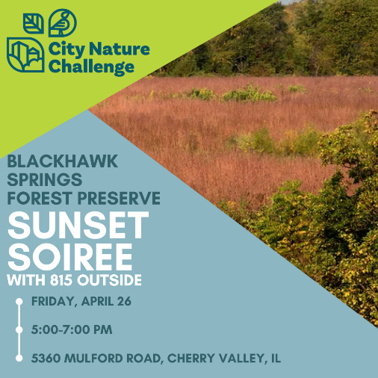
- 6:00pm-7:00pm: Evening Guided Hike @ Nardi Equine Preserve, Byron

Saturday, 4/27
- 7:00am-11:00am: Bird-watching and Donuts @ He-Leo Two Rivers Preserve, Byron
- 9:00am-3:00pm: Open House @ Camp Winnebago, Rockford (guided hikes at 10:30am and 1:00pm)
- 1:00pm-2:30pm: Creek Hike @ Barrick Oaks Homestead Preserve, Byron
- 5:00pm-7:00pm: Evening Hike and Creek Sampling @ Howard Colman Hall Creek Preserve, Rockford

Sunday, 4/28
- 9:00am-10:30am: Guided Hike @ Harlem Hills Natural Area, Loves Park
- 1:00pm-2:00pm: Pollinator and Plant Hike @ Spencer Conservation Area, Belvidere

Monday, 4/29
- 5:00pm-6:00pm: Guided Hike @ Kinnikinnick Creek Conservation Area

There are so many opportunities to celebrate Earth Day! Let us know how you plan to celebrate by leaving a comment below!

This blog was authored by Rebecca Rankins, Community Engagement Manager with Severson Dells Nature Center. Severson Dells is a non-profit nature education center in Rockford, IL. For more information on Severson Dells’ programs and activities, visit SeversonDells.org

