Rockford Region Summer Music Guide
Welcome to the ultimate summer music guide for all you music lovers in the Rockford Region! With the warm weather rolling in, it's time to dust off your picnic blankets, grab your friends and family, and head out to enjoy some amazing live music. Whether you're into a laid-back evening by the river or rocking out in the middle of the woods, we've got you covered with the top outdoor concert series to add to your summer playlist.
SPECIAL EVENTS
CRE8IV Music & Arts Festival: May 31 – June 2, Downtown Rockford, IL
Live music and creative performances on two stages, mural painting, local food trucks, creative interactive activities, mural tours and more. Artists and bands from around the country, as well as local favorites, are set to create new murals and perform on stages.
Old Settlers Days: June 13 - 16 at Settlers Park, Rockton, IL
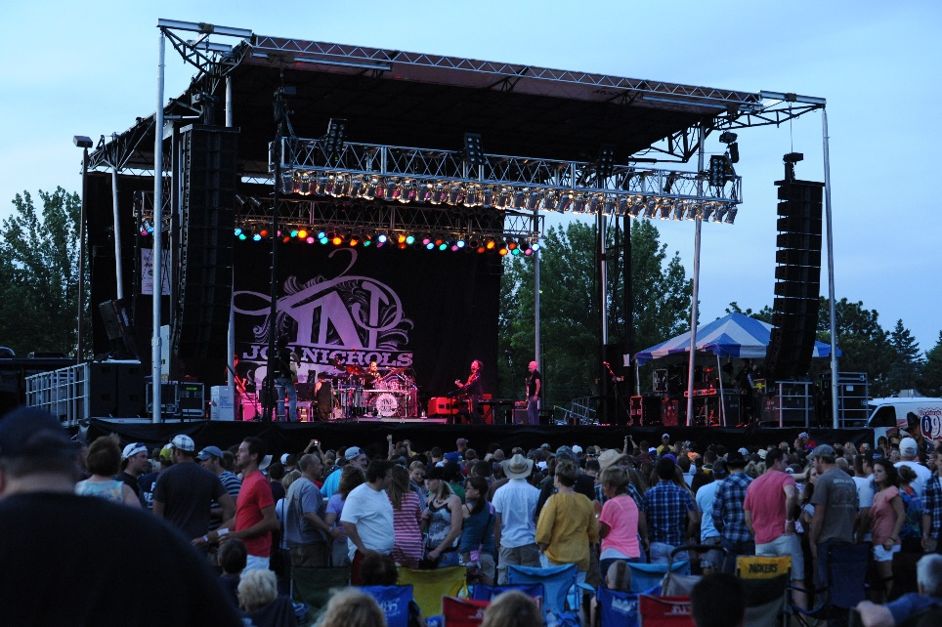
34th Annual Juneteenth Celebration: June 19 at Sinnissippi Park Music Shell
Rockford hosts the longest running Juneteenth Celebration in the state of Illinois. This event will be in collaboration with Tommy Meeks' annual Juneteenth Celebration, hosted by Emmett Cannon, with music provided by Vic Acid.
Suburb Fest: June 22 at Pig Minds Brewing
Rhythm of the Heart Festival: July 27 at Loves Park Festival Grounds
Festa Italiana: August 2 – 4 at Boylan Catholic High School Grounds
Polish Fest: August 11 at St. Stanislaus Church
Music and dancing all day, kids games, bingo. Polish ethnic foods include pierogi, potato pancakes, polish sausage, domestic and Polish beer and much, much more.
Winnebago County Fair: August 14 - 18 at Winnebago County Fairgrounds
Crossroads Blues Festival: August 24 at Lyran Park
MONDAY
Dockside Live
When: Mondays, May - September (6 - 9 p.m.)
Where: Prairie St. Brewing Co.
Cost: Free
Relax by the Rock River with fantastic drinks and food while local and regional artists serenade you into the evening.
TUESDAY
Music in the Park
When: Tuesdays and Thursdays, June - August (7 p.m.)
Where: Sinnissippi Park Music Shell
Cost: Free | $5 Select Prime Concerts
Enjoy free concerts in the historic Sinnissippi Park, featuring a diverse lineup of local and regional talent. Bonus: Catch the renowned Phantom Regiment in action!
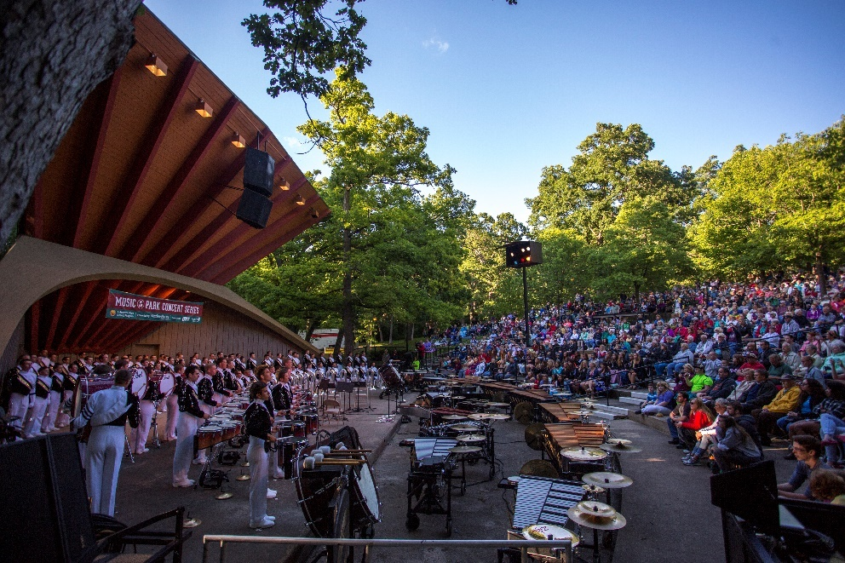
Tuesday Evening in the Gardens
When: Tuesdays, May - August (5 p.m.)
Where: Anderson Japanese Gardens
Cost: Adults $12 | Seniors $11 | Students & Military $10 | 5 & under FREE
Experience enchanting live music in the serene setting of Anderson Japanese Gardens. Pack a picnic or indulge in local vendors' offerings for a romantic date or friends’ night out.
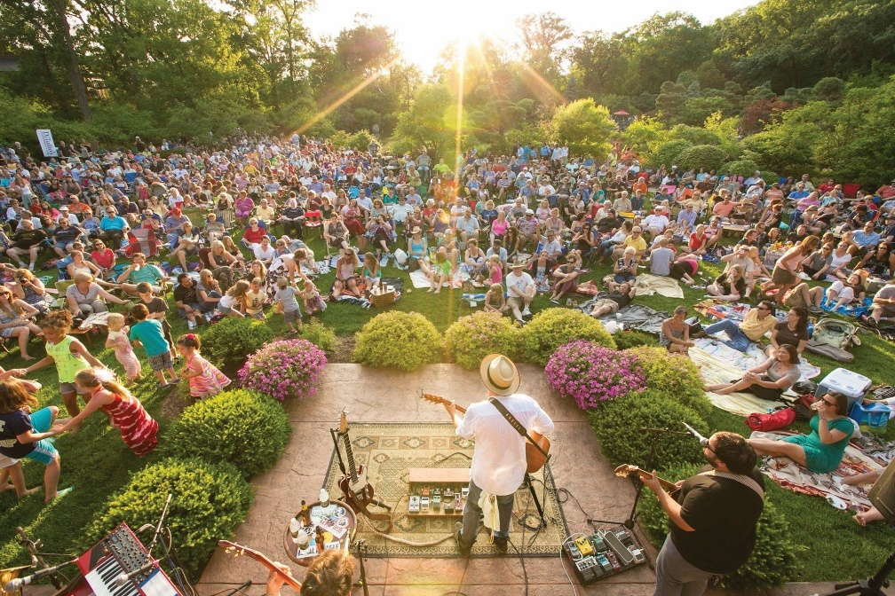
WEDNESDAY
Music on the Rock
When: Wednesdays, June - August (4:30 - 8:30 p.m.)
Where: Burpee Museum of Natural History
Cost: Free
Unwind on the museum terrace with drinks and treats while enjoying live music by the Rock River.
Rockton River Market
When: Wednesdays May - September (5 - 8 p.m.)
Where: Settler's Park Rockton
Cost: Free
The Rockton River Market is all about fun! Shop to great live music in downtown Rockton while visiting a variety of food and goods vendors every Wednesday, June through August!
Alchemy at Aldeen
When: Wednesdays, May – September (6 – 9 p.m.)
Where: Alchemy at Aldeen Outdoor Patio
Cost: Free
Relax on Alchemy’s outdoor patio overlooking the stunning scenery of Aldeen golf course. Savor delicious food and drinks while listening to some great bands.
Franchesco’s Summer Concert Series
When: Wednesdays, Thursdays, Fridays, May – September (6 – 8 p.m.)
Where: Franchesco’s Ristorante
Cost: Free
Italian food and live music are a match made in heaven! Franchesco’s offers three days of weekly music all summer long.
THURSDAY
Dinner on the Dock
When: Thursdays, May - September (5 - 10 p.m.)
Where: Prairie St. Brewing Co.
Cost: Free
Dock your boat and join the community for a classic Rockford tradition featuring craft beers, delicious eats, and top-notch local artists.
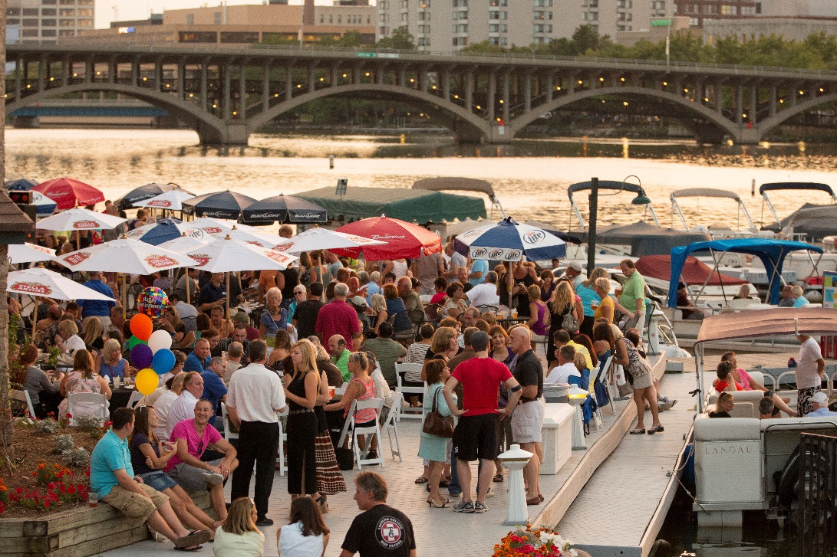
Music in the Park
When: Tuesdays and Thursdays, June - August (7 p.m.)
Where: Sinnissippi Park Music Shell
Cost: Free | $5 Select Prime Concerts
Franchesco’s Summer Concert Series
When: Wednesdays, Thursdays, Fridays, May – September (6 – 8 p.m.)
Where: Franchesco’s Ristorante
Cost: Free
FRIDAYS
Music on the Mall
When: Fridays, June - August (6:30 p.m.)
Where: Edgebrook Shopping Center
Cost: Free
Enjoy live music while strolling, dining, and shopping at Edgebrook Shopping Center. The perfect blend of relaxation and entertainment!
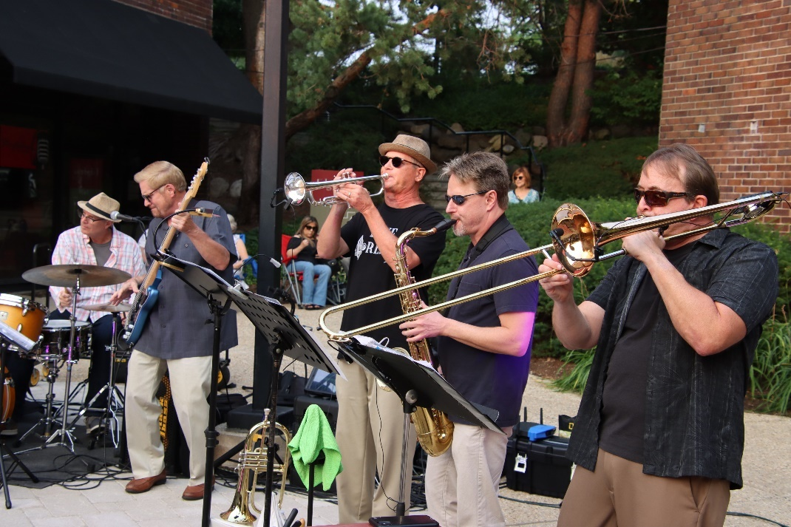
Rockford City Market
When: Fridays, May - September (4:00 - 8:30 p.m.) | 4:00 – 7:30 p.m. (after Labor Day)
Where: City Market Pavilion
Cost: Free
Dive into a culinary and musical adventure at the bustling Rockford City Market. Sample delicious foods, shop local vendors, and groove to live performances every week!
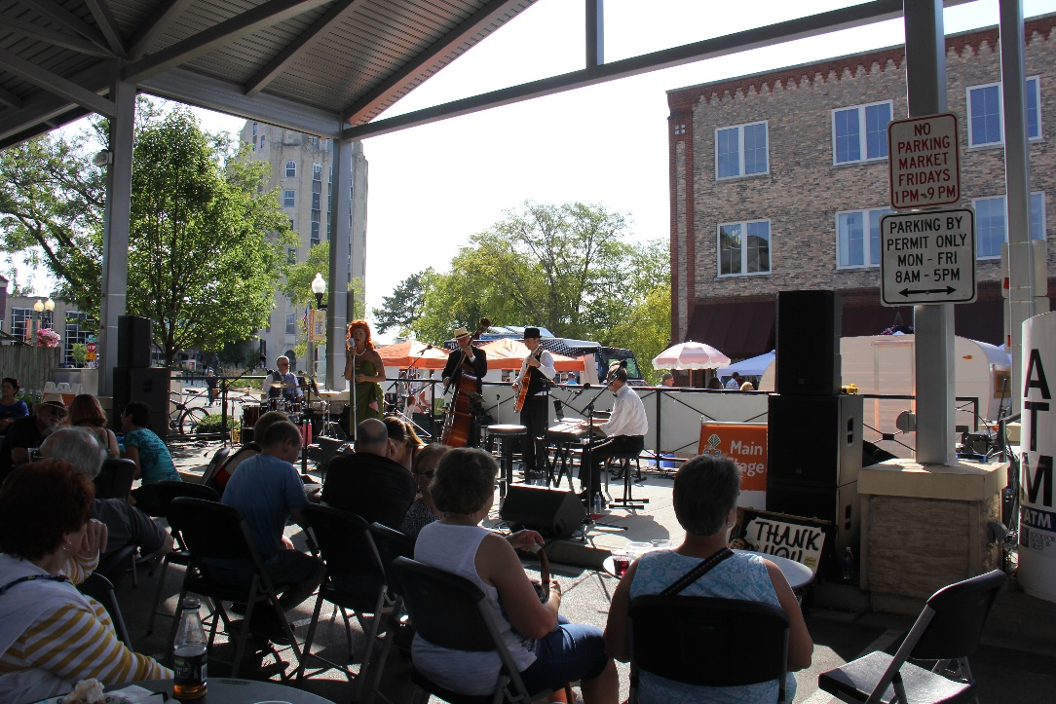
Franchesco’s Summer Concert Series
When: Wednesdays, Thursdays, Fridays, May – September (6 – 8 p.m.)
Where: Franchesco’s Ristorante
Cost: Free
SUNDAYS
Live at Levings/Domingos En El Parque
When: Sundays, June - August (5 - 8 p.m.)
Where: Levings Park
Cost: Free
Join the community for the Live at Levings Summer Concert Series as well as Domingos En El Parque every Sunday over the summer.
Woodsong Summer Concert Series
When: Sundays Various dates: July, August, & September (6 p.m.)
Where: Klehm Arboretum and Botanic Garden
Cost: Public $15 | $12 Members
Experience Ravinia-style concerts amidst the picturesque Fountain Garden at Klehm Arboretum.
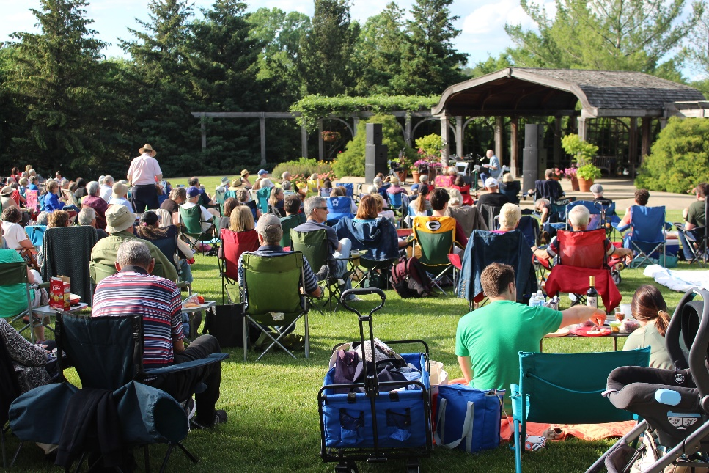
With so many fantastic outdoor concerts and events happening throughout the summer and early fall, there's no shortage of opportunities to groove to your favorite tunes. So, grab your calendar, mark down these dates, and get ready to soak up the sun and sounds of summer in Winnebago County!

