Haunted History of Rockford

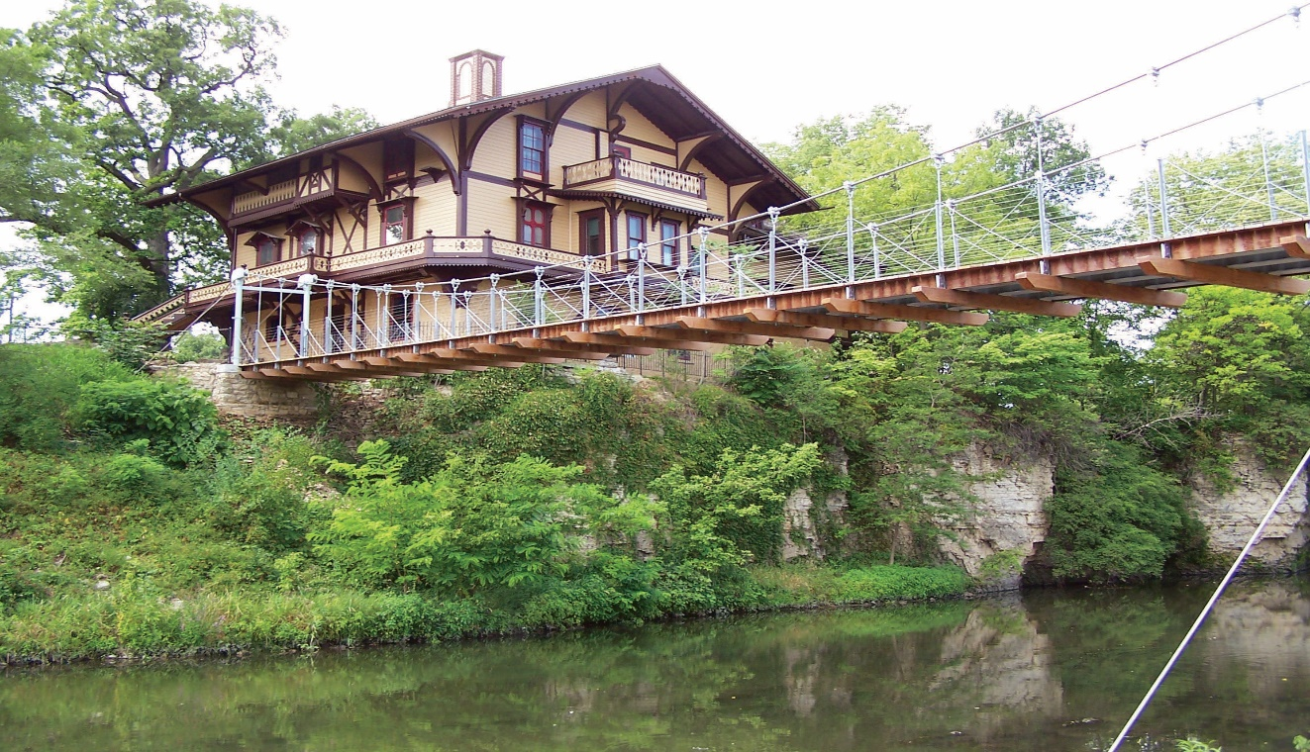

It is fall again in the stateline. Time for colorful leaves, cool days and longer, darker nights. Which makes it the perfect time for spooky stories.

And thanks to Rockford’s rich history, there are plenty of ghost stories here. There are the well-known stories like the Tinker Swiss Cottage. This Victorian mansion built on top of a limestone bluff has so many ghost encounters that two national ghost shows have filmed there. Many people have encountered their own experiences that range from smelling cigar smoke, hearing disembodied voices and seeing full bodied apparitions. It is the best documented haunted location in the city. Executive Director Samantha Hochmann hosts year-round paranormal evenings in the home giving plenty of opportunities to have your own paranormal experience.

These well-known stories are spine chilling in their own right, but the lesser-known hauntings can sometimes seem scarier. These encounters can shake even the heartiest of souls because the entities are unknown.

Veteran’s Memorial Hall and Museum

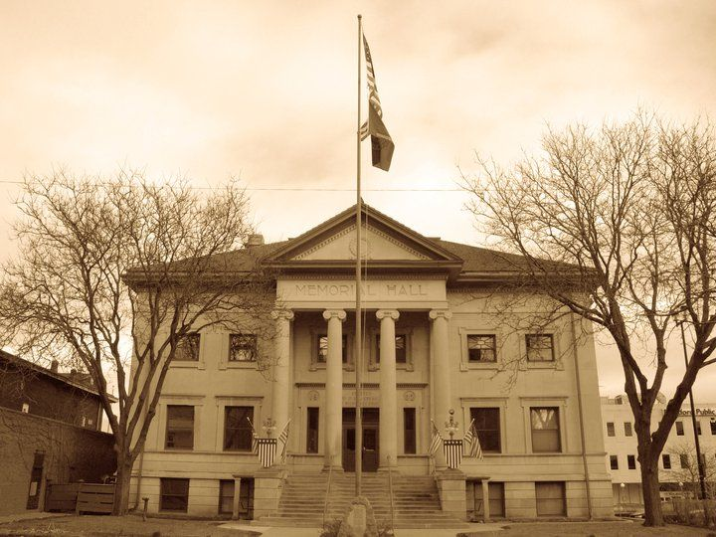

One haunted place in downtown Rockford that might surprise people is the Veterans Memorial Hall. It was built in 1903 and was the first ever of its kind built in Illinois and according to some sources, the entire United States. Its purpose was (according to the website), “to serve as a constant reminder to all of the sacrifices given by the brave men and women from Winnebago County and a way for following generations to remember and learn about their lives.”

It has gone through many challenges over the years, but its purpose has always remained the same: to serve Winnebago County’s veterans and their families.

Many dramatic events have taken place inside the stone walls of the hall. Thomas G. Lawler, the man who fought so hard for the building, was laid in state there before his funeral. Several thousand people came through in the four hours his body was on display.

Other stories echo in the building, harder to decipher, but just as deeply imprinted upon the hall. Many people see a woman walking on different floors. This author has even seen her, though I did not realize she was an apparition at the time. I was waiting outside the door that opens onto Main Street. I had been waiting a few minutes and was starting to wonder if I should knock again, when I saw a woman dressed in a long gown descending the stairs. I thought maybe she was there assisting the manager, so I knocked on the glass. The woman never looked at me as she walked down the stairs to the first floor and turned the corner to continue down to the basement. I was really annoyed by this time, and when Director Scott Lewandowski came to let me in a few minutes later, I shared the story and told him the young lady was very rude when she ignored my knockings. I was surprised when he informed me that he was alone in the building.

Research over the years has provided a possible identity of the woman. The Damon family had a son serving in France during World War I. Grant Damon was due for a visit in 1918, and his mother went to the Veterans Memorial Hall to receive the details of her son’s return home. When she got to the hall, however, she received the unimaginable news that her son, Grant, had died a month before from injuries suffered when he was caught in a mustard gas attack. One does not even want to imagine Mrs. Damon’s suffering when she received the devastating news that Grant would not be coming home. There is still something of that emotion that remains of when Mrs. Damon received the news of her son’s death. Different psychics have sensed her there, still caught in that life-changing moment.

Another experience seems to verify her identity. Recently, a security guard was locking up the building after an event. It was very late and the man had turned off all of the lights in the basement and was halfway up the stairs when a woman’s voice called to him from the darkness below. His impression was that she said, “I’m Ella.” Grant Damon’s mother’s name was Della.
Other historic places in town offer us glimpses into the past. The two homes that make up the Heritage Park Museum Center are two little treasures that anyone interested in history should visit. This includes anyone interested in paranormal activity. The Graham-Ginestra House was built in 1857 by Freeman Graham, Sr. The next family to own it was the Leo Ginestra family. Both families were important to Rockford. And it seems, both still inhabit the home on South Main Street. Staff have heard voices, felt like someone was watching them and even seen the family members. The families seem very proud of their legacy and want to continue to have visitors into their home. And if you are lucky, you might hear music playing or even see one of them pass through a doorway.

Ethnic Heritage Museum

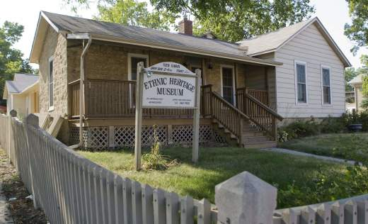

The Ethnic Heritage House right next door to The Graham-Ginestra home was also built in the 1850’s and offers visitors a unique peek into the different histories of several ethnic groups that settled here in Rockford. Here the entities seem to be watching and sometimes trying to scare visitors and staff. There are mannequins in the Polish Gallery in the front room of the house that are used to display the traditional festival clothing. Sometimes, the dolls are moved around when the staff comes in. This was quite startling in the beginning but now the staff has become accustomed to these little pranks.

Paranormal investigators have caught lots of interesting EVPs here as well. One is of a little boy named Mark who can sometimes be heard calling for someone to play with him. Board President Jocelyn Hare is very open to exploring more of the history and mysteries of both of these historic homes.

Another less known ghost story takes place in the heart of downtown Rockford. Haskell Park has been a part of Rockford almost from the beginning. It was platted as the West Side Public Square in the 1830’s. The land was donated to the city by George Haskell and his brother-in-law, John Edwards.

It remains a park today though it has been through many changes over the years. Postcards from the late 1800’s and early 1900’s show a beautiful place with an elaborate three-tiered fountain at the center of the park. Children once used it as a playground while couples used the benches as a courting place.

The beautiful fountain shown in those postcards would become quite noteworthy in June of 1902. The newspapers from June 13 tell the story of a man who was passing through the park late one evening. Just as he was passing the fountain a strange noise caused him to look at the water. There in the moonlight he saw a sight that nearly paralyzed him with fright. A shadowy, shimmering form seemed to rise from the water. At first it was a dark mist but then the man was horrified to see it take on a human shape. Though it had no distinguishing features, he saw what he imagined to be a skeletal hand as the specter reached its arms toward him.

This broke the man’s paralysis, and he bellowed in fear while he began to run through the park as if the very devil himself was chasing him. He stated in the interview that he didn’t slow down until he reached his house.

The man’s friends all teased him viciously about the story until others started to experience the same ghostly shape that emerged from the fountain, always reaching out for whoever braved the park late in the evening. Later stories claimed that the spirit eventually freed itself from the fountain and would follow them to the boundaries of the park. It always appeared as a black, swirling shadow.

Though no one could identify the spirit there are several possibilities for the haunting. One is the tragic tale of James and Kate French. They were a couple who lived in Rockford in 1896. It was in this park that James waited for his estranged wife to return from assisting a family friend who was ill. Witnesses later testified that he waited there for hours, pacing and watching. Though at first no one knew the reason why he appeared so agitated, his motive soon became all too clear. James chased his wife down and shot her inside a house that she ran into for safety. James was later hanged for his crime. Maybe it was his spirit that wandered the place where he waited for wife to appear.

Haskell Park

Another possibility comes from the suggestion that Haskell Park lies over a Native American burial ground and the spirits of those buried there can find no rest. Sara Bowker, a psychic who is a part of the Haunted Rockford Paranormal Events first encountered these lost souls on a recent tour. She sensed the spirits who continue to wander the area looking desperately for the place where their bodies once rested.

The stories of shadows moving from tree to tree continue to this day. Others claim to feel watched as they walk through the park. One witness described it as feeling like a victim stalked by prey. It makes one thing abundantly clear, the peaceful park that once existed is now haunted by the events that have taken place here.

Some of the places mentioned in this article will be part of a Rockford’s Most Haunted Event planned for Saturday, October 28 from 6:00p.m.-11:00p.m. Find out more on the Haunted Rockford website www.hauntedrockford.com.

Kathi Kresol has been researching Rockford’s past for over 19 years. She uses the stories she finds for her articles for the Rock River Times, on her website and for her presentations and events. Find more stories and a listing of her events at www.hauntedrockford.com.

