Discover the Nature of Life in the 815
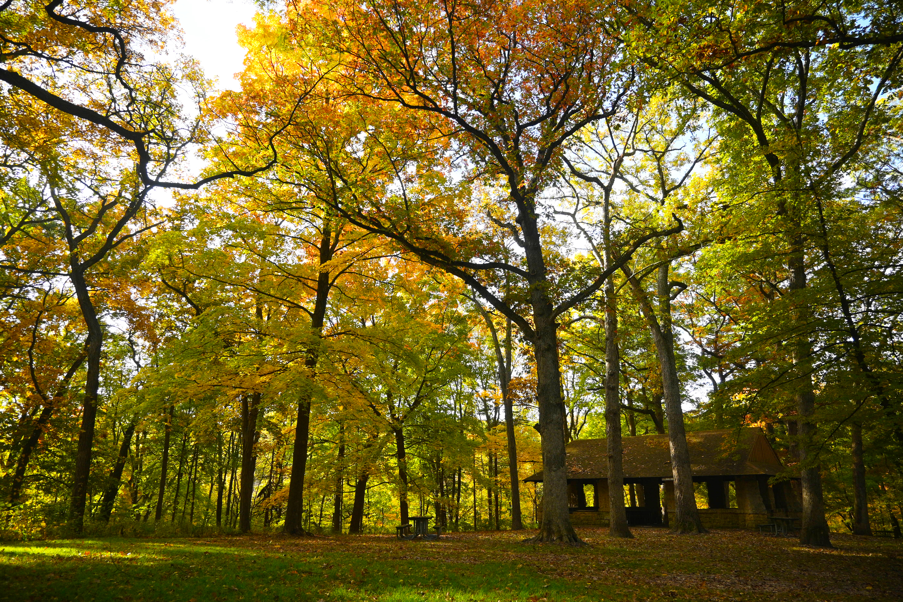
The weather has cooled down and the leaves have changed from green to a collage of oranges, yellows, and reds. Now is the perfect time to enjoy fun outdoor activities in the Rockford region with friends and family! There are many ways you can discover the nature of life in the 815.
Go for a Fall Foliage Walk
Did you know there are 44 forest preserves in Winnebago County? With over 100 miles of hiking trails throughout the forest preserves, there is no shortage of outdoor space to be explored! It is the perfect time to go for a fall foliage walk to see the bold autumn hues sweeping across the Rockford Region. Some of our favorite forest preserves for seeing beautiful fall foliage are Seward Bluffs Forest Preserve, Kishwaukee River Forest Preserve, and Hononegah Forest Preserve.
Learn more about other great leaf peeping spots in the Rockford region.
Cast a Line
Take a short drive to Four Lakes Forest Preserve and cast a line for some end of the season fishing! Four small man-made lakes make for the perfect fishing spot to soak up the natural setting of the forest preserve and create new memories. Most of the forest preserves are located along one of the county’s four beautiful rivers: the Sugar, Pecatonica, Kishwaukee and Rock Rivers offer scenic stream bank fishing as well as access areas for fishing boats.
Plan a Picnic
Pack up some snacks and drinks and head out to one of the many beautiful forest preserves in your area. Reserve a shelterhouse or find a free picnic table to relax, breath in the fresh air and spend some quality time with your friends or family. Many forest preserves offer playgrounds and grills for use. Although all of the forest preserves offer beautiful settings, some fan favorites include Blackhawk Springs Forest Preserve, Headquarters Forest Preserve and Roland Olson Forest Preserve.
Build a Campfire
What’s better than building a campfire on a chilly fall day? Many forest preserves have fire rings for you to build a fire, cozy up, and roast some s’mores. Remember to be responsible and practice smart fire safety! Winnebago County’s newest forest preserve, R. Robert Funderburg Forest Preserve features a beautiful stone fire place available for use and is totally insta-worthy!
Attend a Guided Hike

The Forest Preserve of Winnebago County offers a variety of free, educational programs and guided hikes that are accessible for kids and adults alike! Join in on the fun at the next Howl at the Moon Night Hike hosted by retired forest preserve deputy Tim Speer on Saturday, October 28, 2023 at R. Robert Funderburg Forest Preserve (4551 S. Meridian Road, Rockford IL, 61102). You will experience the forest preserves like never before –listen for nocturnal animals, enjoy roasted s’mores, and hike by the moonlight. Learn more about this hike and other forest preserve programs here.

Whether you are an experienced explorer or first-time tourist, enjoy the beauty of the Rockford region during fall and don’t forget to discover the nature of life!

Renee Pixler is the Communications Coordinator for the Forest Preserves of Winnebago County. She enjoys hiking with her three dogs and spending time with her husband, family, and friends.

