**Rockford Area Ice Cream Tour**

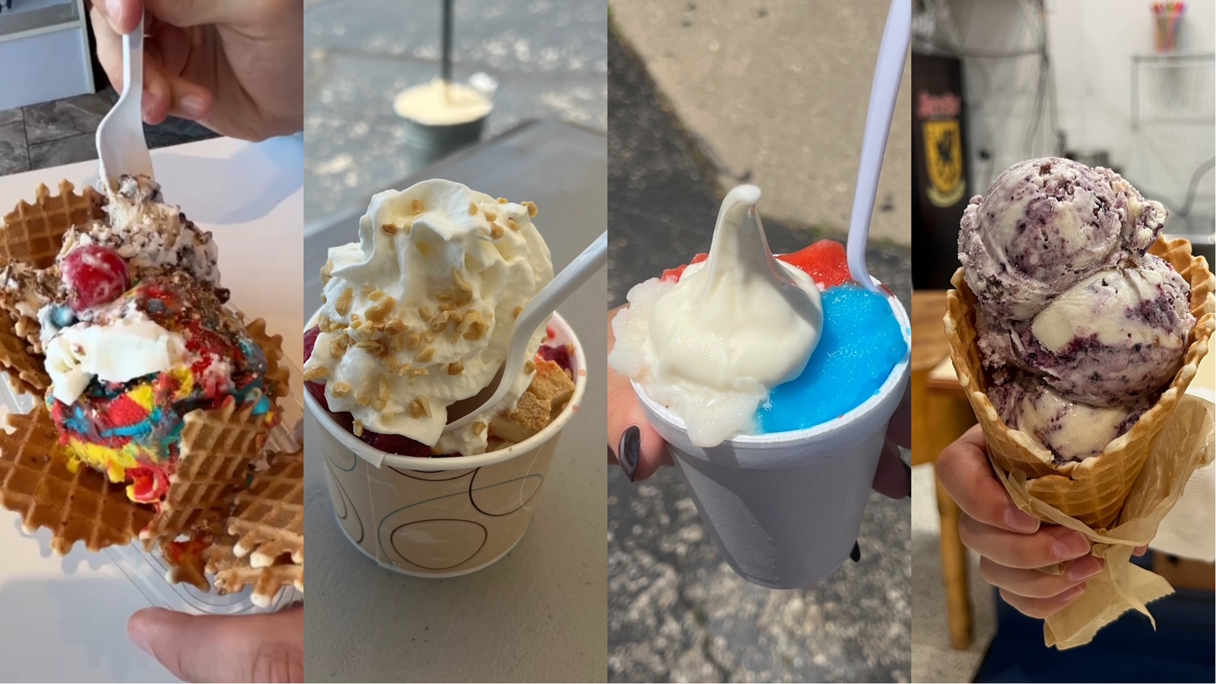

With a wide variety of excellent ice cream shops in the Rockford area, three of us from the GoRockford team decided to go on an “ice cream tour” of the region, trying out just eight of the many great places! At each stop, we wanted to try something truly unique, so we asked for employee recommendations or customer favorites. Keep reading if you want to hear our thoughts on what we tried!

**La Michoacana Crema Rosa Creamery** 609 Kishwaukee St, Rockford, IL 61104

The first stop on our journey was La Michoacana Crema Rosa Creamery. Here, we tried the most popular item on the menu, the Mangonada. With a delicious base of mango sorbet paired with contrasting flavors of Tajin, lime, and Chamoy, the Mangonada served as a wonderful kickoff to our tour. It was a perfect mix of sweet and spicy with a subtle tang. The menu also included many other ice creams including paletas which is a Mexican frozen treat made with fruits. La Michoacana is a must-try!

**Cattle & Cream** 105 Cherry St, Cherry Valley, IL 61016

Our second stop was none other than Cherry Valley’s Cattle & Cream. While there were so many great ice cream flavors to choose from, we were recommended to try the Blueberry Waffle Cone flavor, which did not disappoint!  This ice cream shop has indoor and outdoor seating, making it the perfect place to go no matter the weather. This shop is a part of a grocery store which made it unlike any of the other places we tried.

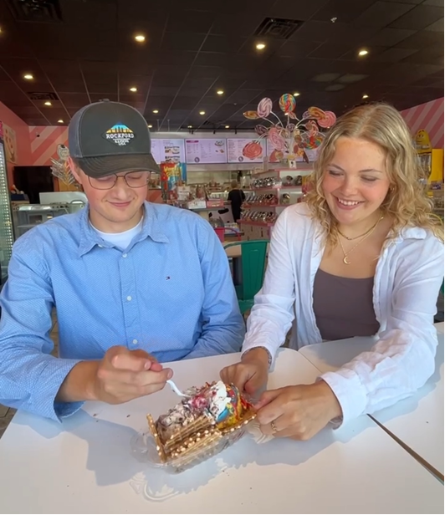

**Sweets N’ Eats** 7096 Walton St, Rockford, IL 61108

Next up on our list was Sweets N’ Eats, on the east side of Rockford. Walking in, you’re instantly immersed in a candy land with endless different treats. Although it was all tempting, we stuck to our mission of trying the ice cream. Here, we ordered Ice Cream Nachos; a savory treat starring two ice cream flavors of your choice on a bed of waffle cone “nachos.” Ecstatic to dive into our dish, we ordered Superman and Bourbon Pecan Pie ice creams, topped off with Snickers pieces to accompany our complimentary whipped cream and cherry. The ice cream nachos were a hit!

**Dairy Depot** 5413 N 2nd St, Loves Park, IL 61111

Our fourth stop was Dairy Depot, the epitome of summertime. With outdoor seating and a unique menu, Dairy Depot did not disappoint. During our visit, we tried the Strawberry Cheesecake Sundae which was recommended by employees. It was delicious vanilla ice cream with strawberries and cheesecake chunks. Also, there were so many flavors to choose from, including a flavor of the week.

**Dairyhäus**

113 E Main St, Rockton, IL 61072

The next stop on our tour was Dairyhäus, known for its homemade ice cream and waffle cones. There is a wide range of ice cream treats on the menu including sundaes, milkshakes, flurries and more. There were many flavors to choose from, including Salty Caramel Cashew, Rockford Roasting Co. Coffee, and what we tried, Wedding Cake. We were very happy with that flavor choice and want to go back to try the others!

**Willyums Dari Fair** 2813 Kilburn Ave, Rockford, IL 61101

Another shop we tried was Willyums Dari Fair. The shop has the classic summertime ice cream shop feel, and there was a large menu of treats to choose from including ice cream cones, coolers, banana splits and more!  We tried a Reese’s cooler (which is comparable to a flurry) and enjoyed it at their outdoor seating. The Reese’s cooler was a perfect summer treat.

**Quixotic Bakery** 116 N Madison St, Rockford, IL 61107

After the Dari Fair, we went to Quixotic Bakery, located at the Indoor City Market. Something special about Quixotic is that it not only serves ice cream, but also baked goods as well. There were many options to choose from, with a wide variety of ice cream flavors and desserts including sundaes, cones, dishes and ice cream sandwiches that are made with the bakery’s cookies or brownies. We chose a flourless (gluten free) ice cream sandwich made with brownies. The sandwich was the perfect treat!

**Zammuto’s** 725 Kent St, Rockford, IL 61102

To conclude our journey, we stopped by Zammuto’s for our final frozen treat. Lots of people come here to try their Granita which is described as an Italian ice/sorbet hybrid. Something to note is there are dairy free options on the menu. We ordered The Unusual, a Granita mixed with ice cream. We chose to try blue raspberry and cherry with vanilla ice cream. True to its name, The Unusual was a unique combination of flavors that was delicious and refreshing. We would come back on another hot summer day to try more from Zammuto’s!

**We had a lot of fun exploring the Rockford area while enjoying some delightful ice cream treats. Each place has different elements that set them apart. You cannot go wrong trying any of these local spots! These are just 8 of the many great places**