Finding the perfect place to get your coffee can be difficult. Whether you’re looking for somewhere to get your morning coffee, or you need a midday pick me up, there are so many options in and around the Rockford area. This blog will take you through a few great spots to visit.

*Photo courtesy of Miranda Brook*

**Rockford Roasting Co. | 416 S Main St, Rockford**

Rockford Roasting Co. is a great place for coffee lovers to unwind. They offer classic lattes, which is something I really love. The prioritization of high-quality coffee and a well-designed environment is what sets this coffee shop apart. Personally, I find it to be the perfect place to get work done. Rockford Roasting company is always filled with all different types of people. Whether you need a meeting place or just want to enjoy some coffee alone, Rockford Roasting Co. is a great option.

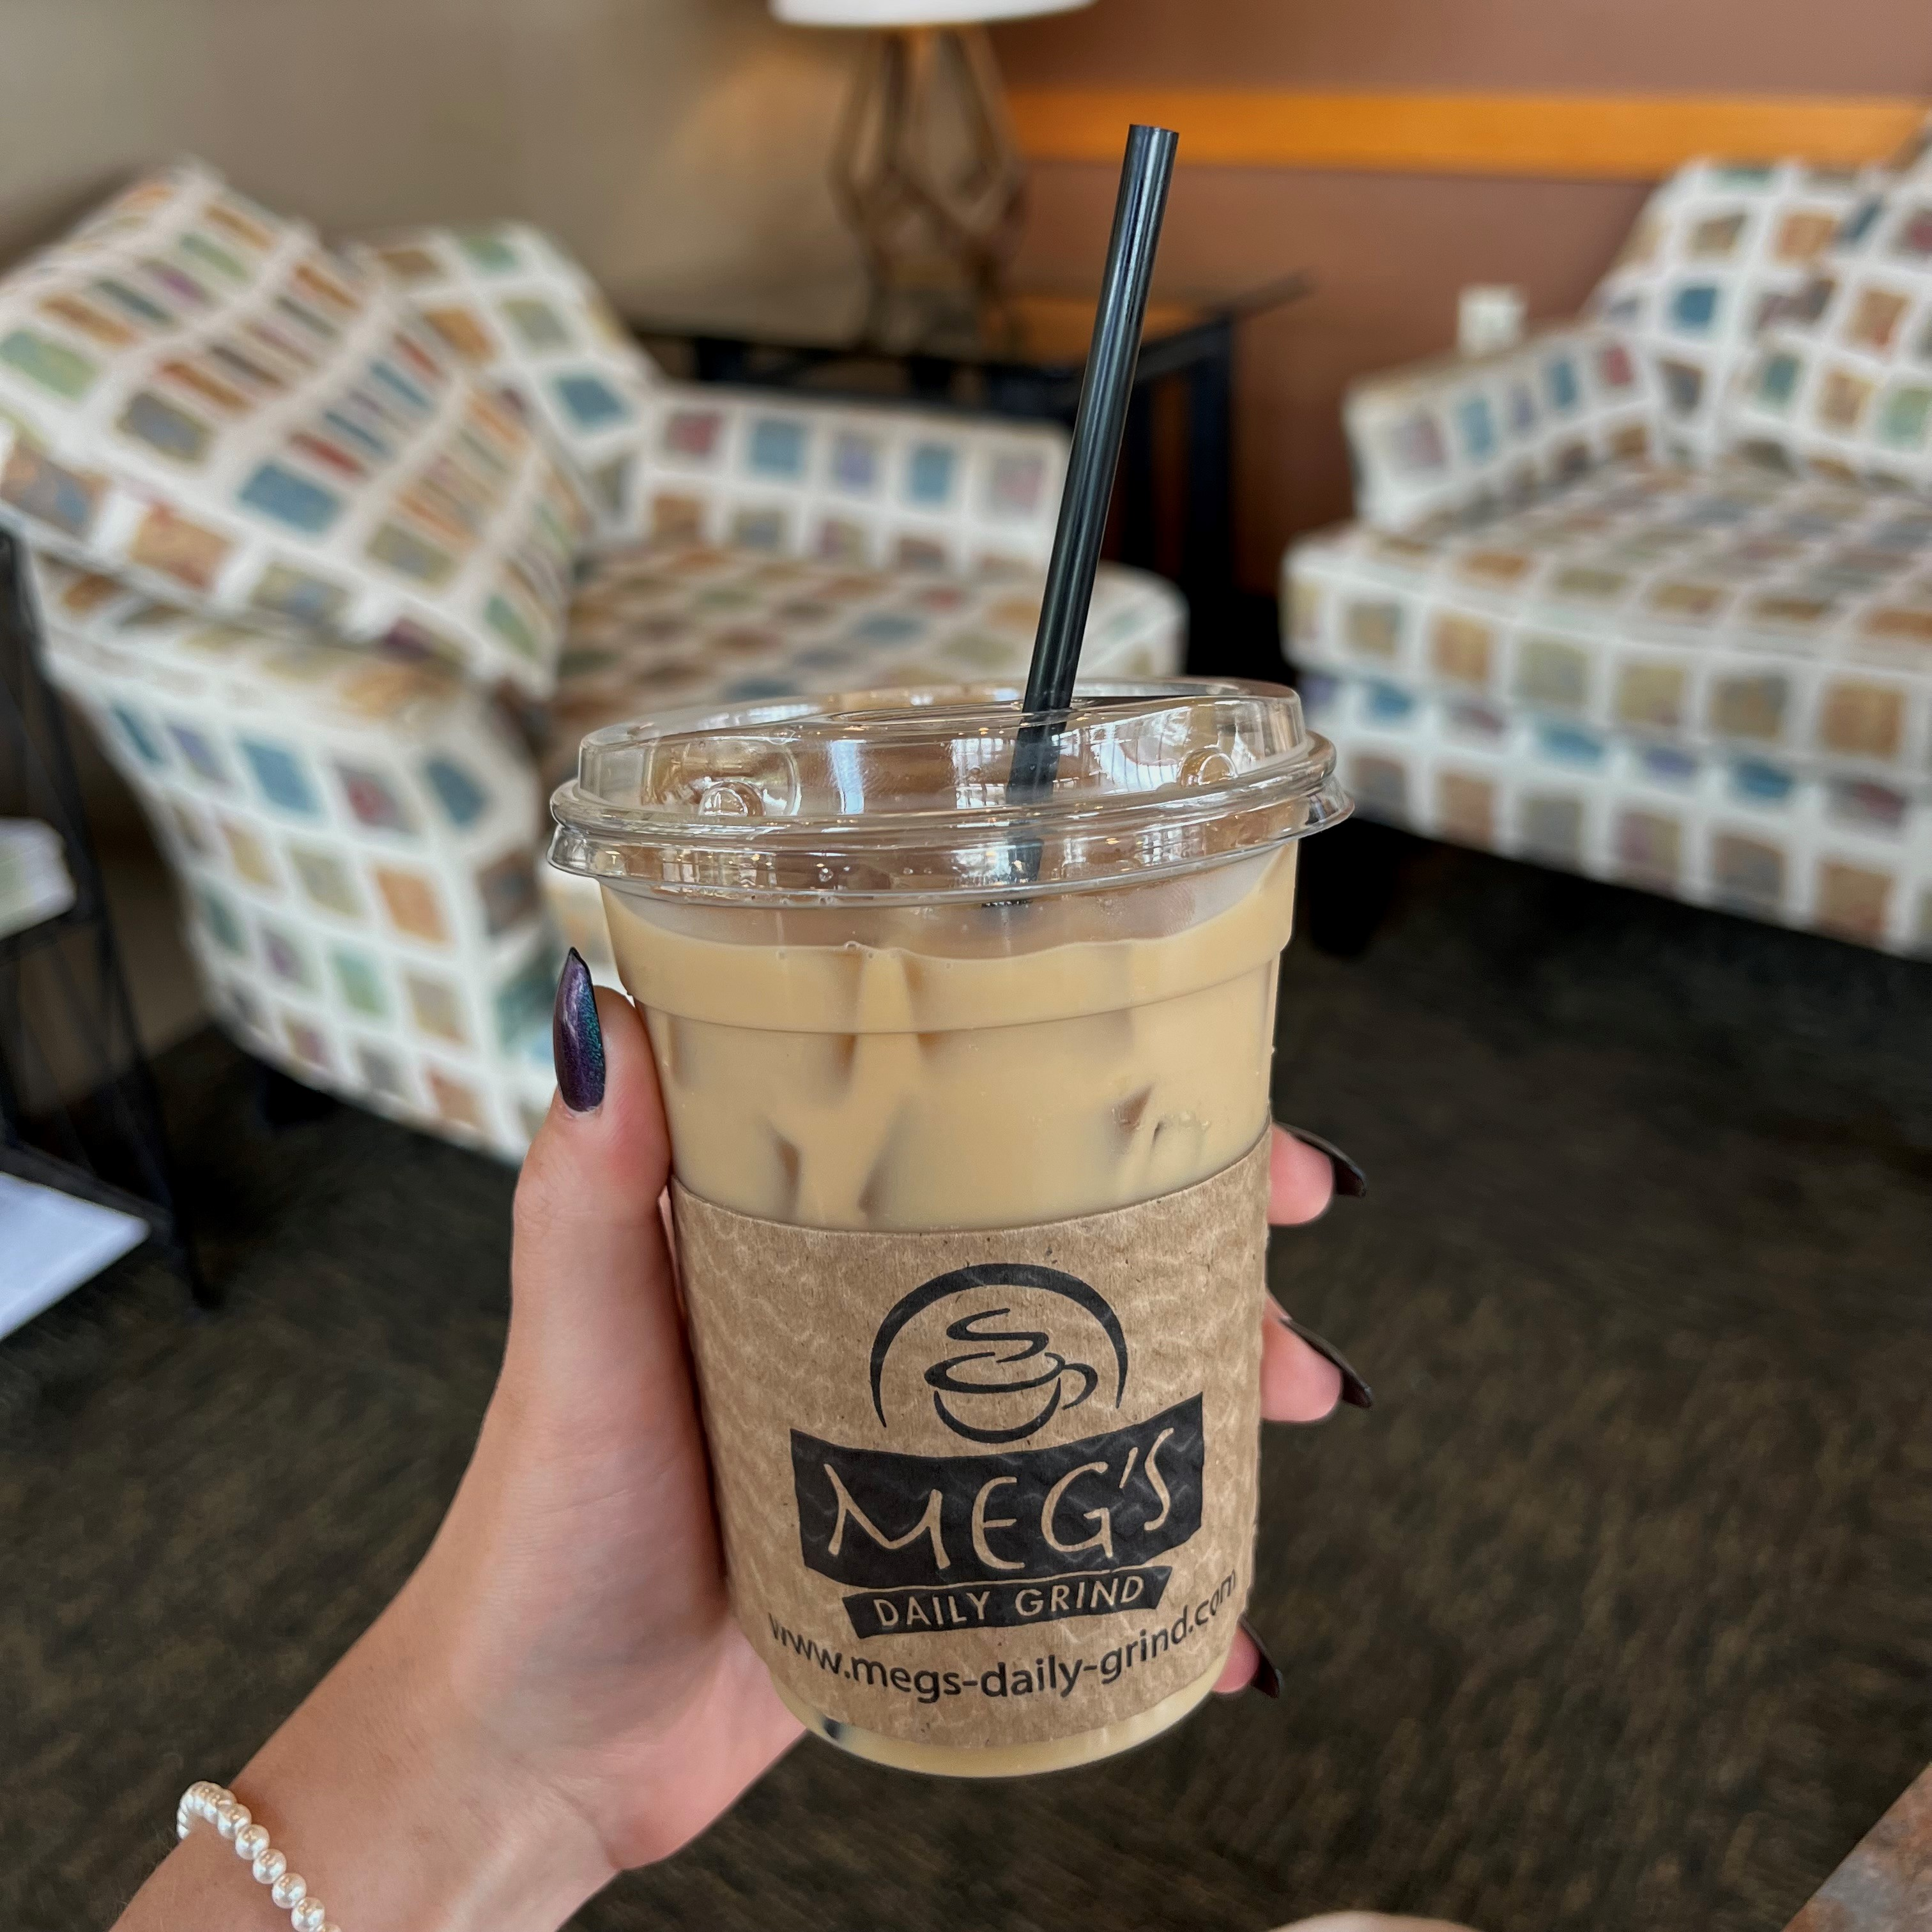

*Photo courtesy of Miranda Brook*

**Meg’s Daily Grind |** **3879 N Perryville Rd, Rockford | 1141 N Alpine Rd, Rockford**

Meg’s Daily Grind is a local coffee shop with two locations in Rockford. It is the coffee shop that I tend to visit most frequently. Their coffee is absolutely delicious. My friends and I like to use Meg’s as a place to meet and catch up. It is a great place to socialize. The atmosphere is great for conversation while enjoying your coffee or a quick bite. You could take your family to Meg’s for a nice lunch as well. When I’m running short on time, Meg’s drive through is also extremely convenient.

**Velvet Robot | 1292 S Alpine Rd, Rockford | 10514 Main St, Roscoe**

If you’re looking for a unique and exciting coffee experience, Velvet Robot Coffee could be the perfect place for you! With two locations in Roscoe and Rockford, you can choose from a menu with exceptional range. Whether you want a simple coffee or a complex and unique blended drink, you can find it here. Many menu items are themed based on holidays, movies, characters, and more. Their wide variety of beverages provide people of all ages and tastes with a great experience.

*Photo courtesy of Miranda Brook*

**Inzombia Coffee | 306 E State St, Rockford**

Inzombia’s convenient downtown location, nostalgic 90’s design, and tasty coffee make for an amazing atmosphere. Coffee lovers can enjoy their coffee while being transported back to the 90’s with the unique decorations inside the shop. My favorite menu item is their cold brew. They have lots of different flavors and types of coffee to choose from. They have a variety of sweet treats as well. The excentric interior and menu options make Inzombia enjoyable for people of all ages including kids. It is a must-visit coffee shop in downtown Rockford!

*Photo courtesy of Miranda Brook*

**Dee Dee’s Main Street Coffee | 101 W Main St, Rockton, IL**

Warm, cozy, and relaxing are the words that come to mind when I think of Dee Dee’s. It is located right in the heart of downtown Rockton. The area is filled with cute shops and lots of character that will make your visit to Dee Dee’s unique and exciting. The atmosphere combined with their amazing drinks creates an opportunity to unwind. For me, it’s a great place to enjoy some time alone with a book or my headphones. They also have some tasty treats available for purchase if you get hungry.

**Mary’s Market Café and Bakery | 2636 McFarland Rd, Rockford, IL | 4431 E State St, Rockford, IL**

With so many amazing options in the area, it can be hard to choose where to go for your coffee. If you’re also hungry, Mary’s Market is the perfect choice. Their coffee is delicious, and you can pair it with a wide variety of food options from their extensive menu. You can choose from traditional breakfast and lunch menu items, to skillets, biscuits and gravy, Italian beef, tacos, and so much more. I would highly recommend going to Mary’s Market with family or friends and sitting down with a good meal to compliment your delicious coffee.

Other places loved by many include Katie’s Cup, Wired Café, My Café Amore, and Rosie’s Coffee Company. Each place has its own unique drinks, atmosphere, and location. Based on all of the listed factors, The Rockford region provides the perfect coffee shop for all coffee lovers!