Make A Splash This Summer: Winnebago County’s Water Activities
The Rockford Region is overflowing with ways to cool down this summer. Whether you enjoy an active day of water sports or floating down a lazy river, Winnebago County has you covered. Make waves this summer by exploring our amazing selection of aquatic activities, water you waiting for?
Take A Dive in the 815
Pearl Lake Beach | South Beloit, IL
This old sand quarry-turned beach and RV resort is the perfect place to cool down on a summer afternoon. Enjoy swimming in clear water, a giant floating playground, inflatable volleyball courts, food trucks, and more with their daily beach pass.
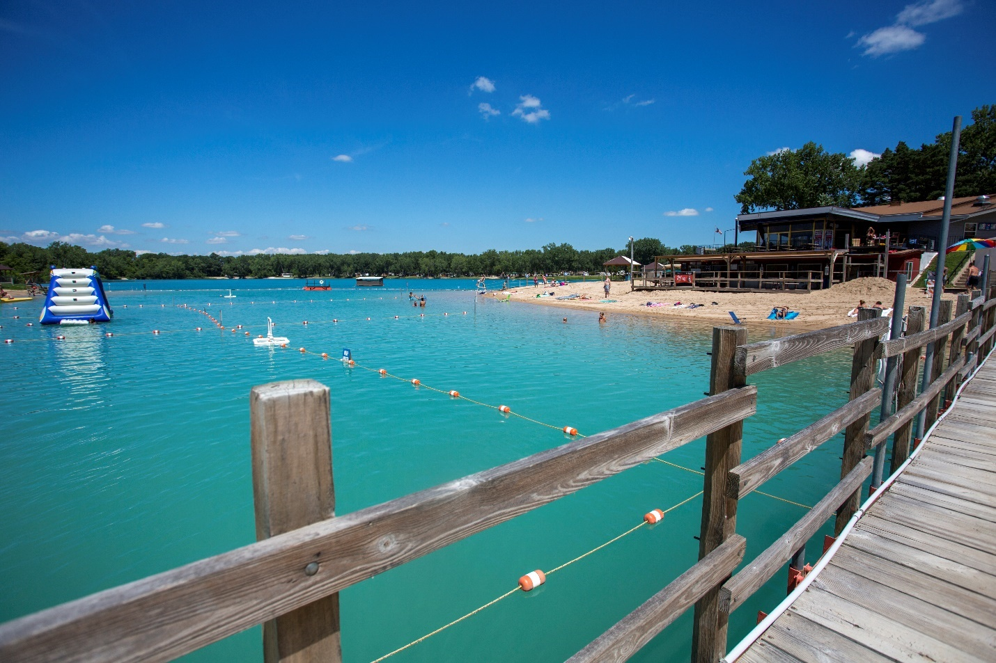
Olsen Lake Beach | Loves Park, IL
Take a dip in Rock Cut State Park’s 60-acre swimming lake, Memorial Day through Labor Day. Amenities include a beach area, swimming area, and boat launch for kayaks, paddle boards, and other self-carry watercraft.
Ride The Waves
West Rock Wake Park | Rockford, IL
Rockford’s Premier wakeboarding park and host to the 2024 World Wake Championships, West Rock’s innovative cable system removes the need for a boat and is perfect for any skill level.
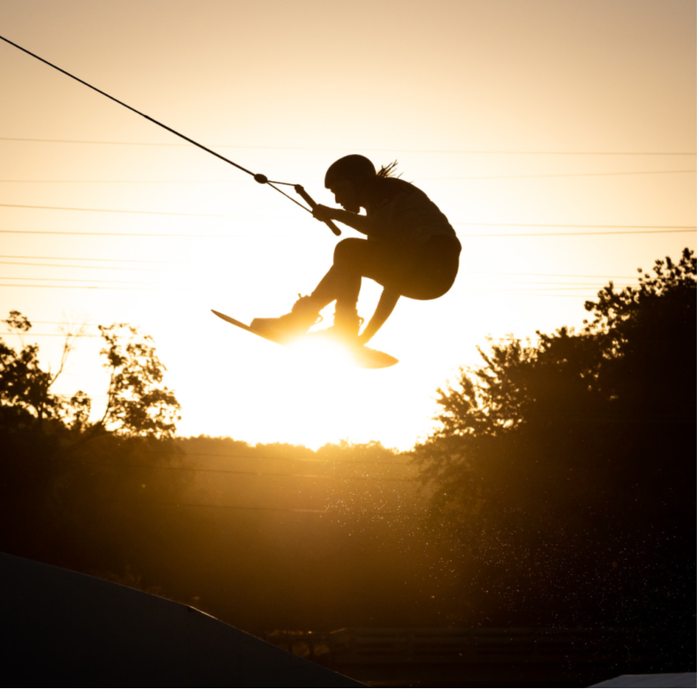
Tubing on the Sugar River | Rockton, IL
Grab your friends and head out to Sugar River Adventures in Rockton. The gentle current of the Sugar River makes for a great lazy day out. Choose from a variety of tubes including an inflatable cooler carrier, perfect for backpacks, coolers, and picnic baskets as you drift down the scenic waterway. They even provide a shuttle that will transport you back to your vehicle at the river’s end.
Six Flags Hurricane Harbor | Rockford, IL
Looking for a fun day out with the whole family? Rockford’s very own water park is home to the largest wavepool in Illinois and features speed slides, tube and body slides, their Splash Magic River, interactive water play area, and Little Lagoon for ages 5 and younger.
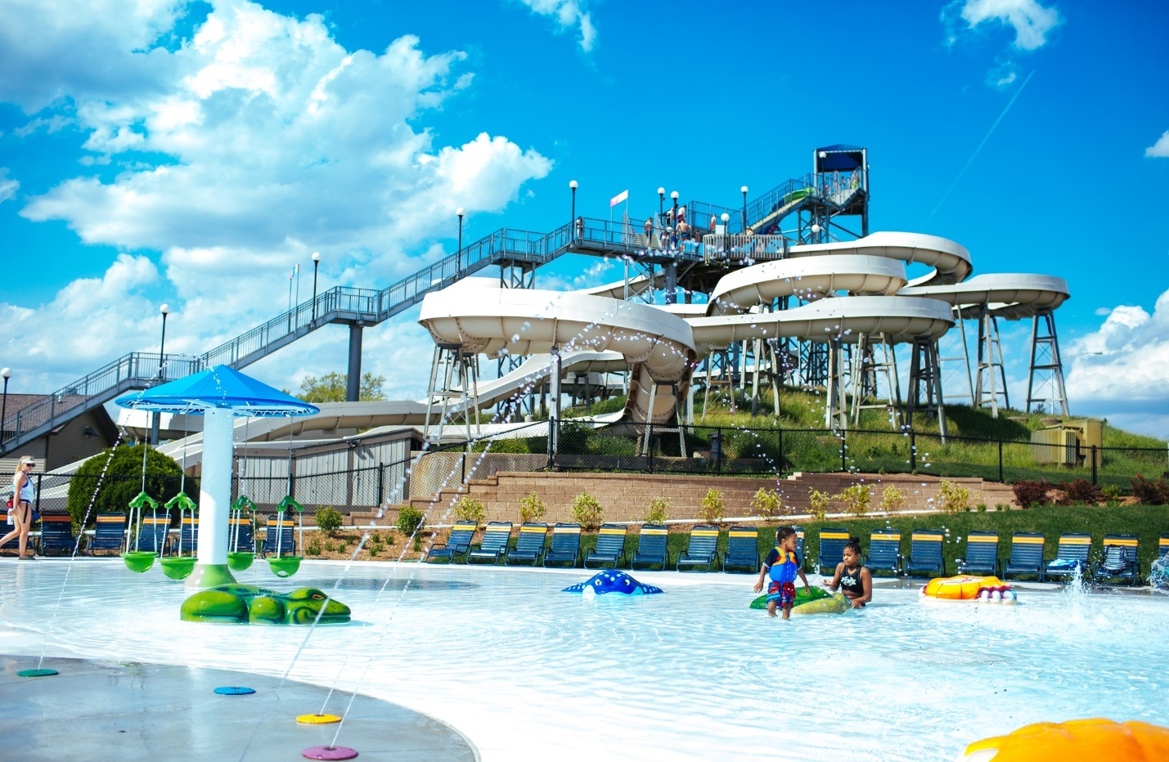
Grab a Paddle
Rent a boat at Rock Cut | Loves Park, IL
Guests at Rock Cut State Park can rent kayaks, canoes, paddle and fishing boats at Pierce Lake. The lake spans 162 acres and is surrounded by the tranquil beauty of the park.
Canoe on the Kishwaukee | Cherry Valley, IL
Rent a canoe and drift down the Kishwaukee River. This 8.5-mile route begins at Baumann Park in Cherry Valley and ends at Atwood Park in New Milford. Wildlife is abundant on this scenic waterway allowing for the opportunity to see bald eagles, blue herons, and turtles.
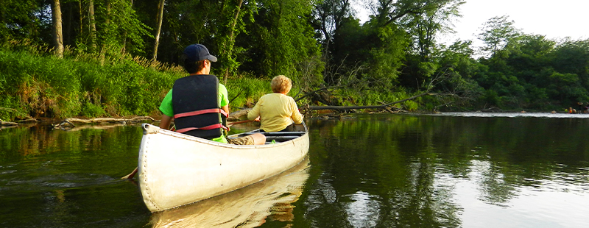
Take a Paddleboarding Lesson | Rockford, IL
Rocktown Adventures is the ultimate outdoor retailer and outfitter in downtown Rockford. They offer paddle sport lessons for all levels and provide monthly group events and excursions on the water. Learn how to safely operate a stand-up paddleboard or other paddle boats by scheduling a lesson today!
Fun With Little Ones
Klehm Arboretum & Botanic Garden | Rockford, IL
Discover Kid’s Creek at the Nancy Olsen Children’s Garden for interactive stream play and a splash pad! Kids can explore themed gardens, an observation tower, and oversized play structures in a natural, playful environment. Cross the wooden bridge to see the rushing stream leading to a serene koi pond. Amenities include a covered gazebo, picnic tables, and spacious restroom facilities.
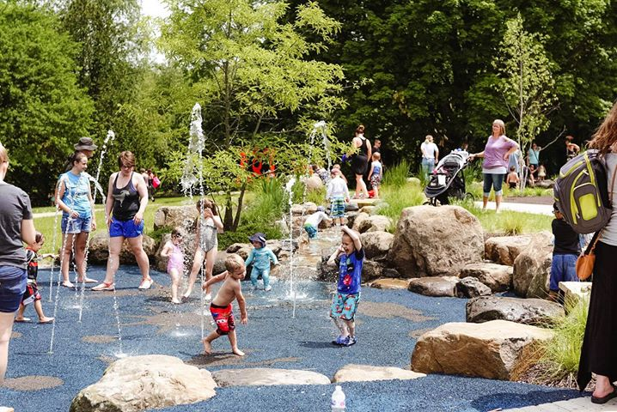
Millenium Fountain Splash Pad | Rockford, IL
Beat the heat by stopping at Waterside Park in downtown Rockford where you can find the newly renovated Millenium Fountain splash pad. This water feature has quickly become a hot spot for visitors to cool off on those hot summer days.
Don’t miss out on the chance to make lasting memories with friends and family—this season, dive into Winnebago County’s vibrant water activities and make a splash like never before!

