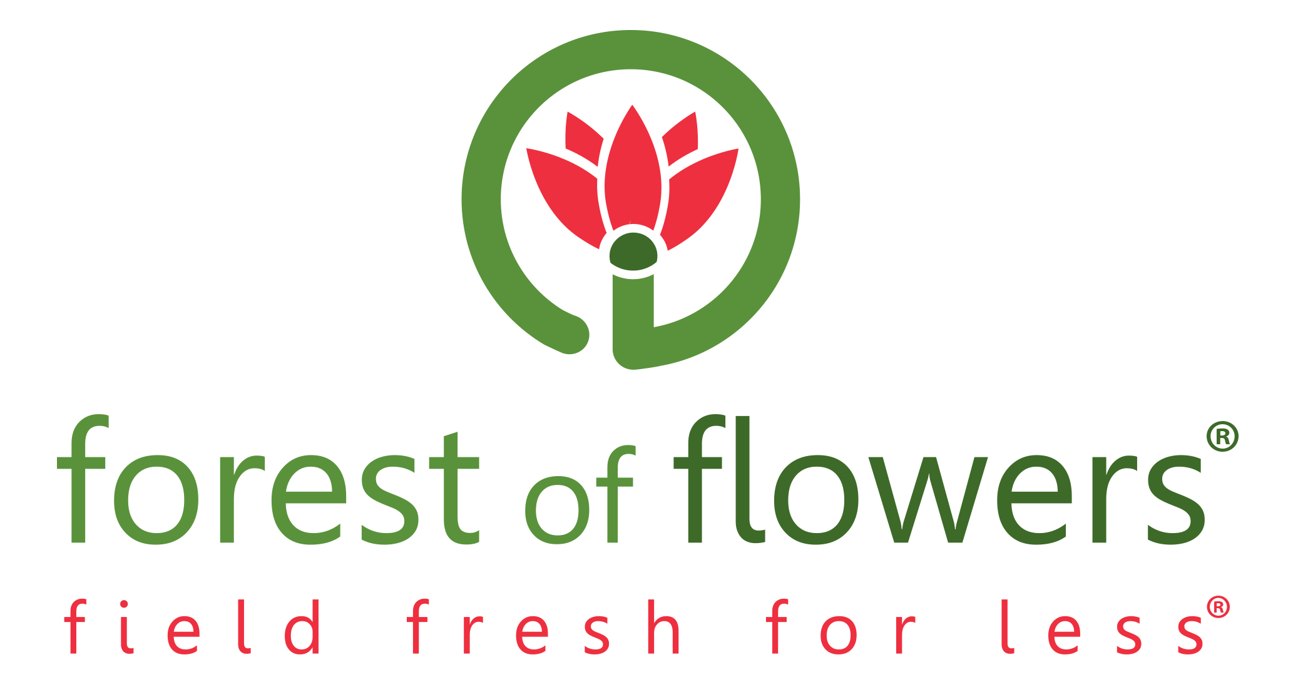
Franchise Questionnaire
(This questionnaire does not obligate either party in any manner)

Mr. Mrs. Ms. First Name Last Name

Sin Address City

Prov Postal Code Email

Home Phone Cell Phone Business Phone

Fax Date of Birth (Month/day/year)

Have you or any company you have been associated with declared bankruptcy? Yes No

If yes please explain

Have you ever been convicted of a criminal offence? Yes No

If yes please explain

Spouse’s First Name Last Name

Spouse’s Date of Birth (m/d/y) Spouse’s Occupation

Number of Dependants Ages

Will you have a partner in the business? (spouse, friend etc.) Yes No

If yes, please indicate:

Partners Involvement: Full Time Part Time Investment Only

Partners First Name Last Name

Partners Relationship to you

Partners Involvement: Full Time Part Time Investment Only

Partners First Name Last Name

Partners Relationship to you

WORK EXPERIENCE

Present Employer May We Contact Yes No

Address City/Prov Phone

Position Annual Salary Name of Supervisor

Dates employed: From To

Prior Employer May We Contact Yes No

Address City/Prov Phone

Position Annual Salary Name of Supervisor

Dates employed: From To

Prior Employer May We Contact Yes No

Address City/Prov Phone

Position Annual Salary Name of Supervisor

Dates employed: From To

EDUCATION

Last year Completed High School : 9 10 11 12 College/University: 1 2 3 4

Name of Post Secondary School Years Attended

Degree Post Graduate Degree

Describe any other training in sales, management, retailing, marketing etc:

STORE LOCATIONS PREFERRED ( please list cities or towns in Southwestern Ontario)

1.

2.

3.

FINANCIAL STATEMENT

Assets |  | Liabilities
Cash on Hand & in Banks |  | Lines of Credit
Notes Collectible |  | Mortgages Home
Home (Market Value) |  | Mortgage Other
Other Real Estate |  | Loans Payable
Securities-stocks, mutual Funds, etc. |  | Credit Cards
Business Interests |  | Unpaid Taxes
Other Assets |  | Other Liabilities
Total Assets |  | total Liabilities
Net Worth (Total Assets – Total Liabilities) $

BANK

Bank May We Contact Yes No

Address City/Prov Phone

ACKNOWLEDGEMENT AND CONSENT

This submission and acceptance of a questionnaire should not be construed as an approval or a future guarantee of becoming a Forest of Flowers® franchisee. To become an “approved” franchisee, there is a formal process that is undertaken with all Applicants.

The undersigned acknowledges that the statements and information made in the attached Franchise Questionnaire fully and truthfully set forth the true and accurate personal information and financial conditions of the applicants as of the date hereof.

The undersigned further acknowledges that for the purposes of determining whether or not the undersigned would be a suitable Forest of Flowers® franchisee, an investigation may be made with respect to the information above, including credit checks, as well as further information with respect to the undersigned’s financial status, litigation history, criminal record history, educational credentials, employment history, character and general reputation. The undersigned hereby consents to the Forest of Flowers® Franchise Corp or its agents collecting and retaining such information and conducting further investigations with respect to such information.

Dated the Day of Year

Signature of Applicant Print Name

Signature of Spouse (if applicable Print Name

Signature of Witness Print Name

Please Return By Mail To:

Franchise Department
Forest of Flowers
841 Wellington Rd. Unit B2
London ON N6E 3R5

Phone: 1-877-891-7649
Phone: 519- 680-5111
www.forestofflowers.com

