

MEGACEL® II GASKET SEAL APPLICATIONS SUBMITTAL SHEET

|  |  |  |  |
| --- | --- | --- | --- |
| AAF CONTROL NO.: |  | P.O.: |  |
| DATE: | February 27, 2024 | BY: |  |
| CUSTOMER: |  | LOCATION: |  |
| CONTACT NAME: |  | REFERENCE: |  |

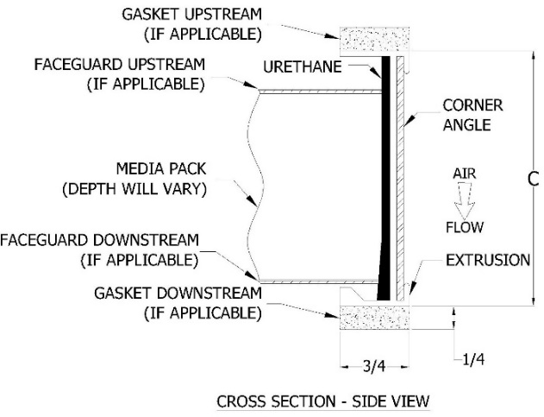

**SIZE:**

THE SIZES DESIGNATORS IS FORMATTED AS FOLLOWS: “EHHZWWZ”

“E” = All Megacel II style codes start with “E”

“HH” = Filter height in whole inches (e.g. “12” for 12 inches, “08” for 8 inches)

“WW” = Filter width in whole inches (e.g. “24” for 24 inches, “09” for 9 inches)

“Z” = Fractions of inches as follows:

A = 0 B = 1/8” C = 1/4” D = 3/8” E = 1/2" F = 5/8”

G = 3/4" H = 7/8” J = 1/16” K = 3/16” L = 5/16” M = 7/16”

N = 9/16” P = 11/16” Q = 13/16” R = 15/16”

EXAMPLES: E24A24A = 24” height x 24” width

E23D23D = 23-3/8” height x 23-3/8” width

E08P33H = 8-11/16” height x 33-7/8” width

**(1) MEDIA** – MEMBRANE:

99.99% HEPA PAO COMPATIBLE (B)

99.995% HEPA PAO COMPATIBLE (H14) (C)

SPECIAL -       (NSP required, enter in Salesforce) (Z)

**(2) CELL SIDE MATERIAL:** EXTRUDED ANODIZED ALUMINUM

2-3/4” (89)

5-7/8” (40)

NON-STANDARD SUBSTITUTE CELL SIDES       (99)

(NSP required, enter in Salesforce)

**(3) FILTER PACK DEPTH:**

50mm (Hot Melt / Polyolefin) (K)

SPECIAL -       (NSP required, enter in Salesforce) (X)

**(4) BOND:**

POLYURETHANE BOND, PATCHING PER IEST RP-CC-001 WITH SILICONE CAULK (2)

POLYURETHANE BOND, PATCHING PER IEST RP-CC-001 WITH NON-SILICONE CAULK (4)

POLYURETHANE BOND, NO PATCHING ALLOWED (6)

SPECIAL -       (NSP required, enter in Salesforce) (9)

**(5) GASKET MATERIAL:**

NONE (P)

NEOPRENE (Dovetail Joints) (R)

NEOPRENE (Butt-jointed) (T)

PORON (Dovetail Joints) (U)

PORON (Butt-jointed) (V)

SILICONE (NOT UL APPROVED) (Y)

SPECIAL -       (NSP required, enter in Salesforce) (Z)

**(6) GASKET LOCATION:**

NONE (0)

AIR ENTERING SIDE (1)

AIR LEAVING SIDE (2)

BOTH SIDES (3)

SPECIAL LOC. -       (NSP required, enter in Salesforce) (4)

**(7) ACCEPTANCE LEVEL:**

**IF “B” MEDIA IS SELECTED IN SECTION 1:**

99.99% on 0.3um (Scanned and Tested) (H)

99.99% on 0.3um (Cold PAO Scan) (S)

**IF “C” MEDIA IS SELECTED IN SECTION 1:**

99.995% on MPPS (H14) (D)

**IF “Z” MEDIA IS SELECTED IN SECTION 1, PLEASE**

**ENTER SPECIAL TEST CRITERIA REQUIRED:**

      (NSP required, enter in Salesforce)

**(8) FACEGUARD:**

NO FACEGUARD (A)

WHITE EPOXY POWDERCOATED EXPANDED STEEL (B)

EXPANDED 304 STAINLESS STEEL (C)

PERFORATED 304 STAINLESS STEEL (D)

PERFORMATED ANODIZED ALUMINUM (E)

SPECIAL FACEGUARD -       (NSP required, enter in Salesforce) (Z)

**(9) FACEGUARD LOCATION:**

NONE (0)

AIR ENTERING SIDE (1)

AIR LEAVING SIDE (2)

BOTH SIDES (3)

SPECIAL -       (NSP required, enter in Salesforce) (9)

**(10) CENTER DIVIDER:**

NO CENTER DIVIDER OR TEST PORT (A)

CENTER DIVIDER (Parallel to “HH” dimension, centered on “WW” dimension) (B)

CENTER DIVIDER AND 1 TEST PORT (C)

CENTER DIVIDER AND 2 TEST PORTS (D)

SPECIAL -       (NSP required, enter in Salesforce) (Z)

|  |  |  |  |  |  |  |
| --- | --- | --- | --- | --- | --- | --- |
| **QTY** | **PART NUMBER** | **STYLE CODE** | **A** | **B** | **C** | **NOTES** |
|  |  |  |  |  |  |  |
|  |  |  |  |  |  |  |
|  |  |  |  |  |  |  |
|  |  |  |  |  |  |  |

Customer Signature: _________________________________ Approval Date: _______________________

STYLE CODE BUILDER

(USE CODES ON PREVIOUS PAGE AND SIZE CODE THEN INSERT IN TABLE ABOVE)

|  |  |  |  |  |  |  |  |  |  |  |  |  |  |  |
| --- | --- | --- | --- | --- | --- | --- | --- | --- | --- | --- | --- | --- | --- | --- |
|  | Height | Height Fraction | Width | Width Fraction | Sect 1: Media | Sect 2:  Frame | Sect 3:  Pack Depth | Sect 4: Sealant | Sect 5: Gasket Material | Sect 6: Gasket Location | Sect 7:  Test | Sect 8:  Faceguard Material | Sect 9: Faceguard Location | Sect 10:  Center Divider & Test Port(s) |
| E |  |  |  |  |  |  |  |  |  |  |  |  |  |  |
| E |  |  |  |  |  |  |  |  |  |  |  |  |  |  |
| E |  |  |  |  |  |  |  |  |  |  |  |  |  |  |