  AMERICAN AIR FILTER PO BOX 35690 LOUISVILLE KY 40232-5690 | SUBMITTAL AFP-111  MAR/22
AIR FILTRATION PRODUCTS | AstroCel I  METAL CELL SIDES  FLUID SEAL CONSTRUCTION

AAF CONTROL NO.: |  | P.O.:
DATE: | July 30, 2026 | BY:
CUSTOMER: |  | LOCATION:
CONTACT NAME: |  | REFERENCE:

W
H
D
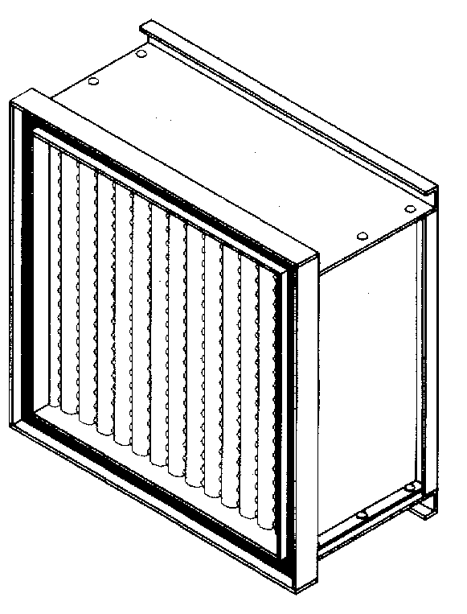
TEST
AIR
FLOW

CROSS SECTION - TOP VIEW
D

AIRFLOW DIRECTION
DETERMINED BY GEL LOCATION.

SIZE: AS SHOWN ON DRAWINGS OR LISTED BELOW.
(1) MEDIA – Water Repellant Glass Media:
99.97% / 99.99% (HEPA) (A)
95% BioCel (MERV 16) (D)
99.999% / 99.9995% (ULPA) (E)
Intersept Treated (99.97% / 99.99%) (I)
Special - (NSP Required, Enter in Salesforce) (Z)

(2) CELL SIDE MATERIAL:
Galvanized Steel (10)
304 Stainless Steel (16)
Mill Finish Aluminum (19)
Special - (NSP Required, Enter in Salesforce) (99)

(3) SEPARATORS:
Aluminum (Standard Capacity) (J)
Aluminum (High Capacity) (H)
Vinyl Coated Aluminum (Standard Capacity) (V)
Vinyl Coated Aluminum (High Capacity) (W)
Special - (NSP Required, Enter in Salesforce) (Z)

(4) BOND MATERIAL (Maximum Temperature Rating 175 Degrees F):
Fire-Retardant Polyurethane (1)
Red Silicone (5)
Special - (NSP Required, Enter in Salesforce) (9)

(5) GEL MATERIAL (Installed in 3/4” DEEP TROUGH):
None (P)
Silicone Gel (F)
Urethane Gel (B)
Special - (NSP Required, Enter in Salesforce) (Z)

(6) GEL LOCATION:
None (“None / P” Must Be Selection in Section 5) (0)
Gel Trough Located on Air Entering Side (1)
Gel Trough Located on Leaving Side (2)
Special - (NSP Required, Enter in Salesforce) (4)
Extractor Clips Air Entering Side / Gel on Air Leaving Side (5)
Extractor Clips Air Leaving Side / Gel on Air Entering Side (6)

(7) ACCEPTANCE LEVEL:
IF “A” MEDIA IS SELECTED IN SECTION 1:
99.97% PAO Tested (0.3um) (A)
99.99% PSL Tested (0.3um) (G)
99.99% Leak-Free Scan & PSL Tested (0.3um) (H)
99.99% PAO Tested (0.3um) (R)
99.99% Cold Hand Scan & PAO Tested (0.3um) (S)
Special - (NSP Required, Enter in Salesforce) (E)

IF “D” MEDIA IS SELECTED IN SECTION 1:
95% DOP (F)
Special - (NSP Required, Enter in Salesforce) (E)

IF “E” MEDIA IS SELECTED IN SECTION 1:
99.999% PSL Tested (0.3um) (J)
99.999% Leak-Free Scan & PSL Tested (0.3um) (K)
99.9995% Leak-Free Scan & PSL Tested (MPPS) (M)
Special - (NSP Required, Enter in Salesforce) (E)

IF “I” MEDIA IS SELECTED IN SECTION 1:
99.97% PAO Tested (0.3um) (A)
99.99% PSL Tested (0.3um) (G)
99.99% Leak-Free Scan & PSL Tested (0.3um) (H)
99.99% PAO Tested (0.3um) (R)
99.99% Cold Hand Scan & PAO Tested (0.3um) (S)
Special - (NSP Required, Enter in Salesforce) (E)

IF “Z” MEDIA IS SELECTED IN SECTION 1, PLEASE
ENTER SPECIAL TEST CRITERIA REQUIRED:
(NSP Required, Enter in Salesforce) (E)

(8) FACEGUARD (4x4 CLOTH MESH, GALVANIZED FOR HIGH CAPACITY /
FLATTENED EXPANDED, GALVANIZED FOR STANDARD CAPACITY) / UL LABEL:
No Faceguard with UL 900 Label (0)
Faceguard Upstream with UL 900 Label (1)
Faceguard Downstream with UL 900 Label (2)
Faceguard Both Sides with UL 900 Label (3)
Special - (NSP Required, Enter in Salesforce) (4)
No Faceguard with UL 586 Label (5)
Faceguard Upstream with UL 586 Label (6)
Faceguard Downstream with UL 586 Label (7)
Faceguard Both Sides with UL 586 Label (8)

UL 900 CLASSIFICATION
ALL METAL AstroCel I FILTERS ARE CLASSIFIED UL 900 UNLESS
UL586 IS ADDED ABOVE.

(9) CENTER DIVIDER & TEST PORT
Center Divider & One Test Port (C)

QUANTITY | PART NUMBER | STYLE CODE | H | W | D | NOTES
Customer Signature: __________________________________________ Approval Date: __________________________

STYLE CODE BUILDER
(USE CODES ON PREVIOUS PAGE AND SIZE CODE BELOW THEN INSERT INTO TABLE ABOVE)
SIZE  (SEE BELOW) | MEDIA (1) | CELL SIDE MATERIAL (2) | SEPARATORS (3) | BOND MATERIAL (4) | GEL MATERIAL (5) | GEL LOCATION (6) | ACCEPTANCE LEVEL (7) | FACEGUARD LOCATION (8)

ASTROCEL I SIZE CODE CHART

SIZE CODE | “A” DIM | “B” DIM | “C” DIM
12 | 8 | 8 | 5-7/8
13 | 12 | 12 | 5-7/8
14 | 24 | 24 | 5-7/8
15 | 24 | 24 | 11-1/2
16 | 24 | 30 | 11-1/2
17 | 24 | 48 | 5-7/8
18 | 24 | 72 | 5-7/8
31 | 12 | 12 | 11-1/2
32 | 12 | 24 | 11-1/2
33 | 15-3/8 | 19-3/8 | 5-7/8
34 | 15-3/8 | 19-3/8 | 11-1/2
35 | 20-7/8 | 20-7/8 | 5-7/8
36 | 20-7/8 | 20-7/8 | 11-1/2
37 | 20-7/8 | 44-7/8 | 5-7/8
38 | 23-1/4 | 23-1/4 | 5-7/8
41 | 23-3/8 | 23-3/8 | 5-7/8
42 | 23-3/8 | 23-3/8 | 11-1/2
43 | 24 | 121 | 5-7/8
44 | 24 | 12 | 11-1/2
45 | 24 | 30 | 5-7/8
46 | 24 | 36 | 5-7/8
47 | 24 | 60 | 5-7/8
48 | 24-3/8 | 19-3/8 | 11-1/2
51 | 30 | 30 | 5-7/8
52 | 30 | 36 | 5-7/8
53 | 30 | 48 | 5-7/8
54 | 30 | 60 | 5-7/8
55 | 30 | 72 | 5-7/8
58 | 36 | 36 | 5-7/8
61 | 36 | 60 | 5-7/8
62 | 36 | 72 | 5-7/8
63 | 23-1/4 | 47-1/4 | 5-7/8
64 | 30 | 24 | 5-7/8
65 | 36 | 48 | 5-7/8
66 | 12 | 24 | 5-7/8
67 | 23-3/4 | 41-1/4 | 5-7/8
68 | 23-1/4 | 29-1/4 | 5-7/8
69 | 23-1/4 | 35-1/4 | 5-7/8
91 | 11-3/8 | 23-3/8 | 5-7/8
92 | 23-3/8 | 11-3/8 | 5-7/8
19 | ALL OTHER | SIZES

