  AMERICAN AIR FILTER PO BOX 35690 LOUISVILLE KY 40232-5690 | SUBMITTAL  MAR/22
AIR FILTRATION PRODUCTS | VARICEL NO-HEADER  METAL CELL SIDES  PAN STYLE CONSTRUCTION

AAF CONTROL NO.: |  | P.O.:
DATE: | July 30, 2026 | BY:
CUSTOMER: |  | LOCATION:
CONTACT NAME: |  | REFERENCE:

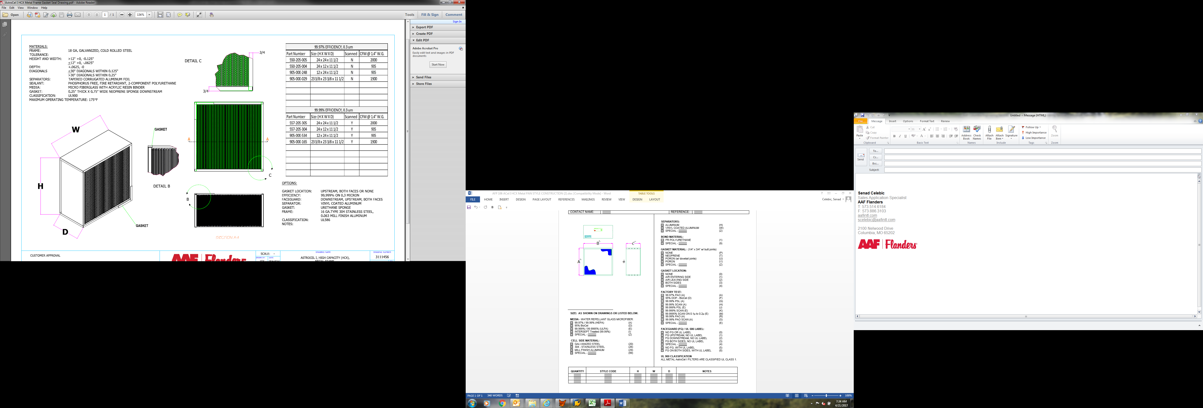
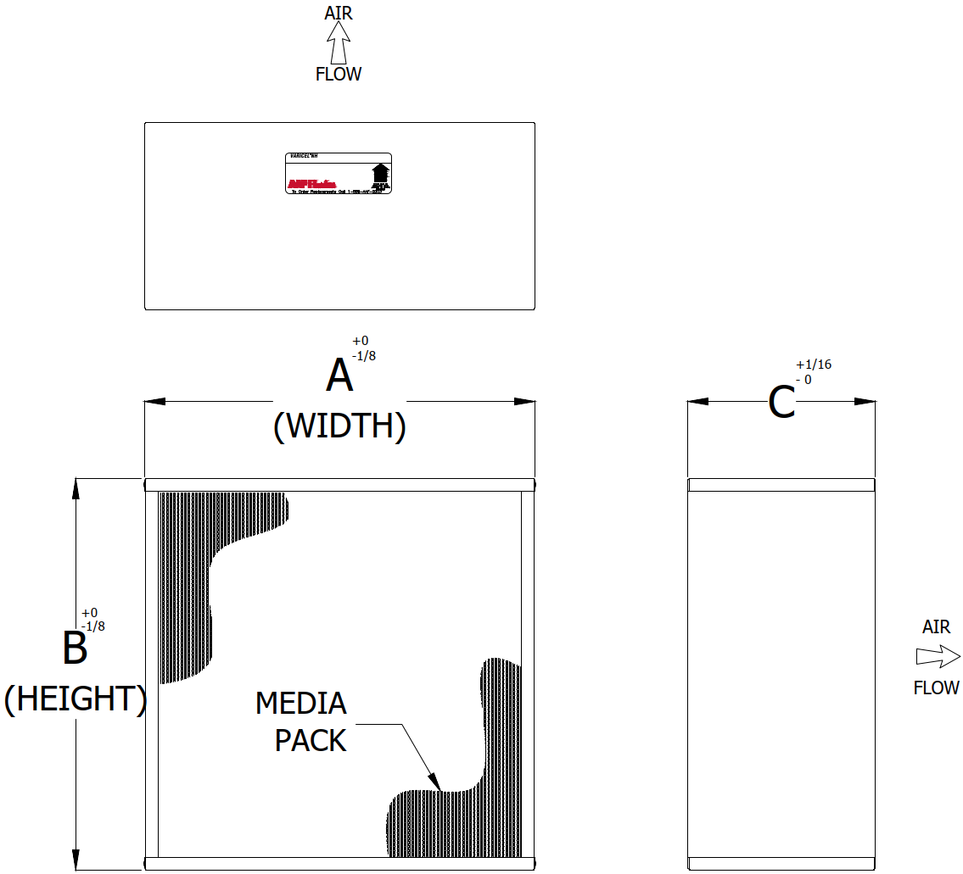

SIZE: AS SHOWN ON DRAWINGS OR LISTED BELOW.

SECTION 1 - MEDIA - WATER REPELLANT GLASS MICROFIBER:
MERV 11 / 60% (Q)
MERV 13 / 80% (R)
MERV 14 / 90% (S)
Special - (X)

SECTION 2 - CELL SIDE MATERIAL:
Galvanized Steel (20)
304 - Stainless Steel (26)
Mill Finish Aluminum (29)
Special - (99)

SECTION 3 - SEPARATORS:
Aluminum (J)
Vinyl Coated Aluminum (V)
Special - (Z)

SECTION 4 - BOND MATERIAL:
FR Polyurethane (1)
Special - (9)

SECTION 5 - GASKET MATERIAL (1/4” x 3/4” w/ Butt Joints):
None (P)
Neoprene (T)
Special - (Z)

SECTON 6 - GASKET LOCATION:
None (0)
Air Entering Side (1)
Air Leaving Side (2)
Both Sides (3)
Special - (4)

SECTION 7 - FACTORY TEST:
None (No Testing Required) (W)
Special - (E)

SECTION 8 – FACEGUARD (Flattened, Expanded Galvanized Metal):
No Faceguard (0)
Faceguard Upstream (1)
Faceguard Downstream (2)
Faceguard Both Sides (3)
Special - (4)

QUANTITY | PART NUMBER | STYLE CODE | H | W | D | NOTES

Signature: ____________________________________________ Date: ______________________________

STYLE CODE BUILDER
(USE CODES ON PREVIOUS PAGE AND SIZE CODE BELOW THEN INSERT INTO TABLE ABOVE)
SIZE  (SEE BELOW) | MEDIA (1) | CELL SIDE MATERIAL (2) | SEPARATORS (3) | BOND MATERIAL (4) | GASKET MATERIAL (5) | GASKET LOCATION (6) | ACCEPTANCE LEVEL (7) | FACEGUARD LOCATION (8)

VARICEL NH SIZE CODE CHART

SIZE CODE | “A” DIM | “B” DIM | “C” DIM
12 | 8 | 8 | 5-7/8
13 | 12 | 12 | 5-7/8
14 | 24 | 24 | 5-7/8
15 | 24 | 24 | 11-1/2
16 | 24 | 30 | 11-1/2
31 | 12 | 12 | 11-1/2
32 | 12 | 24 | 11-1/2
41 | 23-3/8 | 23-3/8 | 5-7/8
42 | 23-3/8 | 23-3/8 | 11-1/2
44 | 24 | 12 | 11-1/2
45 | 24 | 30 | 5-7/8
71 | 30 | 24 | 11-1/2
72 | 19-3/8 | 23-3/8 | 11-1/2
73 | 19-3/8 | 19-3/8 | 11-1/2
74 | 17-3/8 | 23-3/8 | 11-1/2
75 | 15-3/8 | 24-3/8 | 11-1/2
76 | 11-3/8 | 23-3/8 | 11-1/2
77 | 19-3/8 | 24-3/8 | 5-7/8
78 | 19-3/8 | 23-3/8 | 5-7/8
81 | 19-3/8 | 19-3/8 | 5-7/8
82 | 17-3/8 | 23-3/8 | 5-7/8
83 | 15-3/8 | 24-3/8 | 5-7/8
84 | 15-3/8 | 19-3/8 | 5-7/8
85 | 15-3/8 | 19-3/8 | 11-1/2
86 | 11-3/8 | 23-3/8 | 5-7/8
87 | 19-3/8 | 24-3/8 | 11-1/2
92 | 23-3/8 | 11-3/8 | 11-1/2
49 | ALL OTHER | SIZES

