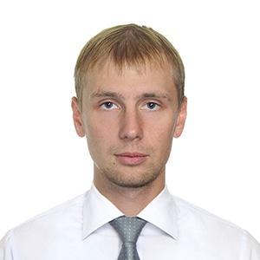 |  | Aleh Yemelyanchyk  Male, 28 years, born in 14 March 1989  +375 (25) 5308404  yem1403@gmail.com — preferred method of communication  Skype: olegpiic  Website: http://aleh.allyou.net/  Reside in: Minsk  Citizenship: Belarus,  Ready to relocate  Languages:  Russian — native  English — upper-intermediate level
Skills
- high-poly modelling for render and baking
- low-poly modelling for games
- sculpting
- texturing (PRB also)
- rendering
- anatomy knowledge
Work experience
January 2015 to November 2015  November 2015 to December 2015  December 2015 to September 2016  October 2016 to March 2017 |  | Freelance work.  Black Sails Game (outsourse), http://fieriagold.com/  Unannounced Project (outsourse)  Cartoon Tanks, Space Shooter (Unity 5 games)
Education
Higher
2013 |  | Belarusian National Technical University
Software Profiсiency
3ds Max, Zbrush  Designer |  | , Substance Painter, Substance Designer, Adobe Photoshop, Marvelous

