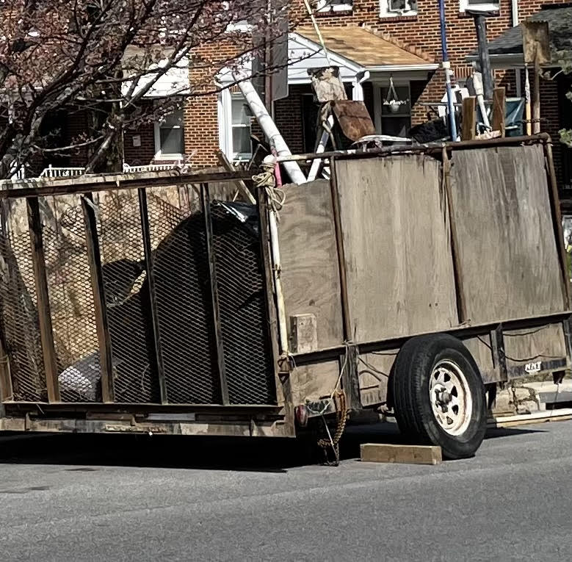

This thing has been parked at the corner of Hoffman Street and 1400 N Ellwood for over 3 weeks; blocking the view of pedestrians and drivers.

