Part 5 of 7 for letter with attachments
July 5, 2025
Mr. Andre Campbell, Building Inspector Administrator
Baltimore City Code Enforcement, DHCD
417 E. Fayette Street
14th Floor
Baltimore, MD 21202

RE: Stop Work Order for 2524 E. Baltimore date 7/2/2025

Mr. Campbell:
(continuation of letter part 5)

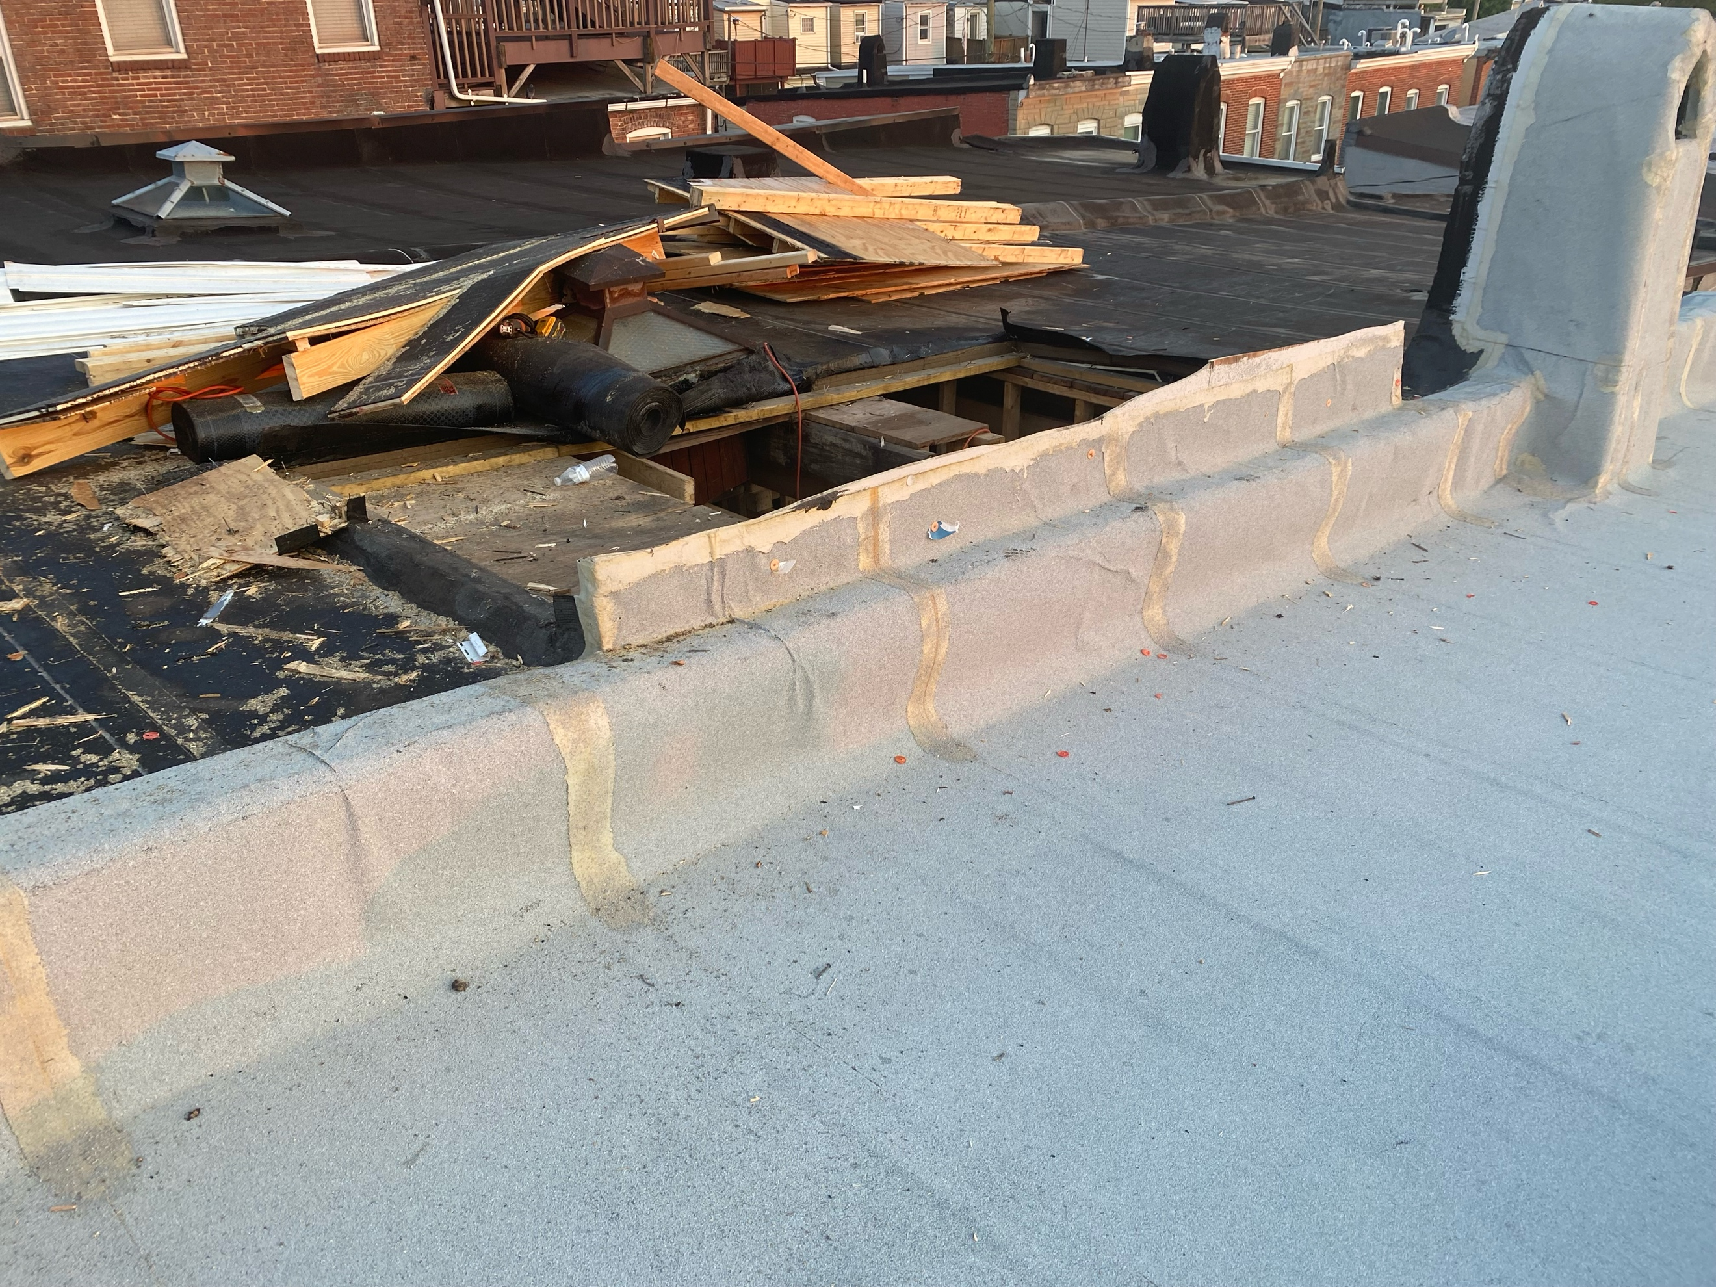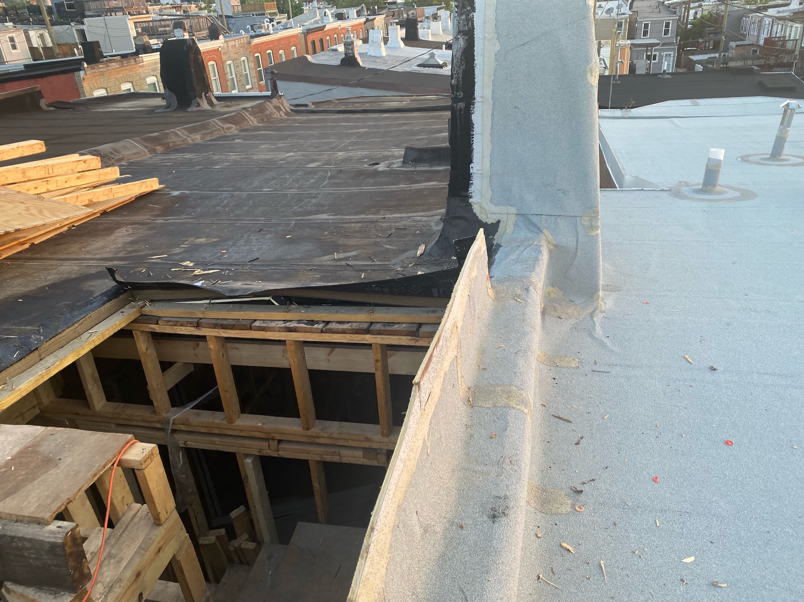

Attachments - Photos of debris in back yard from 7/5 (2x4’s on the ground and on the satellite dish were thrown out of the back window with nails)

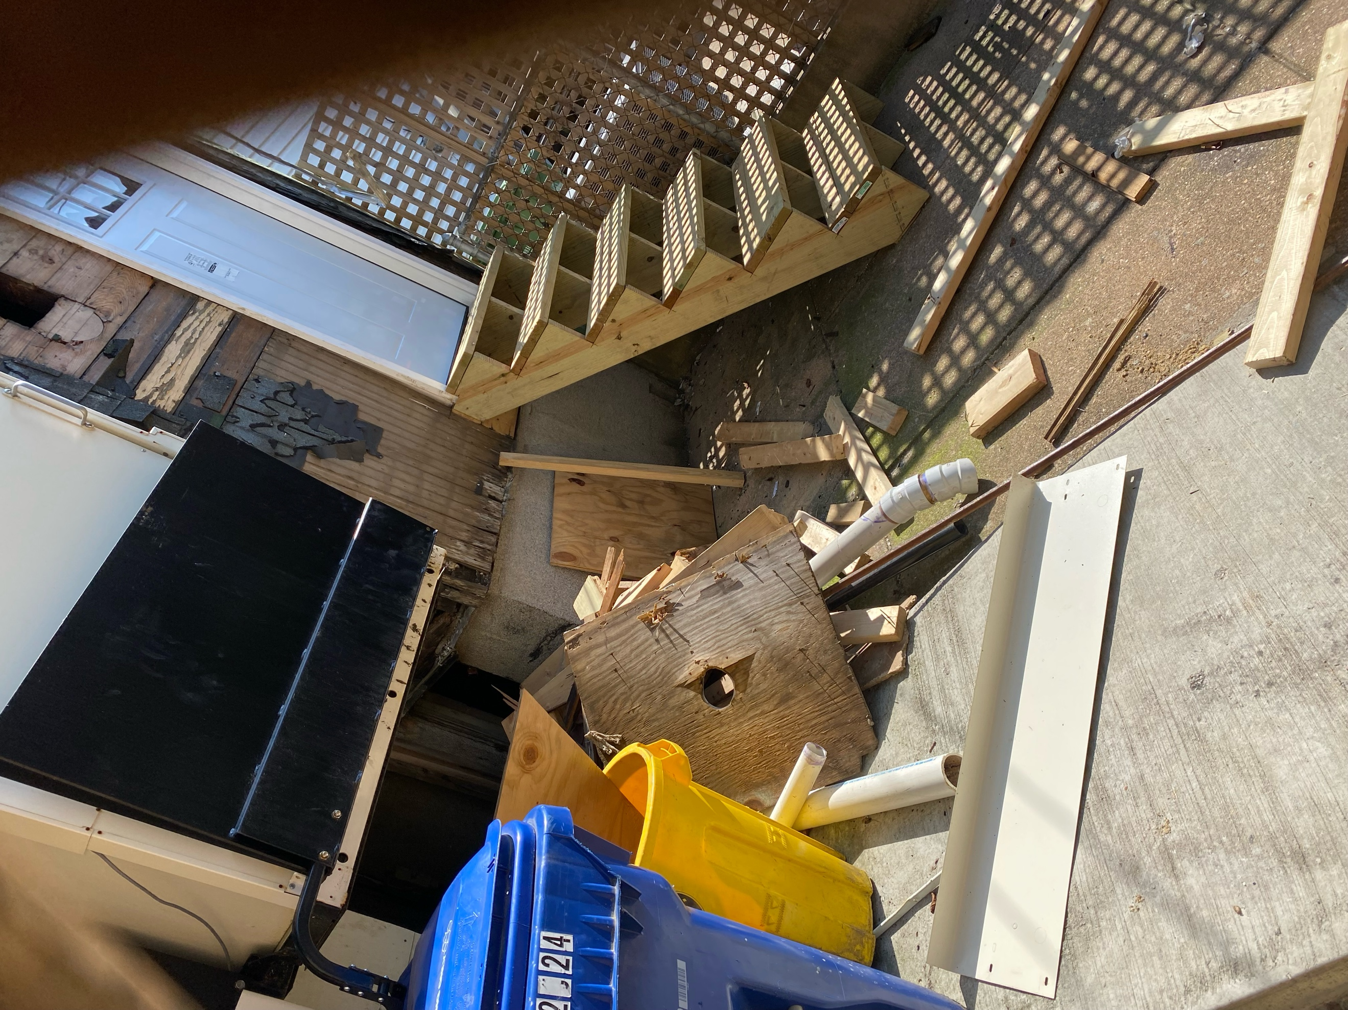
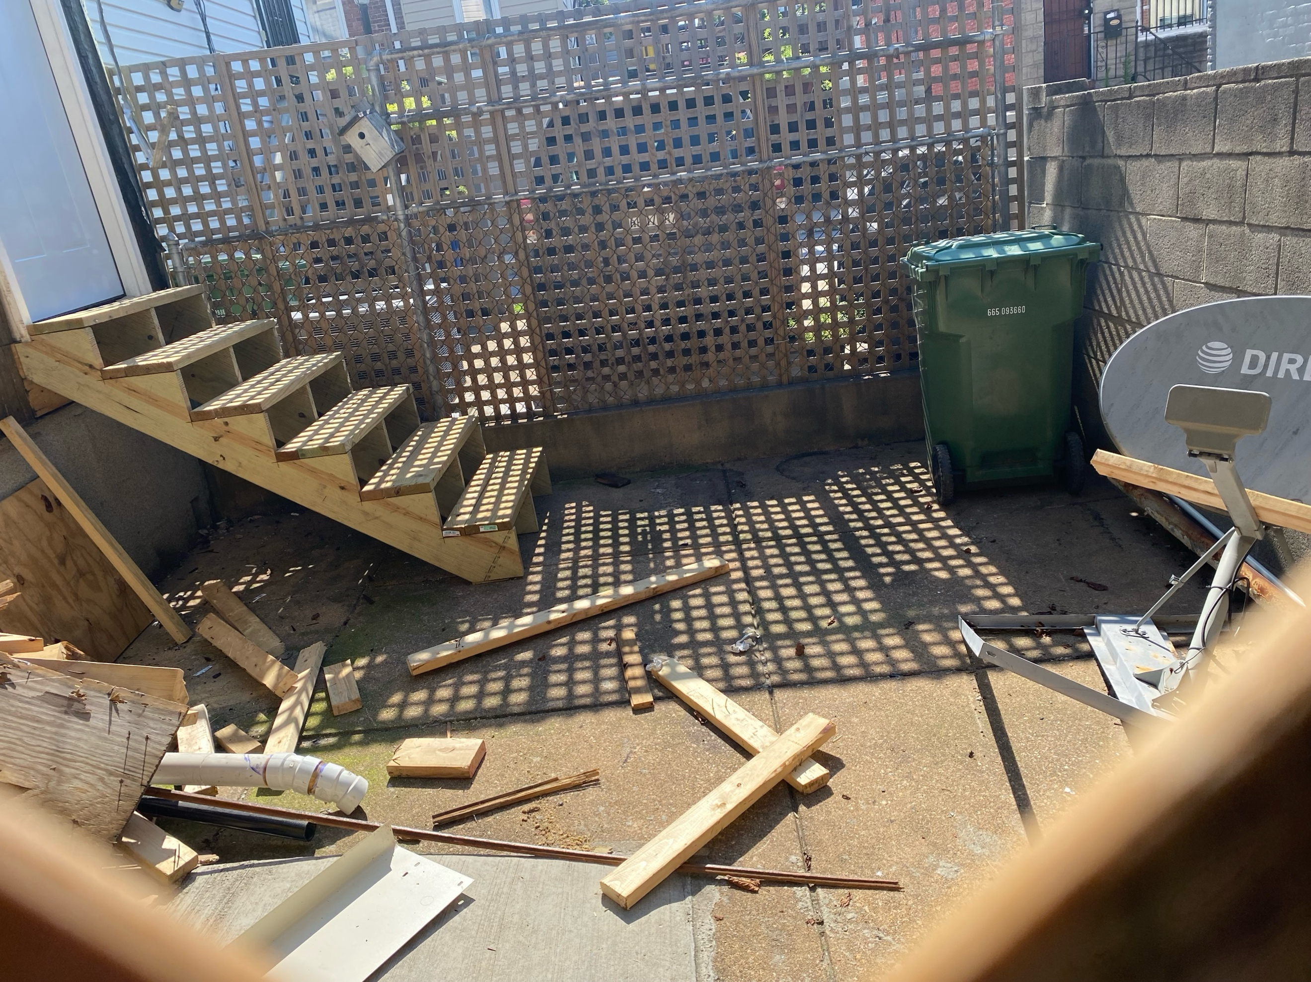

(NOTE: remainder of letter sent as additional attachments to remain under document limit

