Part 6 of 7 for letter with Attachments
July 5, 2025
Mr. Andre Campbell, Building Inspector Administrator
Baltimore City Code Enforcement, DHCD
417 E. Fayette Street
14th Floor
Baltimore, MD 21202

RE: Stop Work Order for 2524 E. Baltimore date 7/2/2025

Mr. Campbell:
(continuation of letter part 6)

Attachments: Materials carried to the roof’s edge and dropped off the roof with last picture showing pile of debris in the backyard after materials dropped out window and off roof on 7/6.
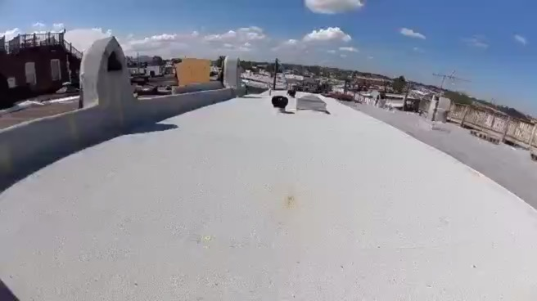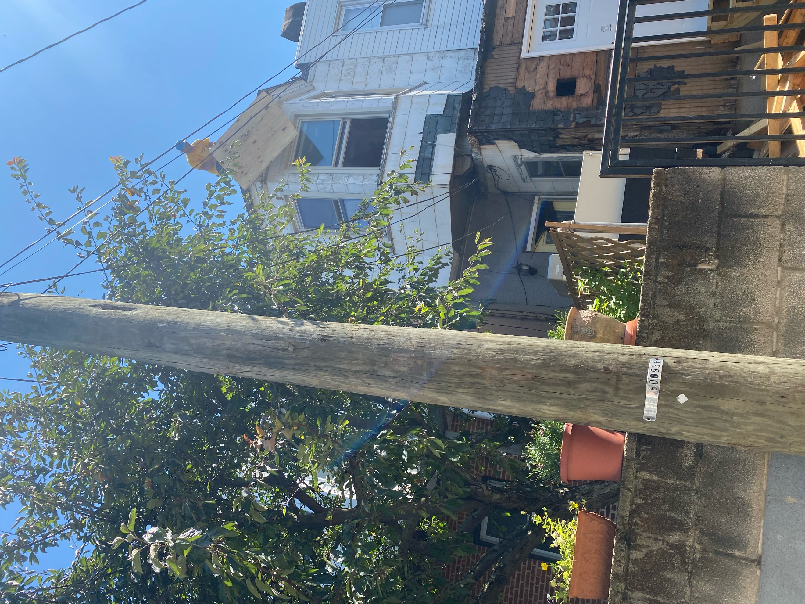

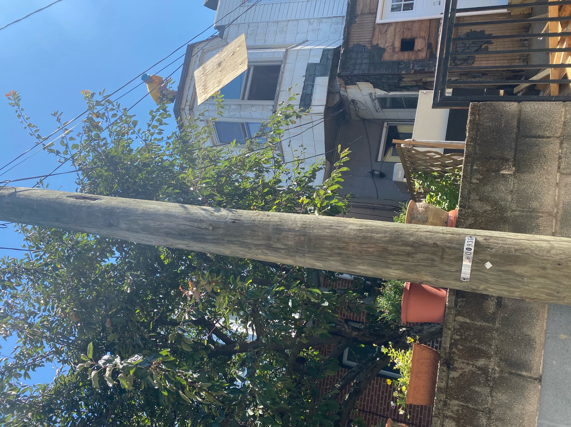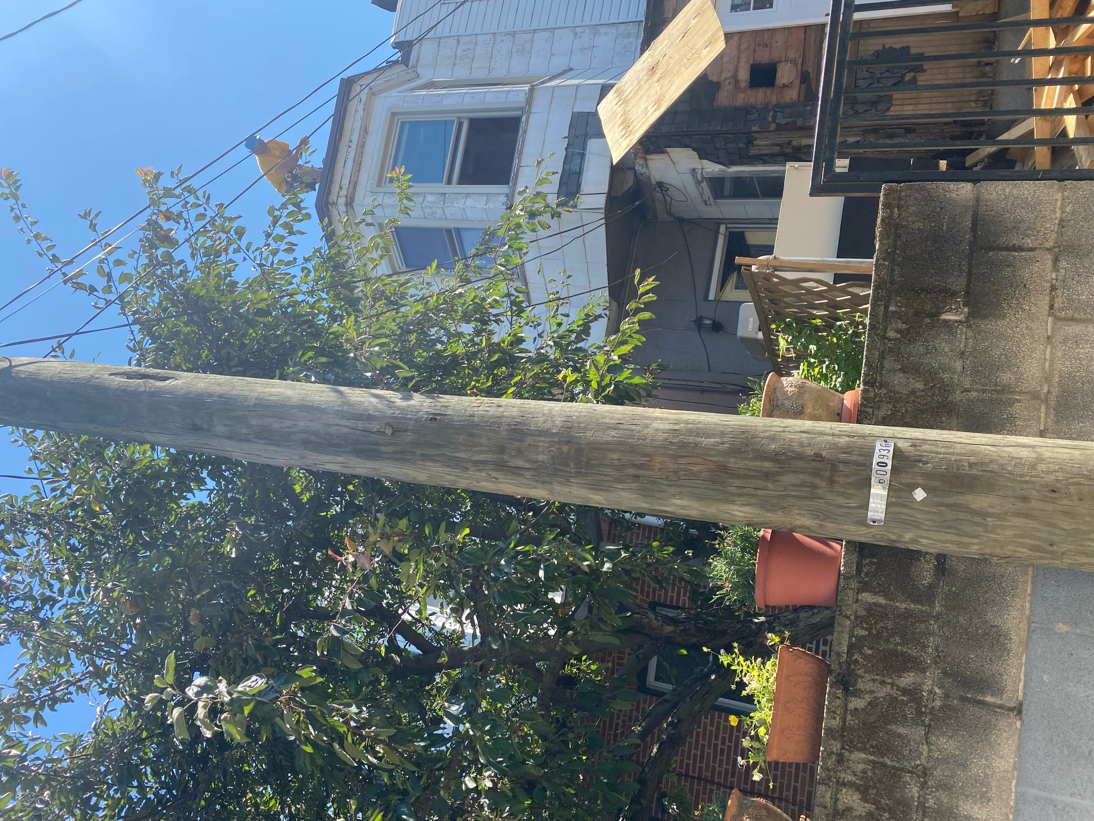

(NOTE: remainder of letter sent as additional attachments to remain under document limit)

