Part 7 of 7 for letter with Attachments
July 5, 2025
Mr. Andre Campbell, Building Inspector Administrator
Baltimore City Code Enforcement, DHCD
417 E. Fayette Street
14th Floor
Baltimore, MD 21202

RE: Stop Work Order for 2524 E. Baltimore date 7/2/2025

Mr. Campbell:
(continuation of letter part 7)

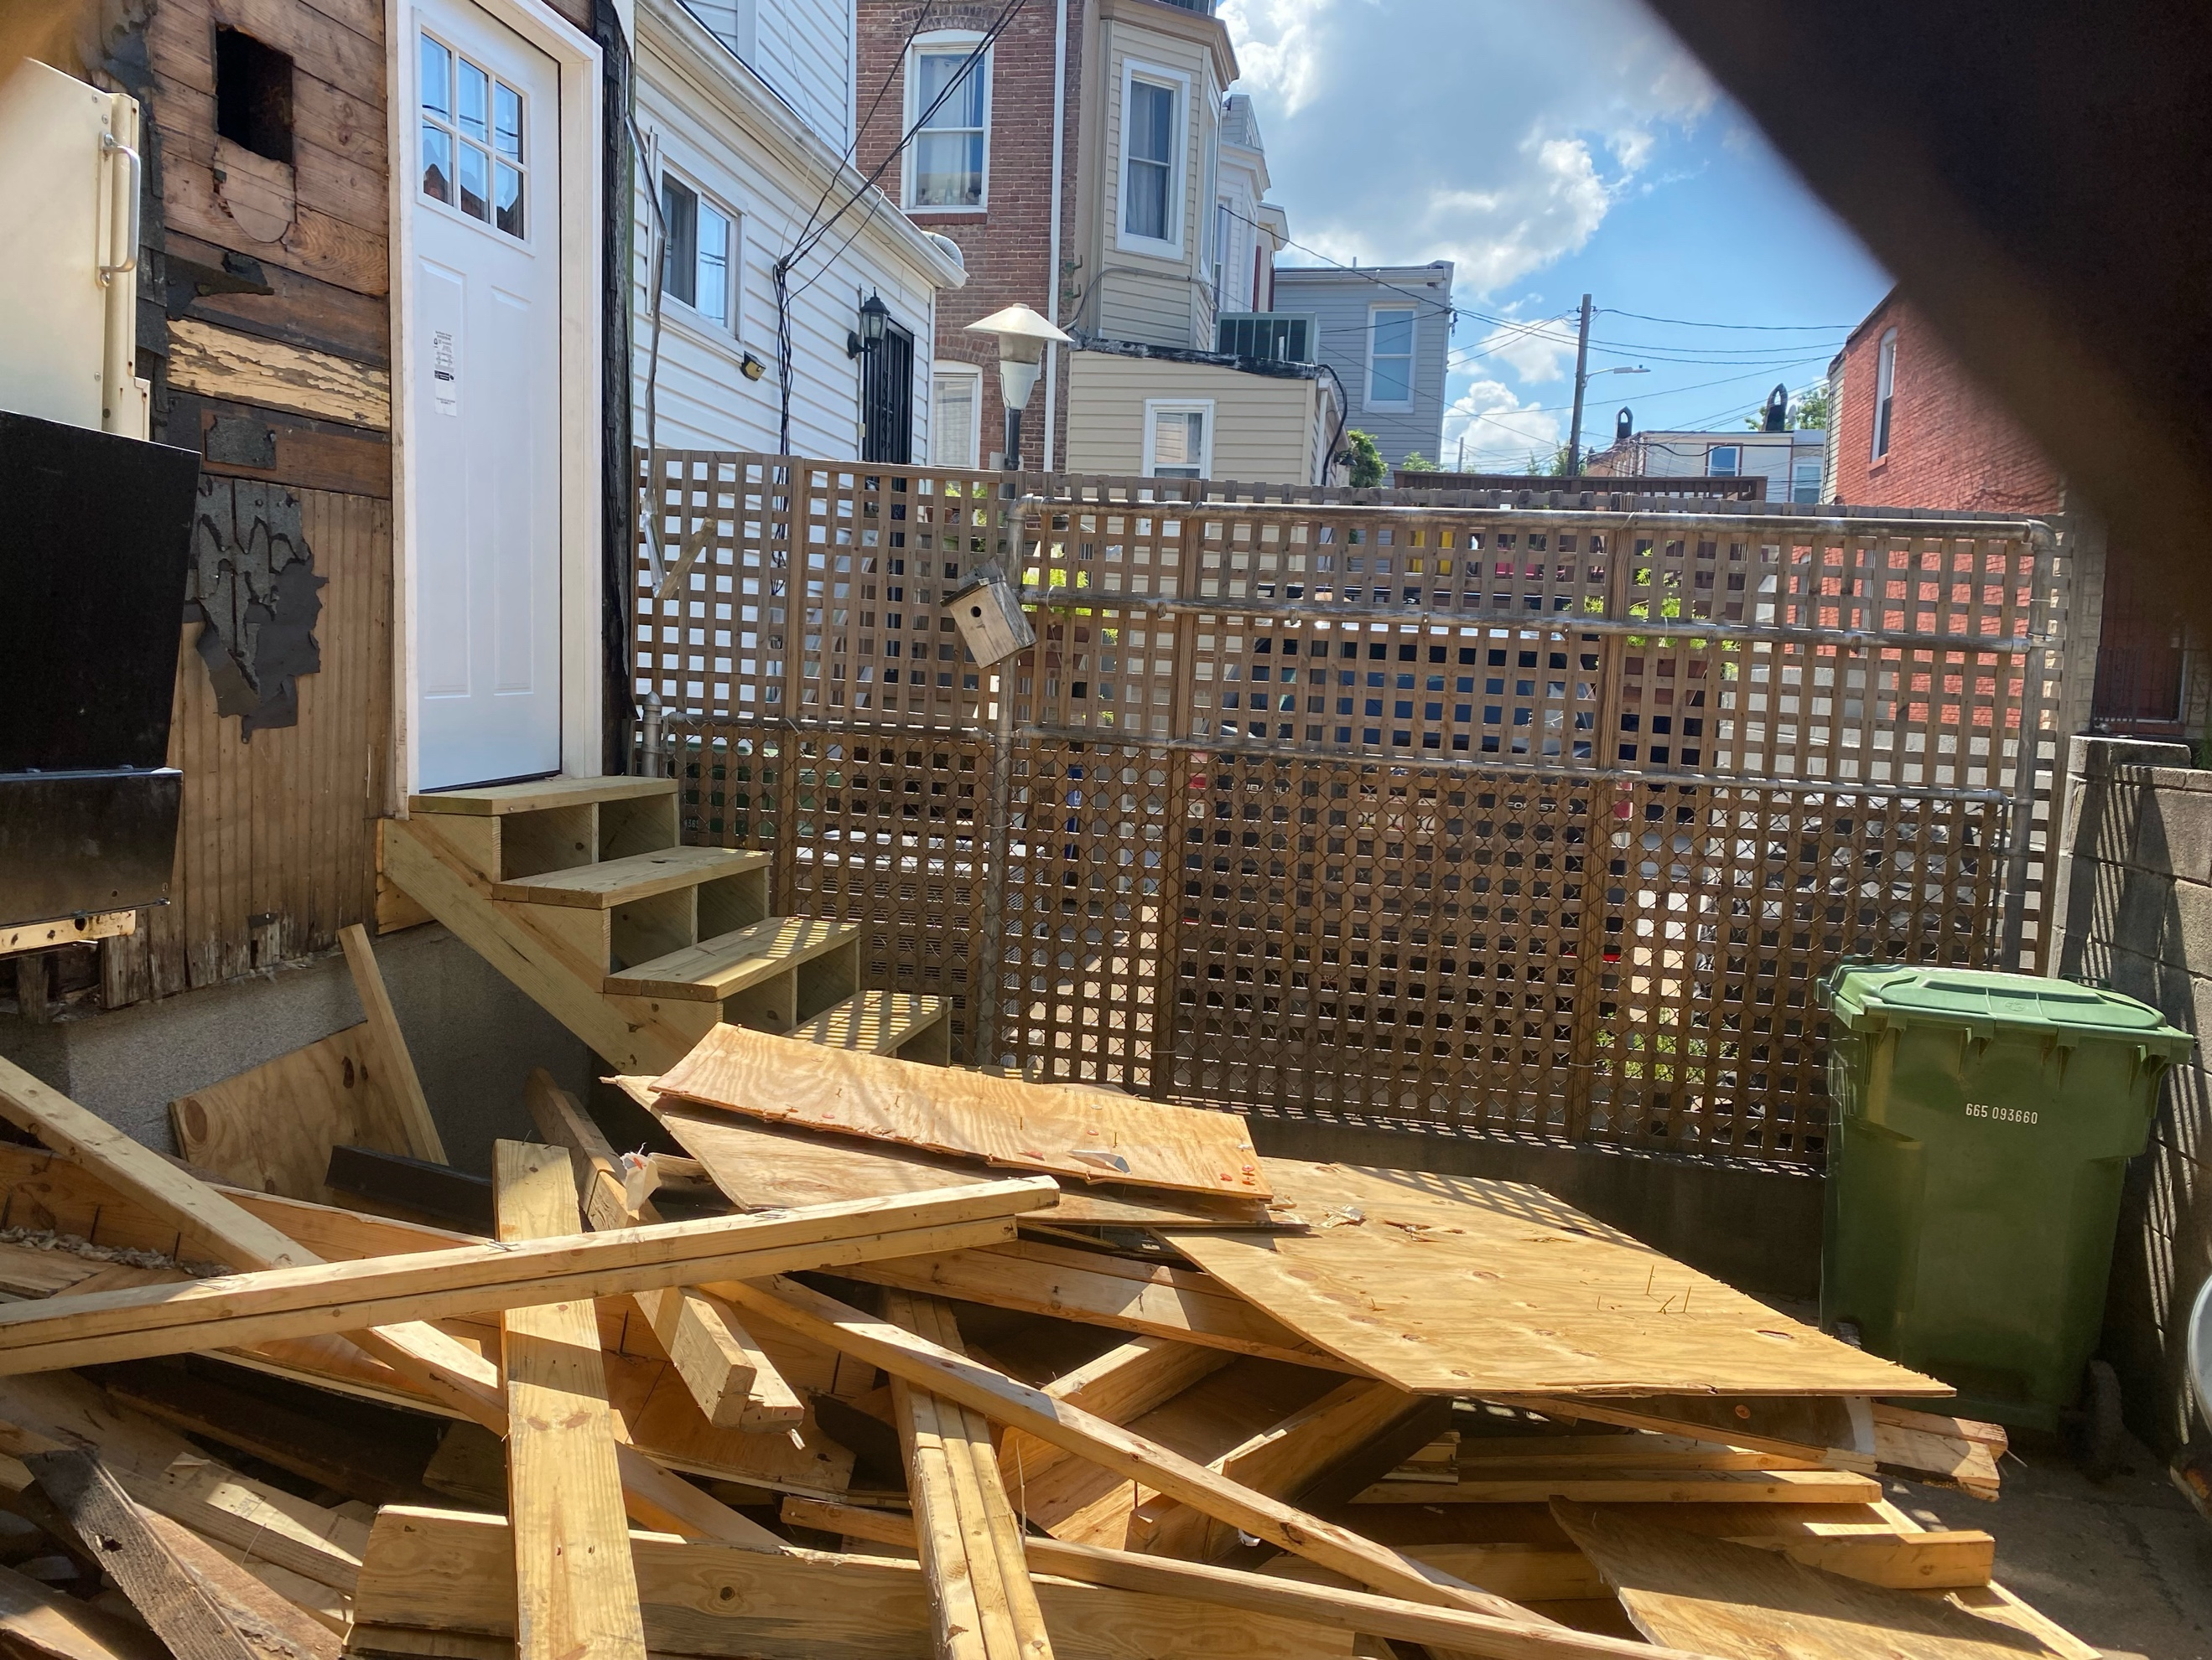

Attachment – Condition of the roof at about 5 pm 7/6
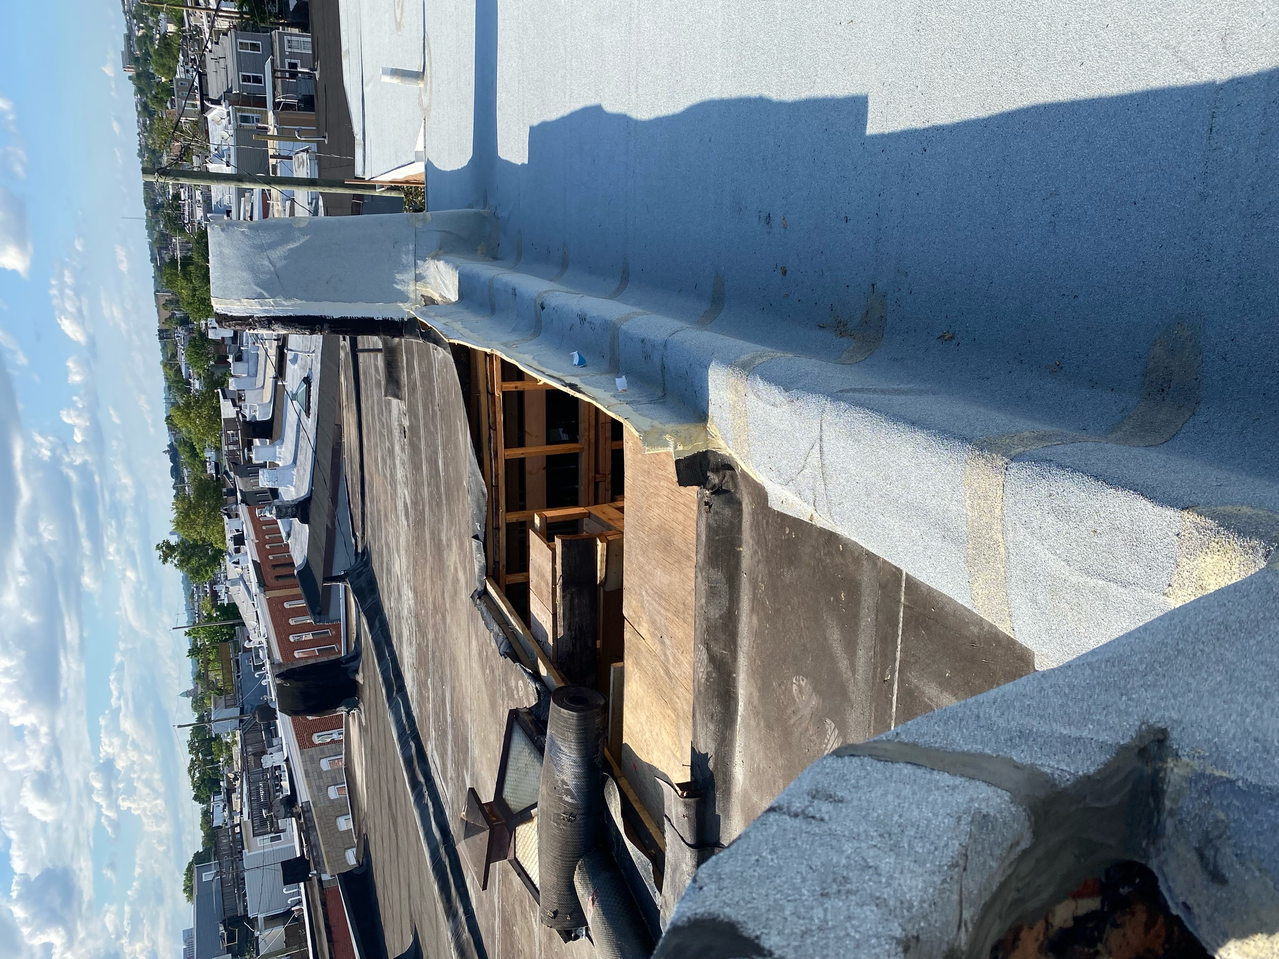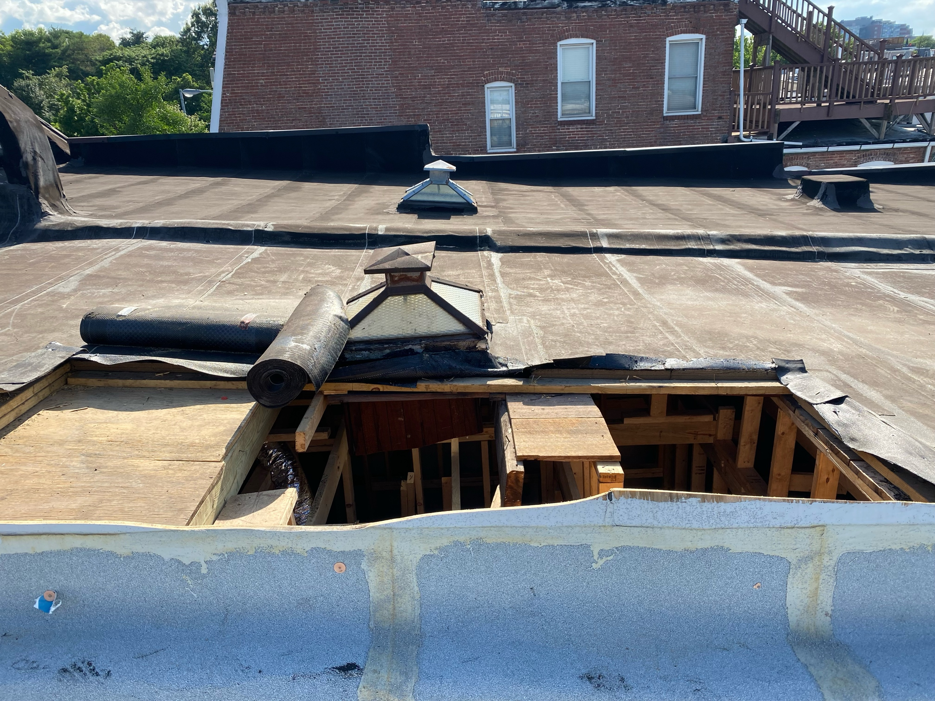

(End of letter with attachments)

