Exhibit 1
Anchor Construction removing concrete under steps and railing at 502 Somerset Rd, Baltimore, MD 21210 at 9:58am ET on Tuesday, July 8th 2025.
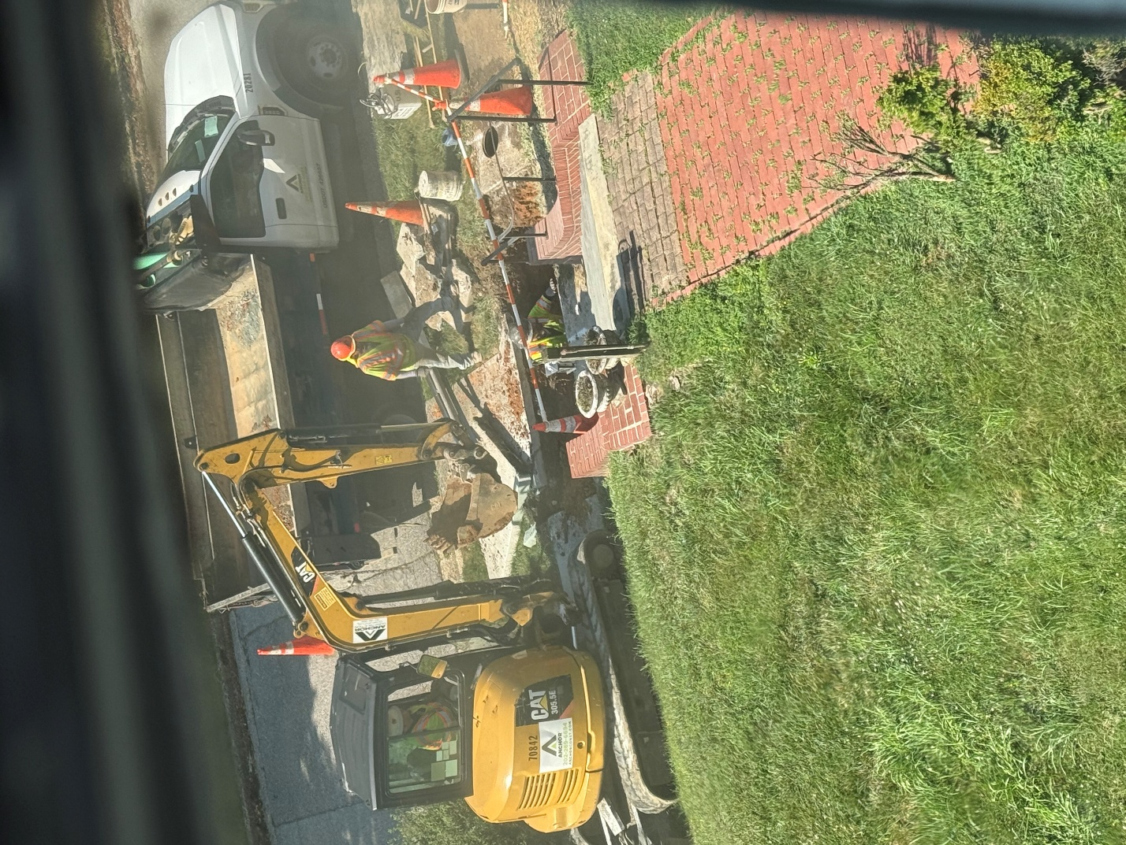

Exhibit 2
No parking sign posted the week of June 30th 2025 for 500 block of Somerset Rd. Sign indicates the construction contractor as Anchor Construction under contract SC #978.
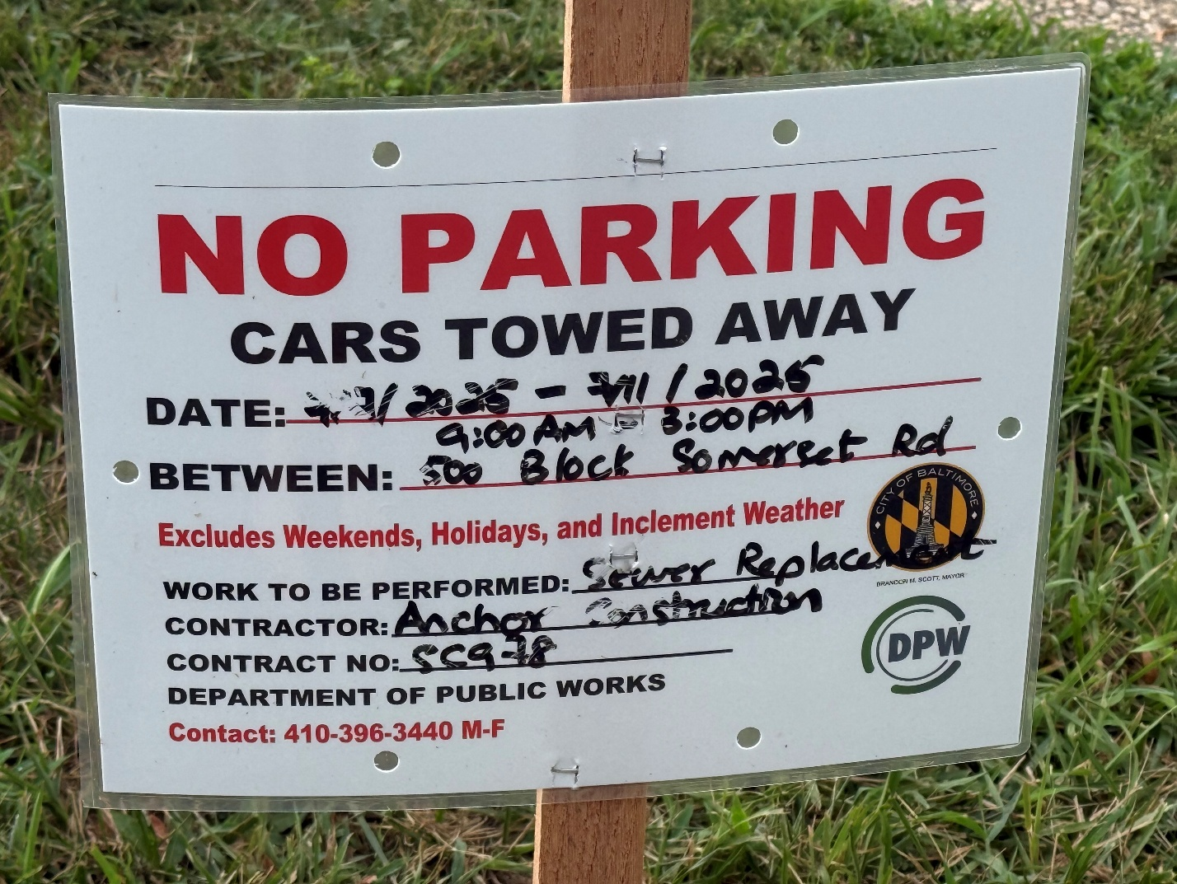

Exhibit 3
Three pictures taken at 4:38pm on July 13th 2025 at 502 Somerset Rd., Baltimore, MD 21210 showing iron railing leading up the front steps with broken feature duck taped in place where sewer replace construction occurred by Anchor Construction.
Picture #1
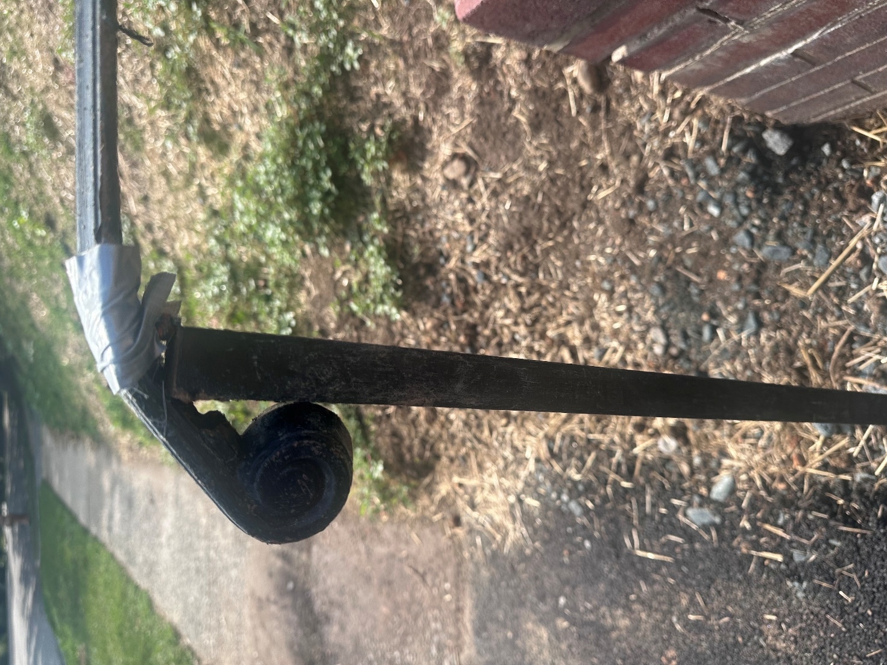

Exhibit 3 (Continued)
Picture #2
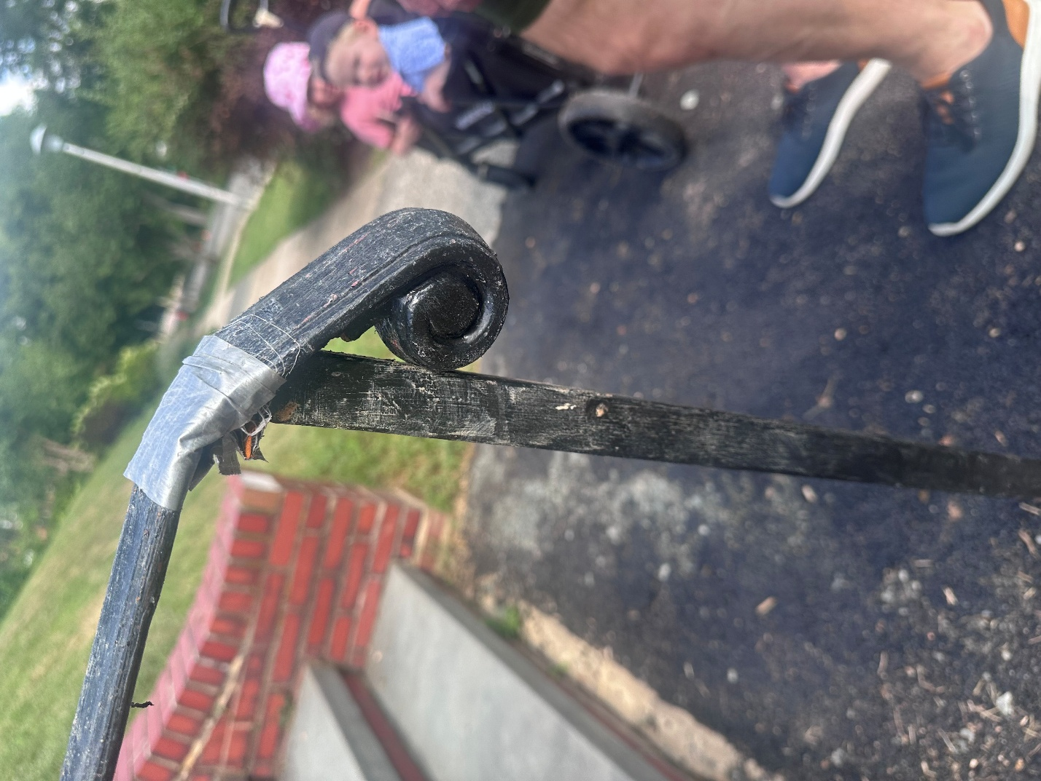

Exhibit 3 (Continued)
Picture #3
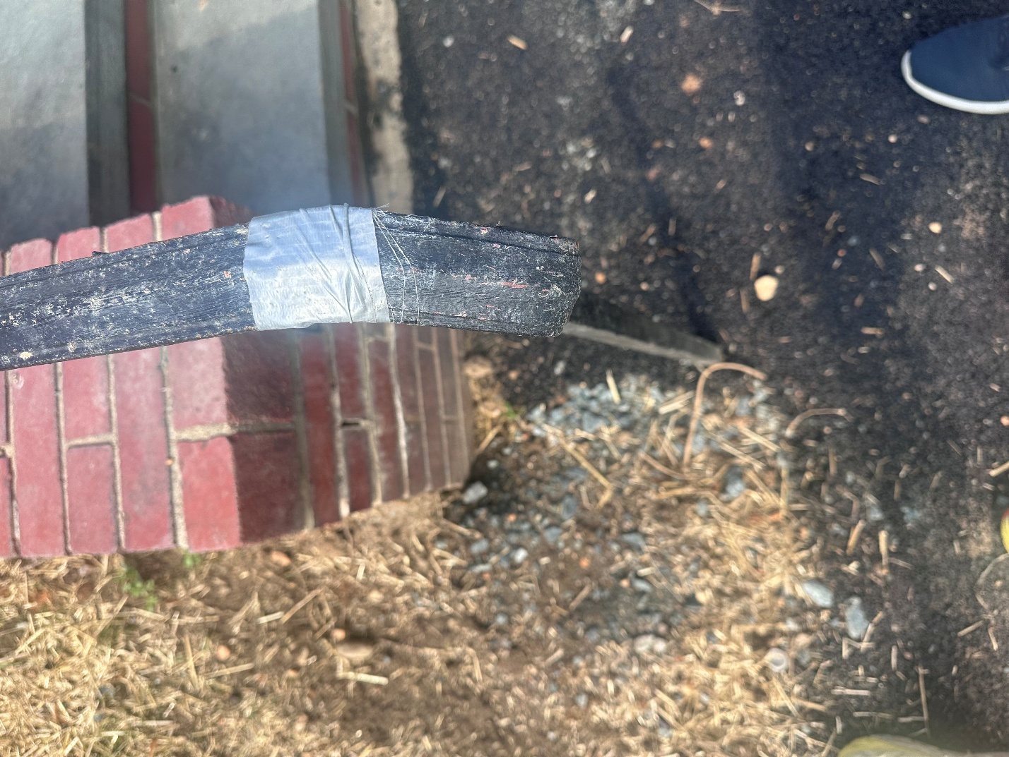

Exhibit 4
Project Facts for Contract SC #978 sponsored by the Department of Public Works for the sewer modifications in Roland Park
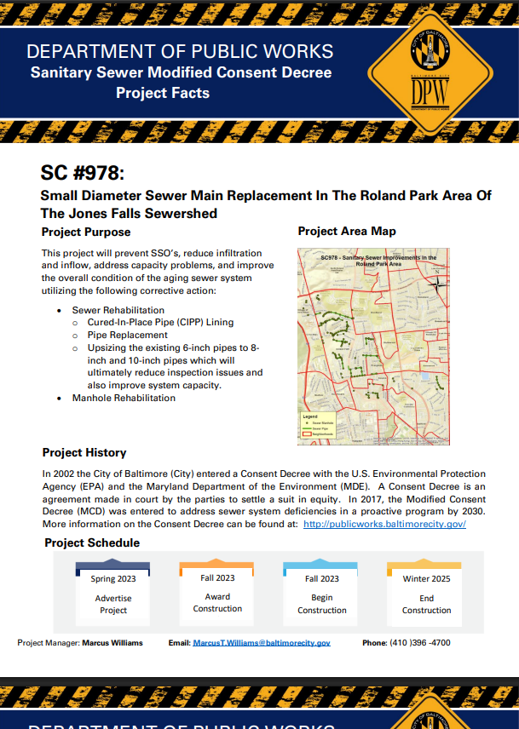
Exhibit 4 (Continued)
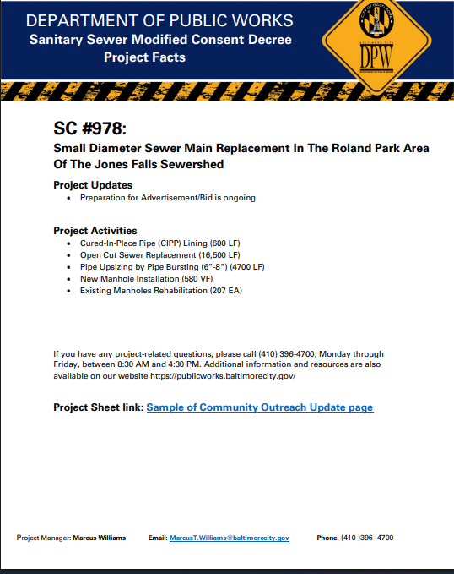
Tracy Blue – Construction Manager

