History of Tree Complaint
311 Request 22-00662437*
311 Request 22-00662444*
*One of these sent by Councilman Torrence Office; believe both were closed out with no action.
25-00220115 – See below; again I believe there was nothing done.

We have completed the City Street Tree Inspection you reported. Your service request number 25-00220115 is now closed.

- To see details click here to view your Service Request:
- Thank you for playing your part in making Baltimore cleaner, safer, and stronger!
- City of Baltimore staff would truly appreciate your constructive feedback by your completing a very brief survey regarding your 3-1-1 experience. Thank you for your continued commitment to the City and allowing us to serve you!

Placed a call to Forestry and spoke with Matthew Rescott. Mr. Rescott was very pleasant and agreed to make sure the tree was assessed. He also encouraged me to still put in a 311 request, which I did (25-00907274). As promised, he did follow up and had the tree trunk shaved. I communicated with him to thank him for following up and let him know there was still an issue with the tree.
Not all shared with Mr. Rescott but, the following are issues:
Photo #1 the tree is extremely large and is growing close to my house
Photo #2 large branches as such continue to fall; this photo is from the first calls where large branches were falling. See the very last page to see branches continue to fall after the last service call
Photos on page 3-6 Shows the many leaves that have to be cleaned up; this prevents me from putting down mulch because I have to replace it every year and the leaves have to be removed before I can do so. The leaves also spill outside of the yard which causes a slip hazard until I can pick up the leaves. Further, they also spill out in the street causing a hazard for cars. While my husband and I understand that it is my our responsibility to pick up the leaves, but because there is so many, we have to do it in shifts and it’s very taxing.

We have dealt with this tree for over 35 years and really would like consideration for it to be replaced with another type that is not so taxing.

#1
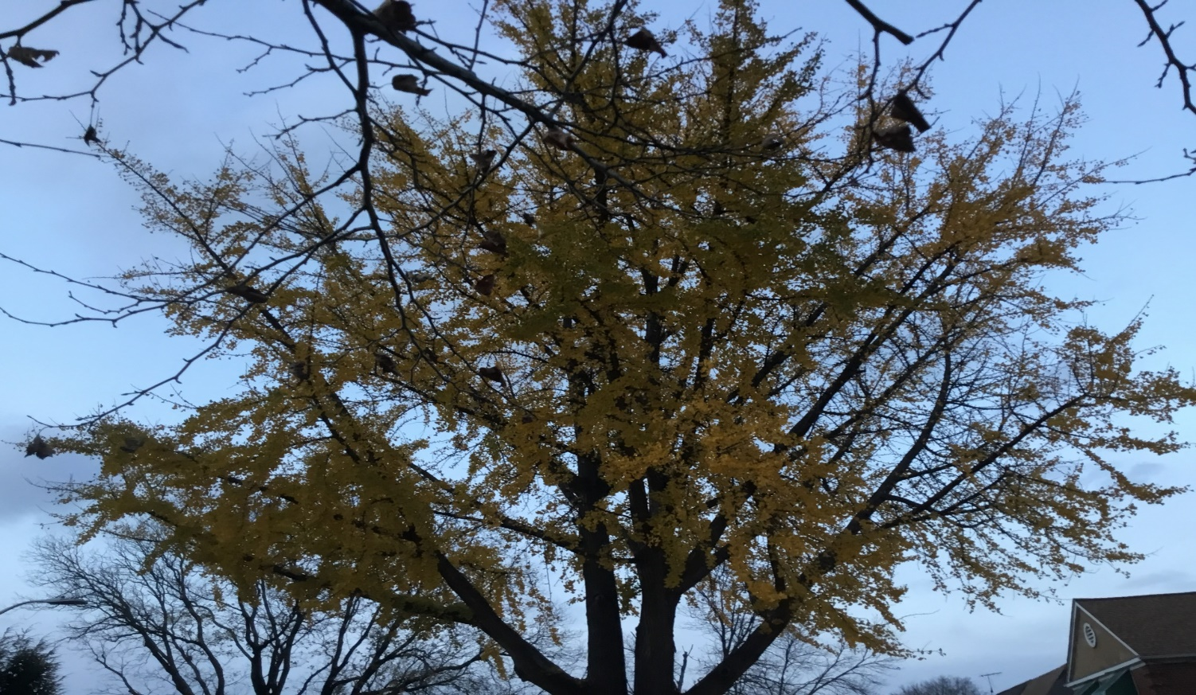
#2
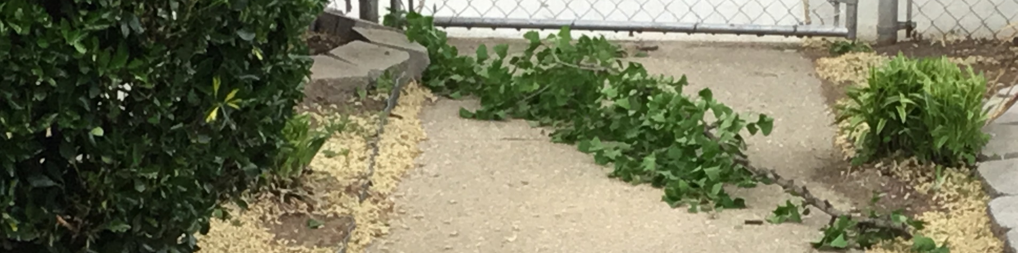

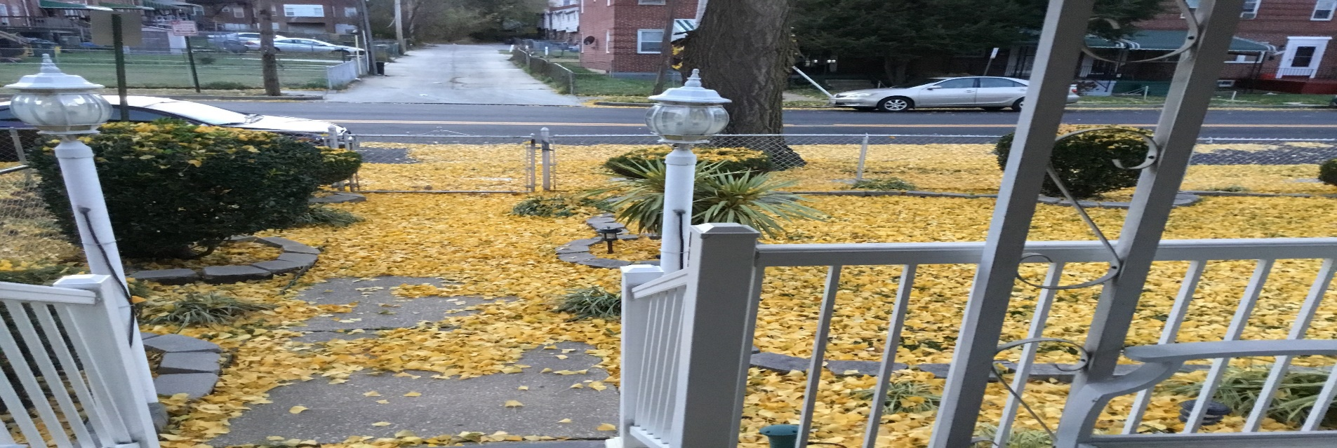
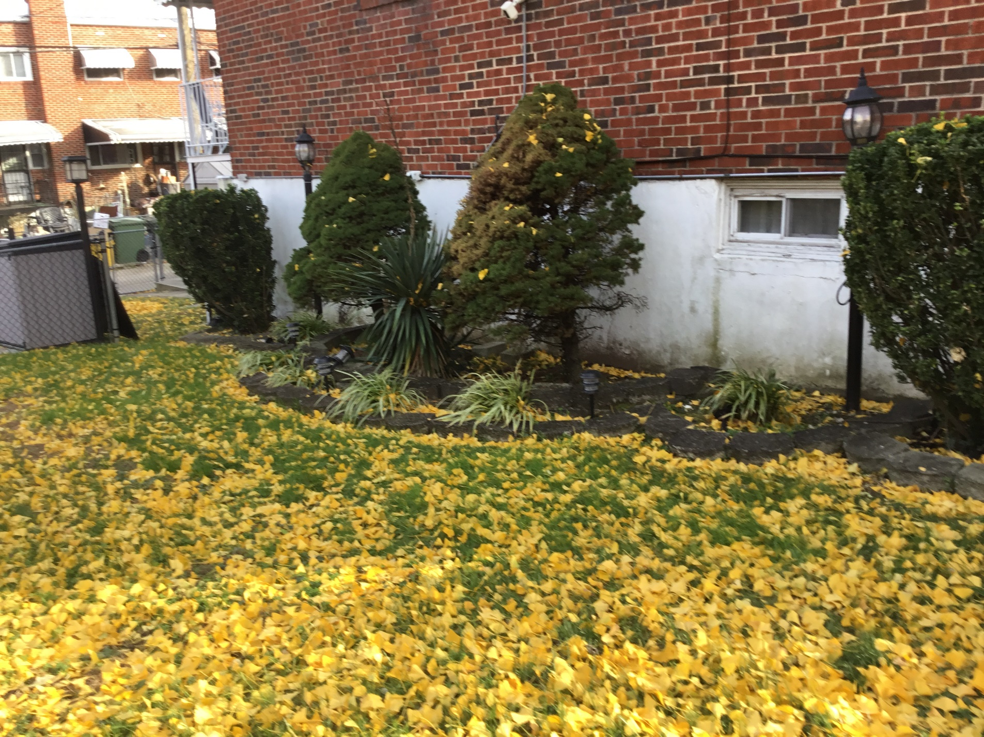
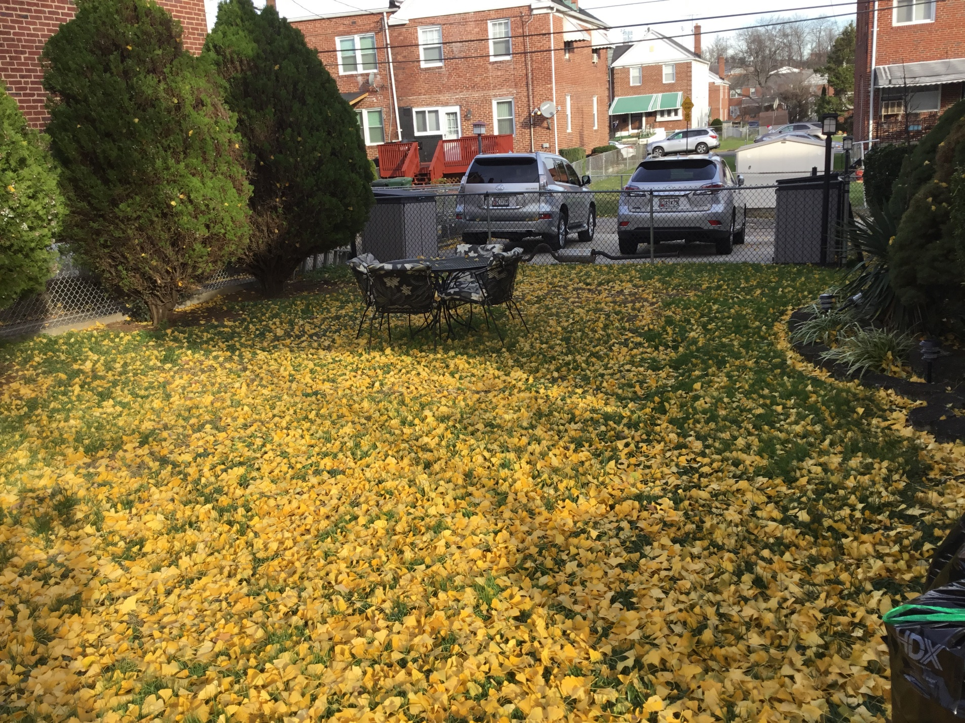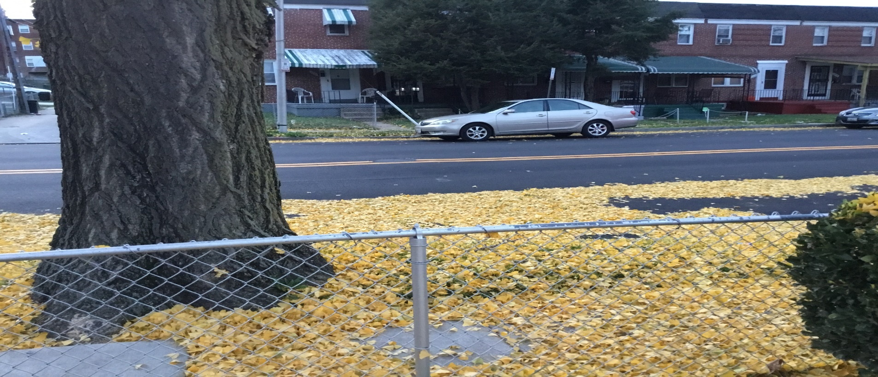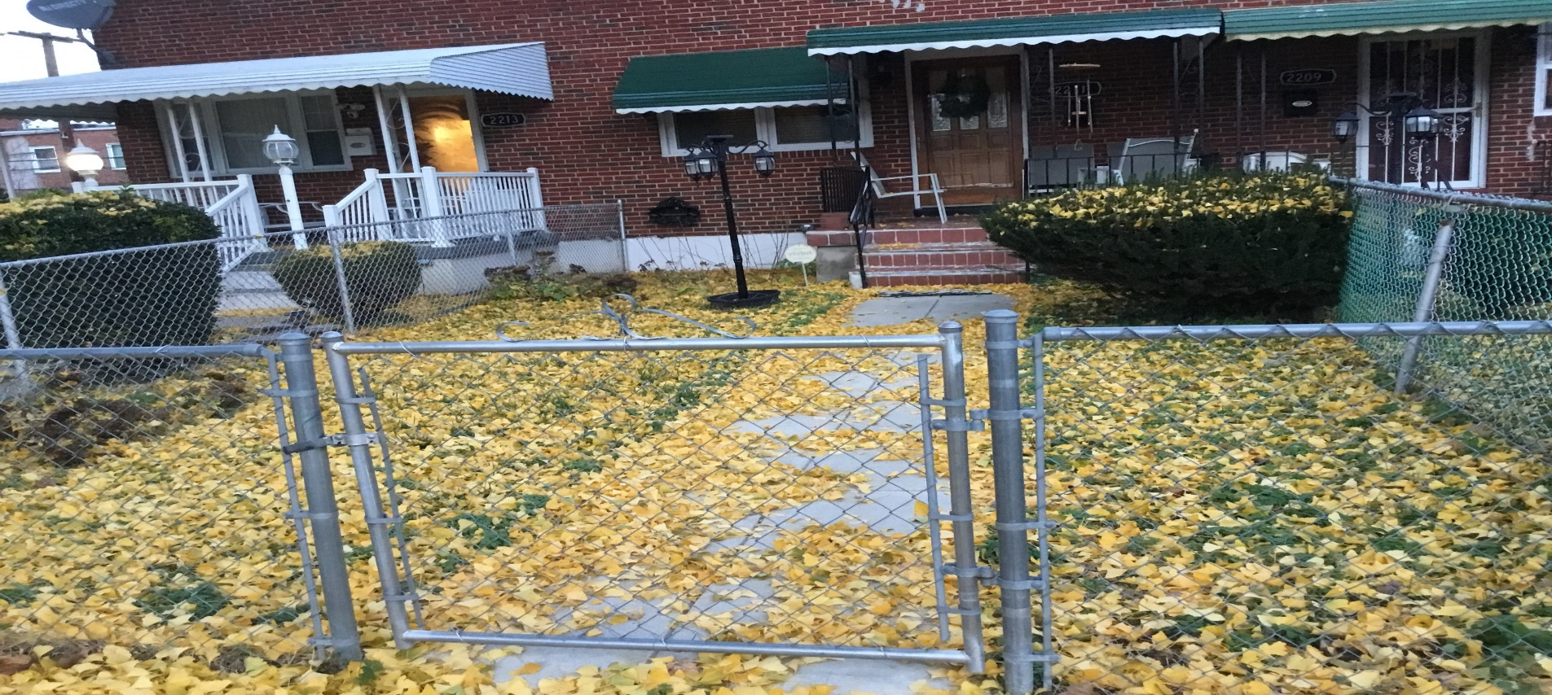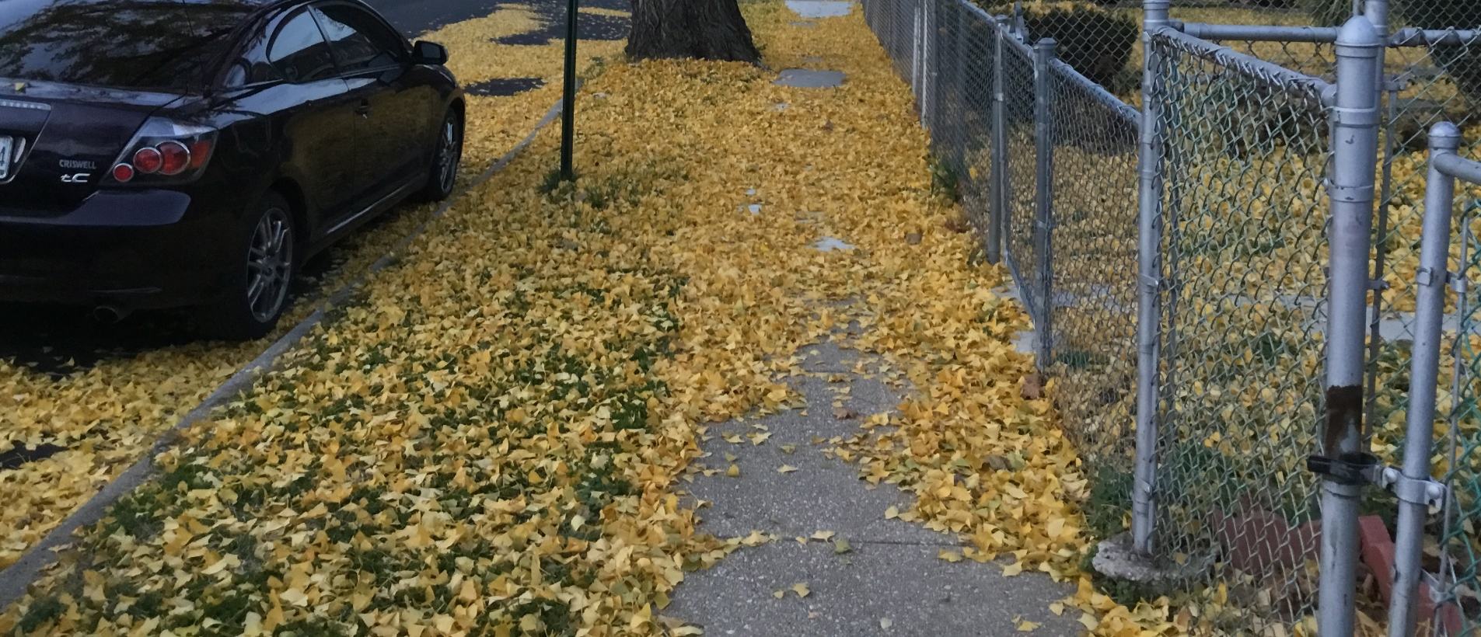
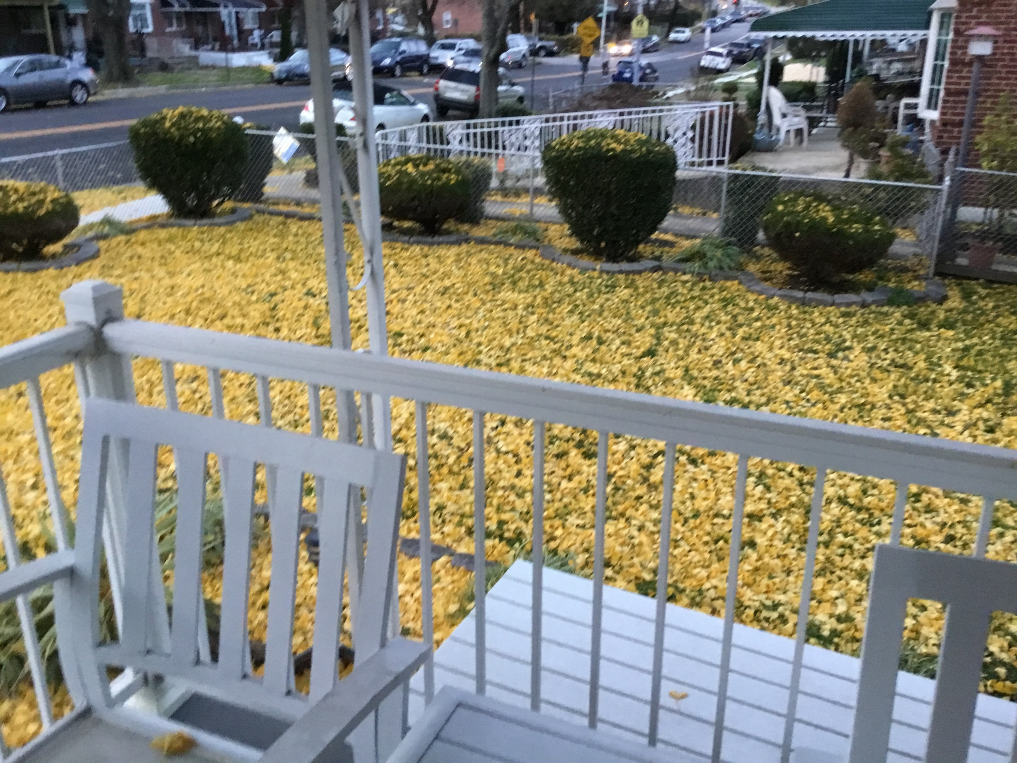

Post Trim in October
