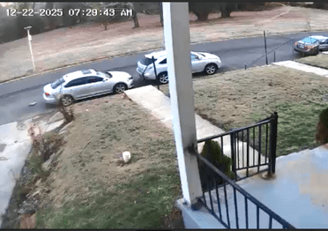
Handicap signs placed 12/21, 5614 driver leaves no space for me to park in front of my house. Afraid to park in the parking pad where she broke through the locked gate on 8/20 to attack me. Criminal case pending 2/2/2026
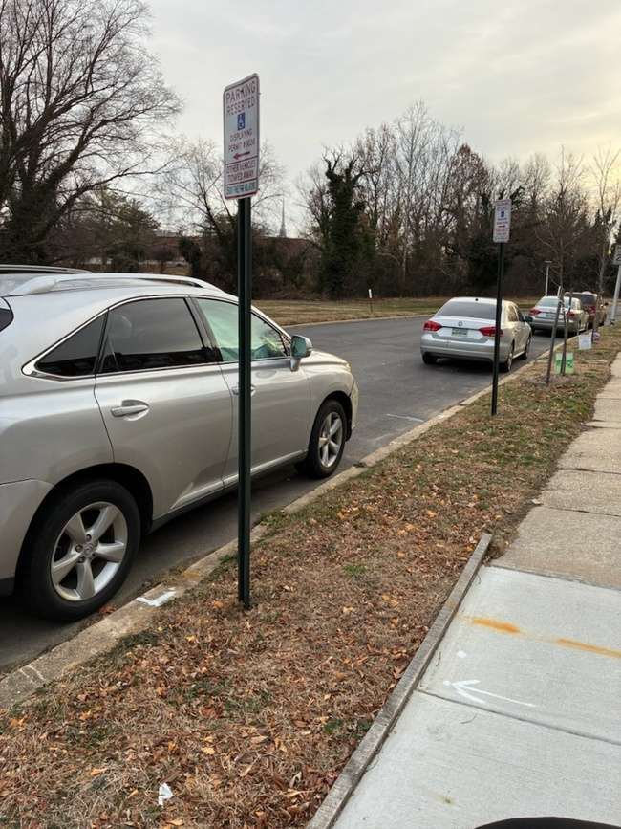SR 1071271 (12/22/2025)
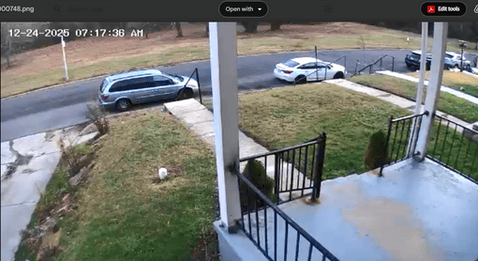
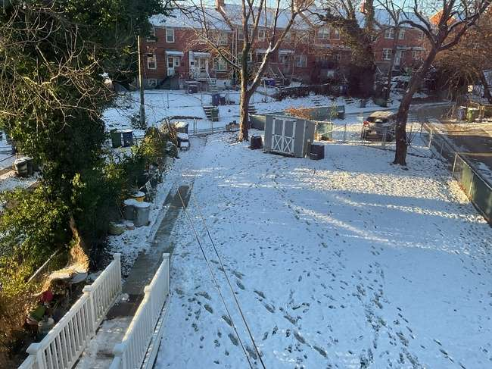
Where Ms. Clay burst through on 8/20, I no longer keep my gates unlocked. Not safe for me or my dogs.
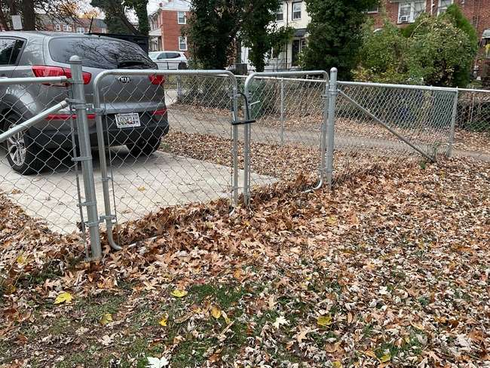
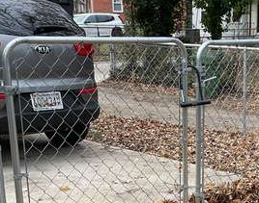

The lock I had to replace after the attack by Ms. Clay on 8/20
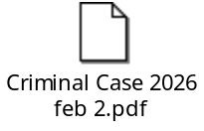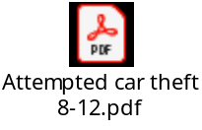
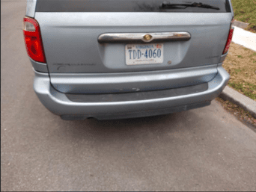In front of my house since 12/23
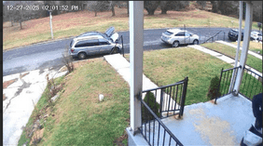
Has not moved since 12/23

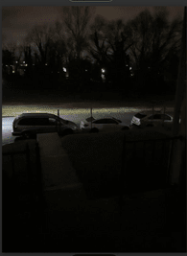

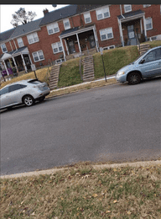Handicapped signs for 5614, I am unable to get them because I have a parking pad. I also have a dangerous neighbor who burst through my locked gate to attack me on 8/20
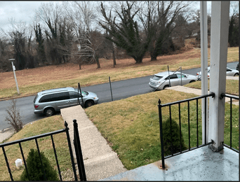12/29/2025

