Inventory of Missing and Damaged Property from Ms. Sayali’s Home
***Of note prior to reading receipts: My full name is Matthew Schuyler Clayton. I go by my middle name, “Schuyler”, hence why orders are under “Schuyler Clayton” as that is also how my name appears on my debit card. These items are in no order, but there is extensive proof that these are my items of which I was not allowed to retrieve and was not lawfully allowed to come to Ms. Sayali’s property to retrieve my belongings. If any of these items are not to be found, she has surely hidden or sold them. I am demanding return of my property within 14 days of this document being received by Ms. Sayali. I am sending several documents and some personal belongings of Ms. Sayali’s via UPS of which I will request a signature of receipt of the shipment. If she is unwilling to part with these items, I am demanding their cash equivalent paid to me through Zelle within 14 days of receiving this letter. The total cost of my missing property is $1,092.25, but if Ms. Sayali wishes to keep these items, I have adjusted the price of some items due to basic wear and tear, which is minimal. Mr. Clayton is willing to accept $948.58 sent via. Zelle and we can of course adjust if she only wants to keep certain items and return the others. It is our hope that Ms. Sayali will make this a smooth process, but we are fully prepared to litigate this in small claims courts if needed. For Ms. Sayali, there will be a line for your initials on each item and line at the bottom for your signature stating you understand what you have read and there will be a section for you to state how you would prefer to proceed. We understand that shipping these items could be costly, so we could arrange a pickup if necessary. Either way, it is our hope that this is a smooth and peaceful process for all parties. We understand that emotions may be high at this time, but we assure that each part of the process will be lawfully followed as stated in the Baltimore City Rental and Housing Laws. If Ms. Sayali wishes to keep some of these items that would be considered in “used” condition, Mr. Clayton is agreeable to sell to her for the marketplace used price.
Missing Property:
- 1 Visco soft 3-inch Memory Foam Mattress Topper Queen purchased on July 23rd, 2025, through Amazon for the price of $190.75. (This was last located on the bed Ms. Sayali, and I shared and was purchased specifically to help with my back that I have recently had 3 lumbar spine surgeries on. Most important item I need returned or reimbursed for ASAP). I will accept $100 for this if she wishes to keep it.
______________
initials
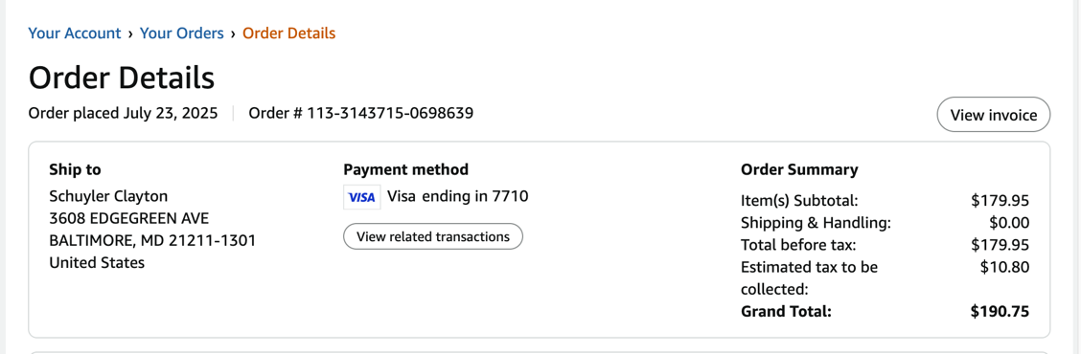

- 1 unopened Dresser for Bedroom manufactured by WLive and purchased through Amazon at the price of $63.59. Ms. Sayali confirmed through email that she had put this in the storage unit, which she did not. Last located in guest bedroom. This had just been delivered when I was illegally evicted, so I will need the full sale price if she wishes to keep.
_________
initials
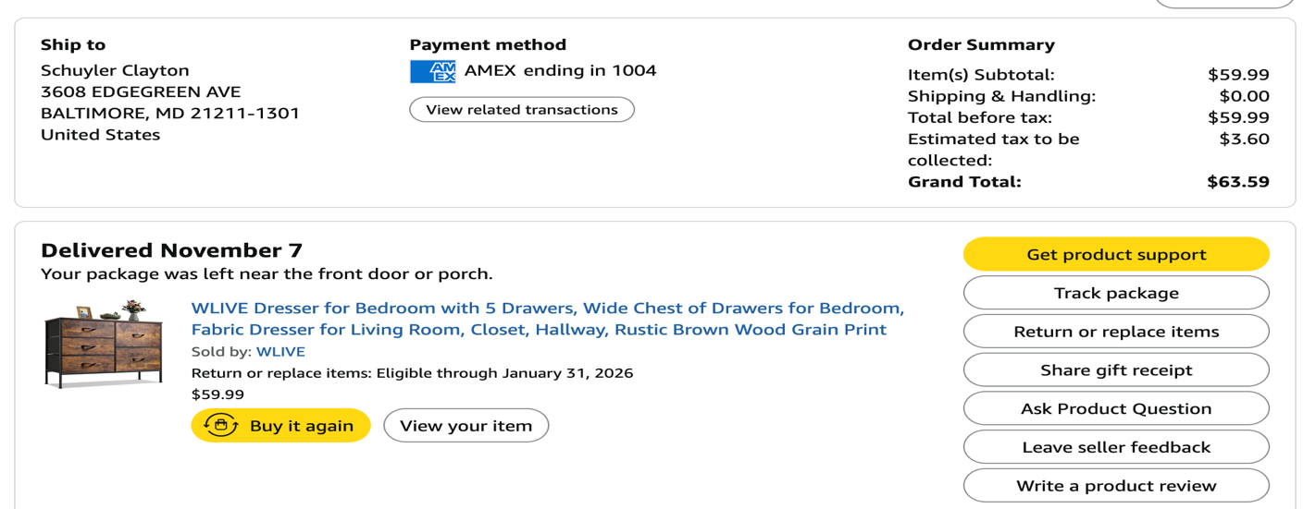

- 1 Veise RZ07 Smart Lock purchased through Amazon on September 12, 2025, for $84.79. I purchased this after we had an intruder. I was not reimbursed and is not customary for a tenant to reinforce doors for a landlord, but Ms. Sayali demanded her other tenant, Hayley Solak, and myself purchase these locks, so “she could sleep at night due to the automatic locking function and her distrust of her other roommate, Ms. Solak, forgetting to lock the door”. Two of the same locks were purchased, I purchased one prior to being illegally evicted. I am asking for either the purchase price or the return of the lock itself. I would accept a used price of $70 for this item. See below for sales receipt.
_______
initials
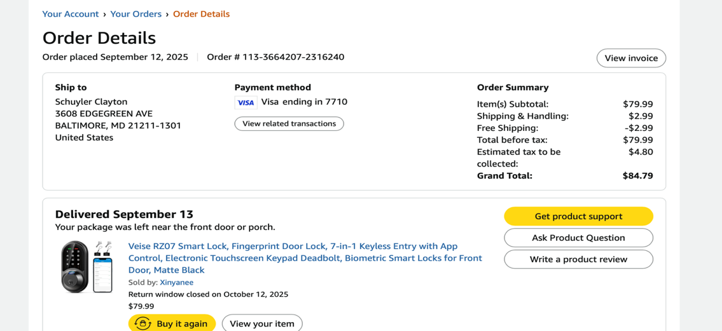

- 1 Ryobi One+ lithium ion 2.08H battery and charger kit purchase through Amazon on July 30, 2025, for the price of $46.63. (Last located in basement of Ms. Sayali’s house next to her 3 set Ryobi battery charger on a rack next to her back basement door). I will accept $35 if she wishes to keep it.
_________
initials
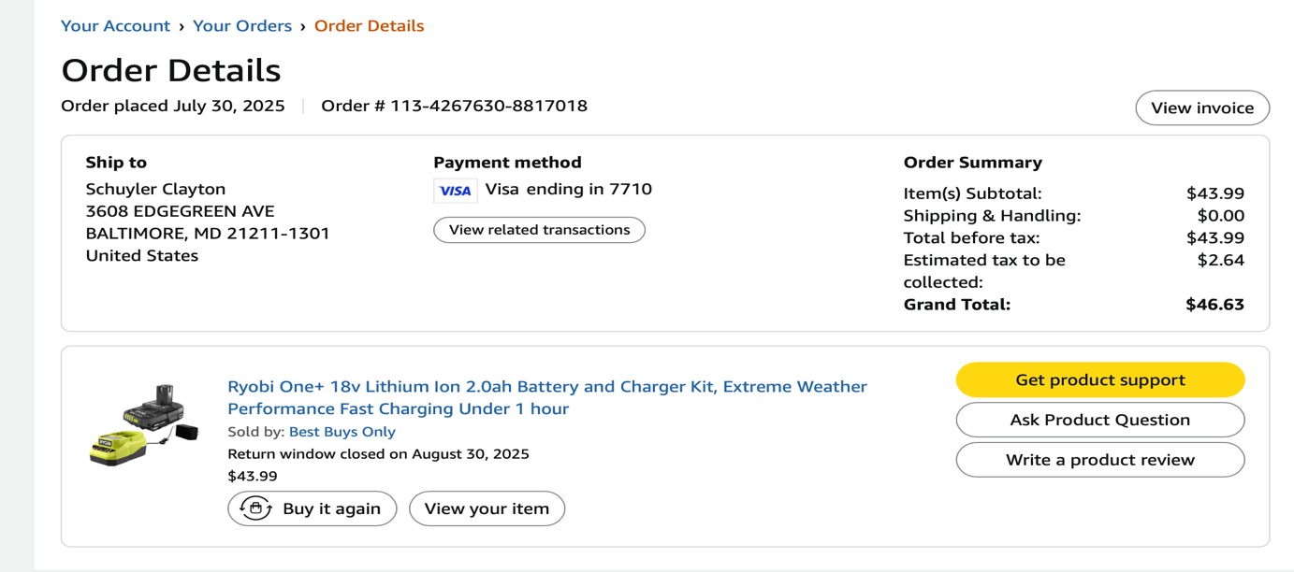

- Byrna CL Basic Launcher – Black less than lethal pistol that fires tear gas, pepper spray, or projectiles for target practice. Purchased on September 05, 2025, at 10:30pm. I purchased 2 of these less than lethal pistols after we had an intruder that was hiding from the police after a carjacking. The night the Byrna’s arrived, Ms. Sayali thought it would be funny to shoot one of these weapons that had been loaded with only CO2 cartridge at the time, although it had been fired earlier so could have had one still in the chamber. Thankfully, there were no projectiles, but did make a loud noise, loud as a real gun, and I felt the pressure of the CO2 as the gun was pointed directly at my forehead, which mortified me as she continued to laugh. I immediately took the weapon from her and instructed her that these were not toys and she was only to use them in case of an armed intruder breaking in the house and with my permission. Both weapons were legally purchased by me and she was only given permission to use this less than lethal weapon with my permission. The total cost of the weapon is $449.99 without tax. This weapon needs to be returned to me as I strongly believe she should not have possession of any firearm, even it is less-than-lethal. Regardless of this fact, it is my weapon that I purchased. Bryna launchers do not have to be registered. **This is an item I am not willing to let her keep. **
___________
initials
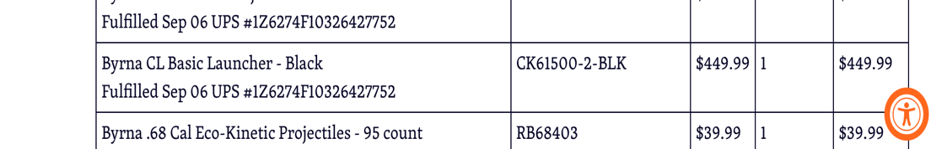
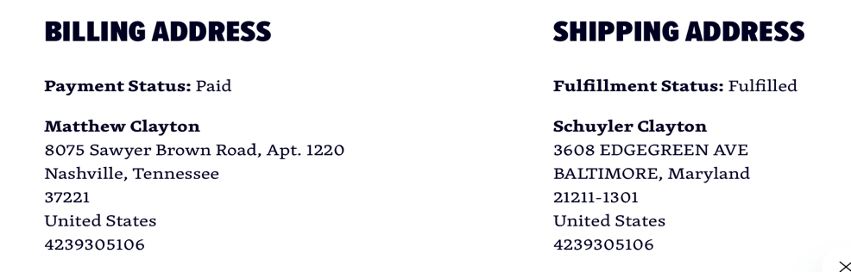

- OIAHOMY Laundry Hamper with Lid, 17.2-gal (65L) Wicker Hamper with removable liner. Purchased on July 25, 2025, for $60.41. If she wishes to keep, I will accept $50.
____________
initials
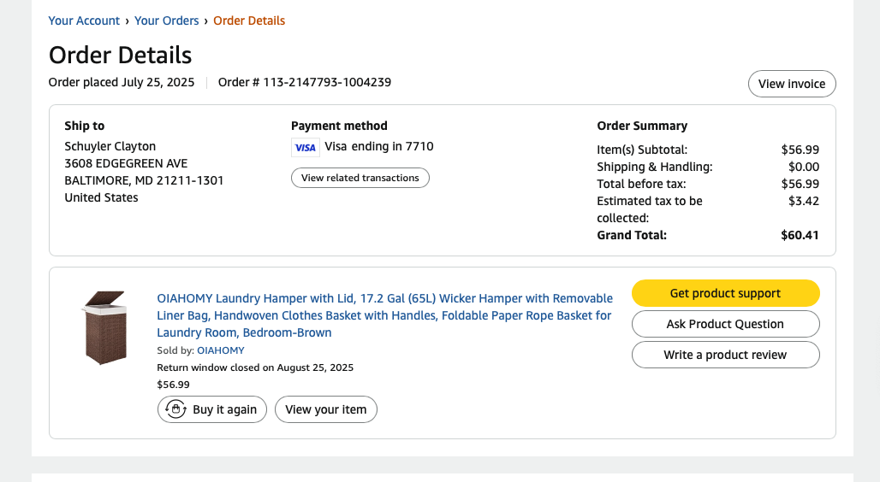

- Last I was allowed to check, I still had 10 unopened bottles of Scotts EZ Seed Patch and Repair Grass Seed. This should be easy to find. They are sitting on the rack next to the hot tub. They were purchased on September 19, 2025, for $180.10. They should have remained unopened, but if Ms. Sayali decided to lay the seed out herself, I will need to collect the total costs of these. This is but a very small portion of the total of grass seed I purchased and laid in her back yard. According to Amazon, I have purchased over 40 bottles of grass seed which totals $720.40, so this is a more than reasonable bargain.
____________
initials
