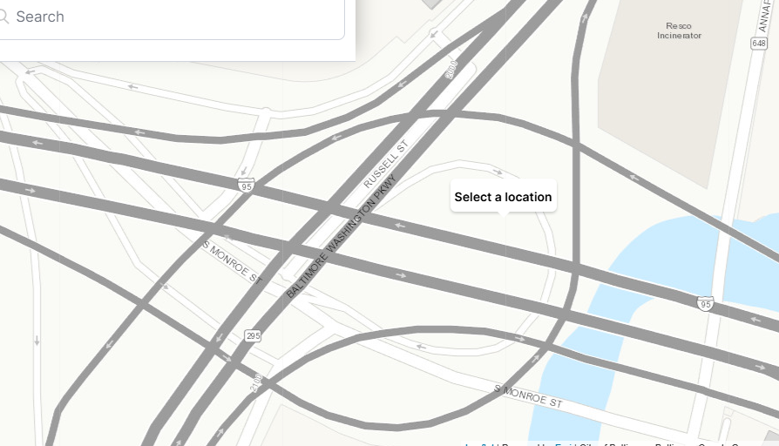
Potholes the entire ramp from I-95 to 295. Same potholes that were filled a month ago, two months ago and six months ago. Most potholes just after the rumble strips

