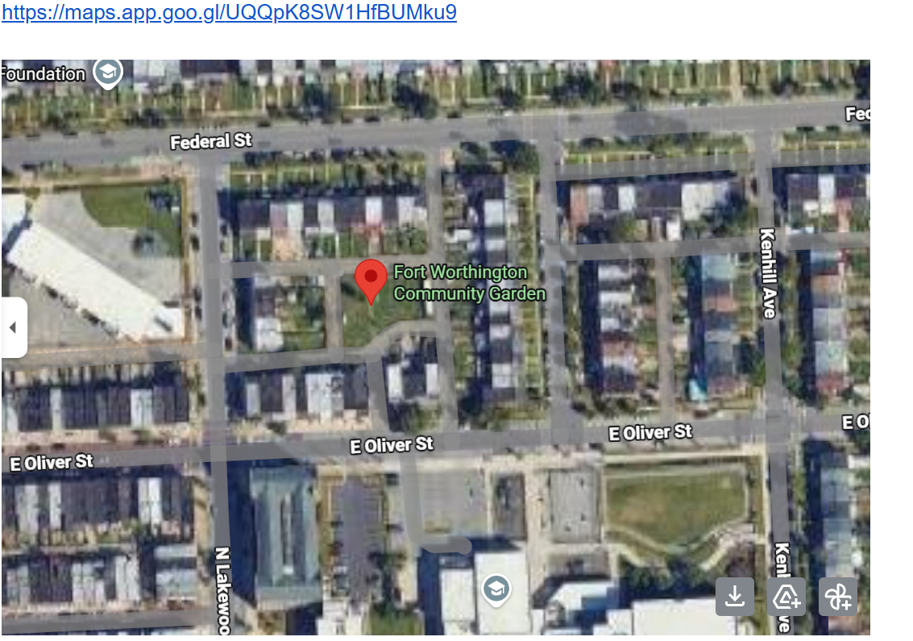
Between E Federal Street and E Oliver Streets AND N Kenhill and N Lakewood alley surrounding Ft Worthington Garden

