#1 View from my back door, towering over the fence and almost to the back of his property
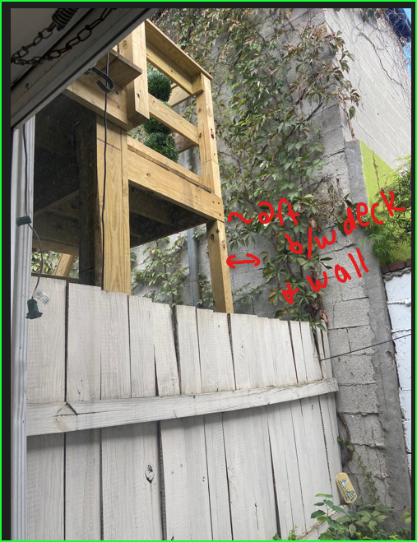

#2 Another view from my back door. Shows stairs squirrels climb up to get directly onto my roof
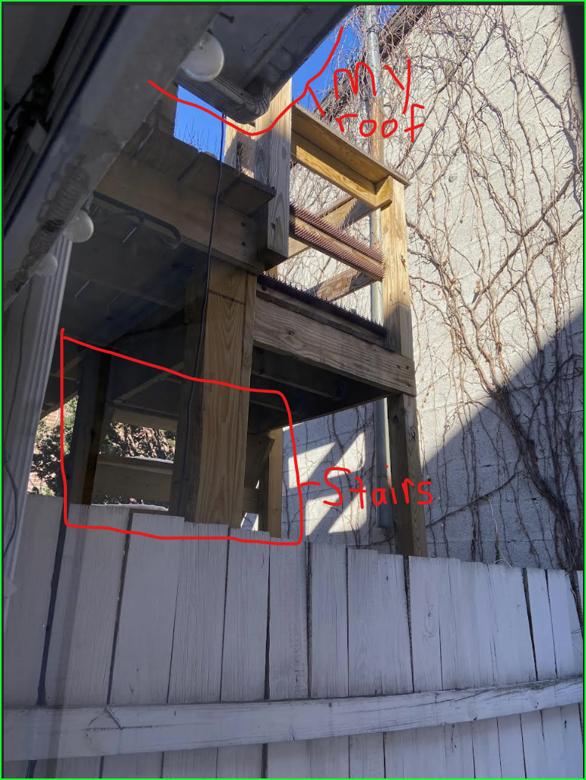
#3 View from his OTHER next door neighbor’s yard at 805 S Bond, towering over her fence and right up against her property as well. Her view was clear prior to construction. Note the railing veers to the left and is not straight, and the clearings along the perimeter are not even close to the code of 4”.

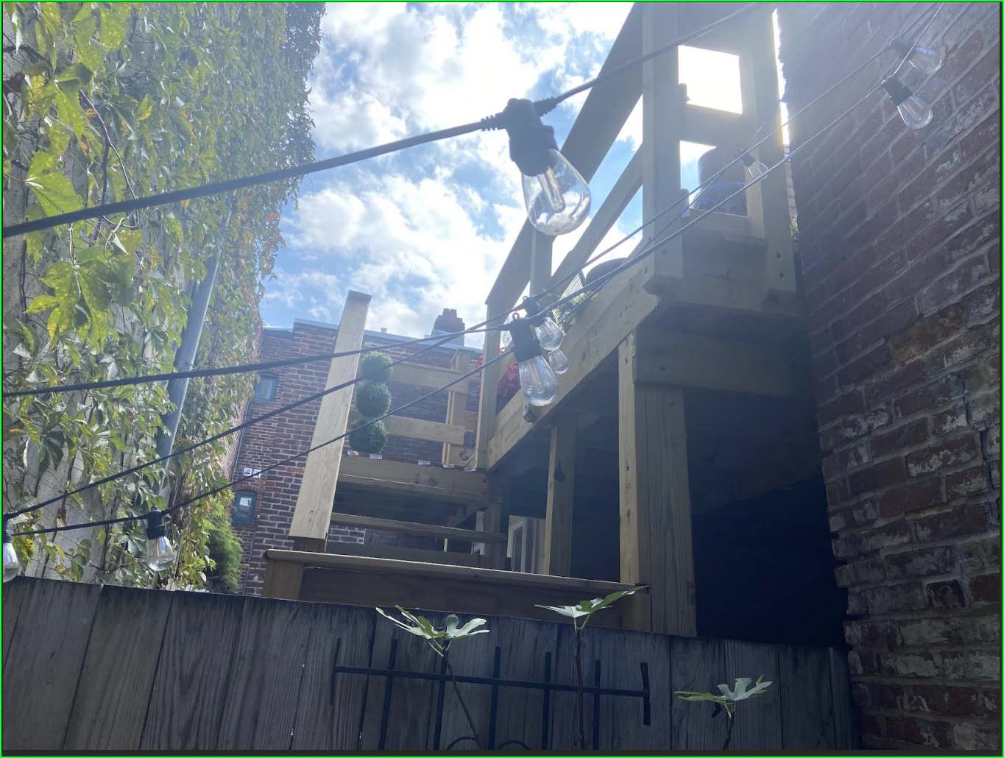

#4 View from my bedroom window looking down. The prior balcony was not in sight from this view. Gives an idea of scale and obvious code violations, plus how greatly this differs in aesthetic from many of the beautiful roof top decks we have in Fells. Note one of many squirrels that now use his deck to get on my roof and cause a nuisance, which never occurred once prior to construction. You can see how much higher the railing on his deck is than the low end of my roof, making it easy for them.
