Maintenance Request

DATE, CLIENT, & SITE

Date Entered: | 4/1/2026
Client: | Baltimore City, DGS
Site: | 30 South Gilmor Street

OFFICER INFORMATION

Employee’s Name: | Ofc. Drayton

MAINTENANCE REQUEST

Maintenance Type: | Illegal Dumping
If Other, What Type:
Details: | On April 1, 2026, approximately 2:00 am Sgt. Cooper reported to the Command Center Trash was Dumped at 30 South Gilmor Street. Sgt. Cooper also sent photos to the command center via cell phone.

NOTIFICATION

Who has been notified? | Command Center
Was Management Emailed? | Yes

PHOTOS

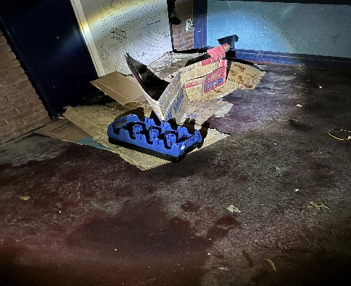

Date: 4/1/2026 | Entered By: Ofc. Drayton | Related Section:

