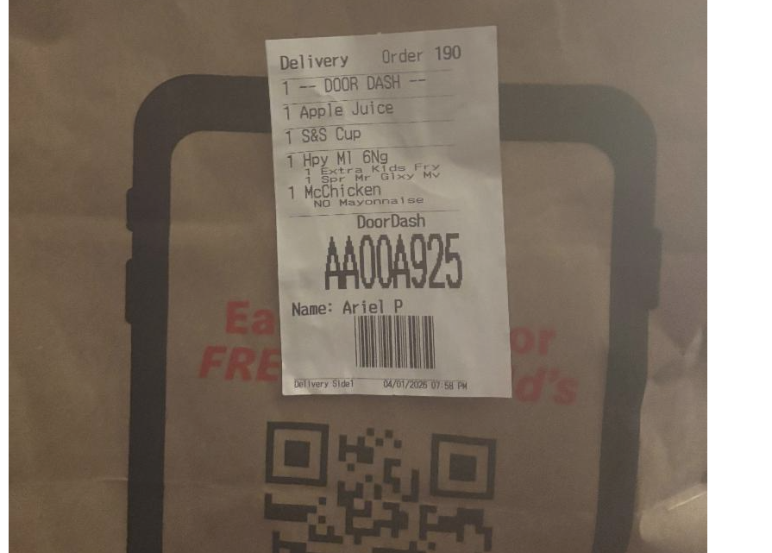

My neighbor’s daughter put her McDonald’s trash in my recycle bin.
I have video, as well. This family has been harassing me for years.
654 Dumbarton Avenue, 21218
This needs to stop! Please send formal letter to this household.

