Licensee
- Rosheda Fortune – HOME OWNER, Contractor, licensed Agent
Wealth Estate LLC
Real Estate License No.: 5012621
Contractor/Salesman License No.: 139724
Instagram: https://www.instagram.com/ro_fortuneflips/

- Delaney Cannon – Selling Agent
Keller Williams Realty Centre
Real Estate License No.: 5014043

Summary
This exhibit documents how the property at 3801 W Overlea Ave was advertised as “fully renovated” and “move-in ready,” and shows the renovation work that was performed between the seller’s 2024 purchase and the 2026 listing.
No permits for the work that has been advertised are in the Baltimore City database since the home was purchased on 11/13/2024 (see Exhibit 3 – Permits found).
Advertising Claims Made by the Licensees
Re: 3801 W Overlea Ave, Baltimore, MD 21206
- “Fully renovated” (Zillow, Redfin, Homes.com)
- “Move-in ready”
- Instagram posts by the seller showing renovation work, including added bathroom and finished basement https://www.instagram.com/ro_fortuneflips/

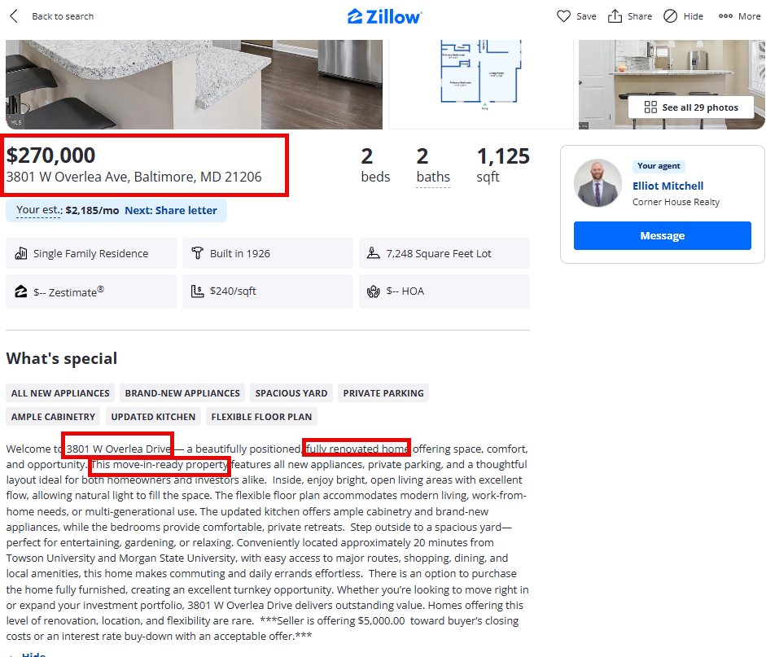
- Instagram Advertisement from Ms. Fortune
https://www.instagram.com/ro_fortuneflips/

  - Added additional Bathroom and Finished Basement
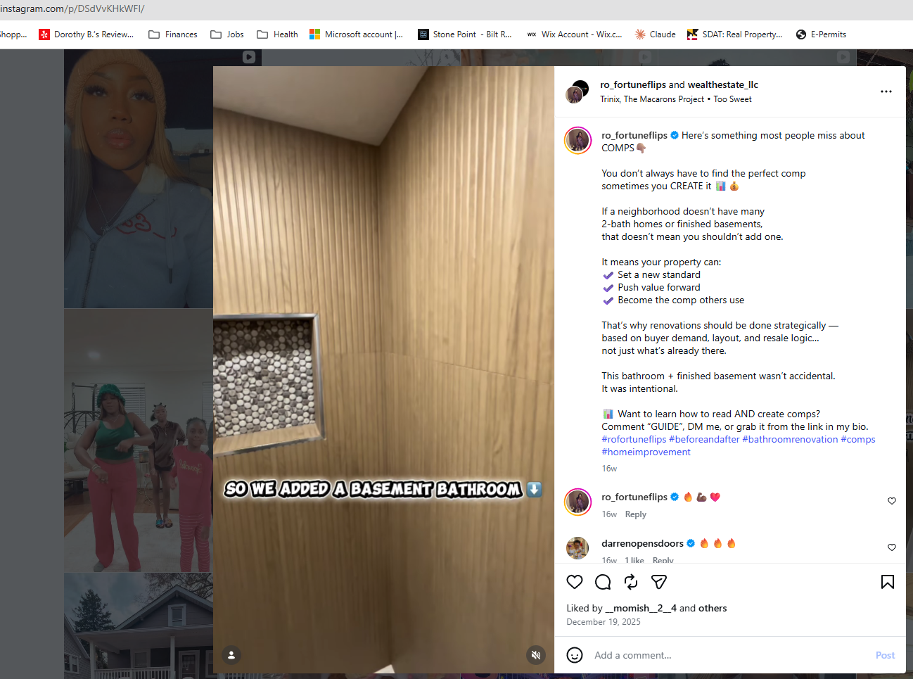
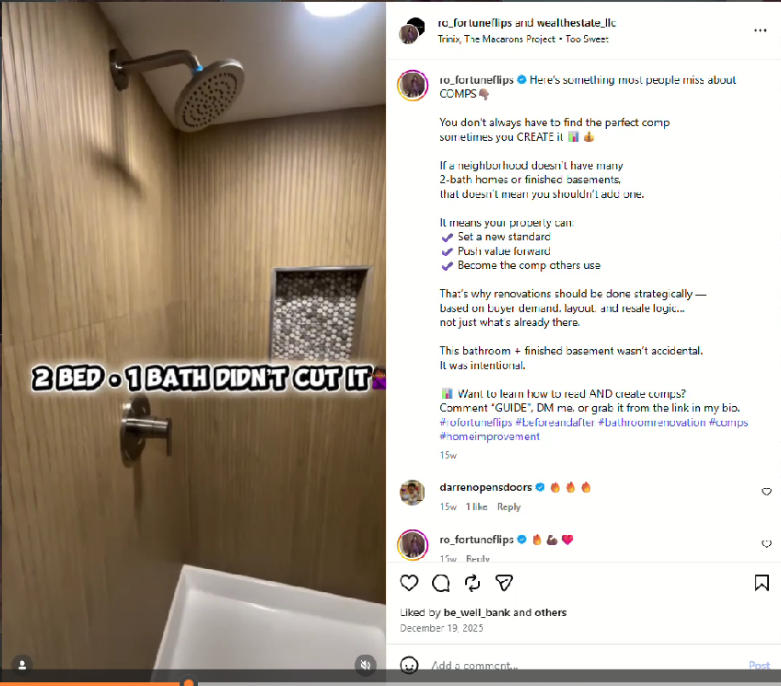
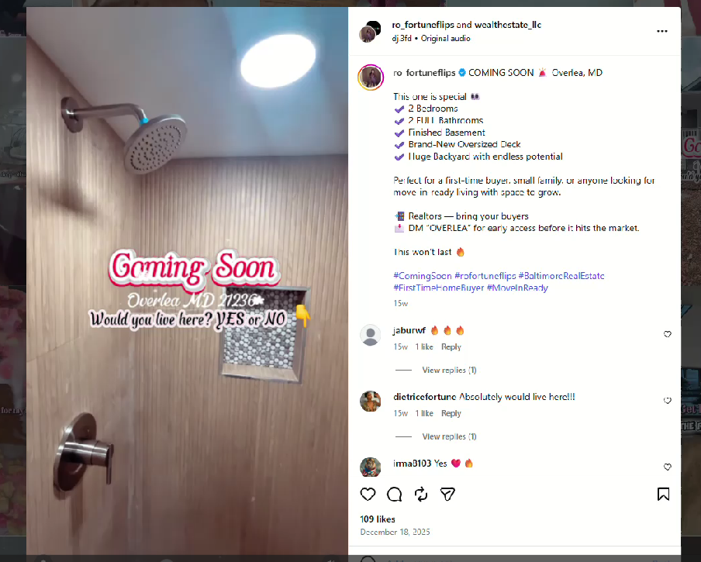

Renovation Work Evident from Listing Photos & Prior Listing History
From SDAT/listing history the following has changed:
- Basement finished
- Additional bathroom added
- Air conditioning installed
- Fireplace covered
- Two kitchen windows removed or covered
- Full interior and exterior repainting
- Doors replaced
- Layout changes visible between 2024 and 2026 listings

SDAT Information:
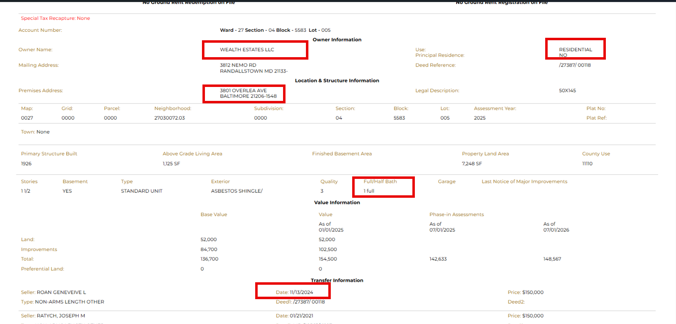

Listings:

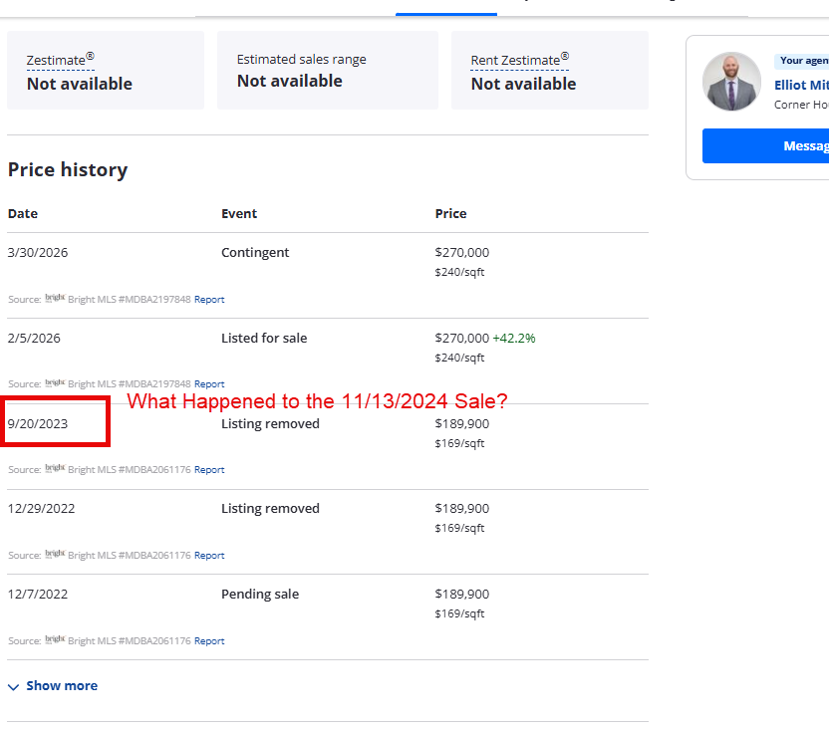
- The home was sold to the current owner on 11/13/2024 as indicated above SDAT image, above. When searching for the original listings with the 3801 Overlea Ave address (not 3801 W Overlea Ave), it appears the following changes have happened:
  - Basement Finished
  - Air Condition added
  - Bathroom Added
  - Fireplace Covered
  - 2 Windows in the Kitchen removed/covered
  - Also the paint color changed inside and out on a 1926 home (see Residential Contract of Sale (MAR) Section
36 B. RENOVATION, REPAIR AND PAINTING OF PROPERTY: In accordance

https://www.zillow.com/myzillow/yourhome/36584293

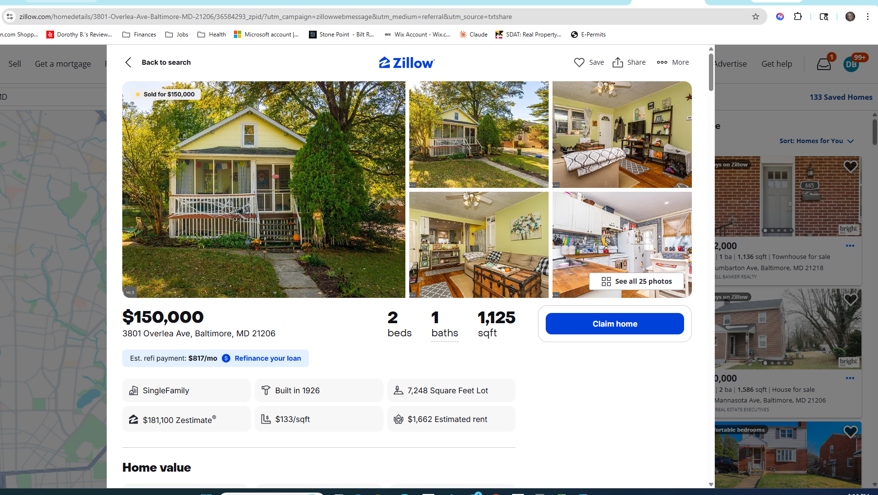
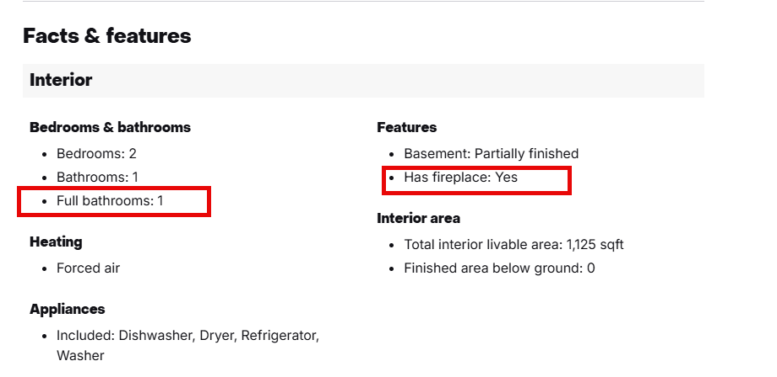
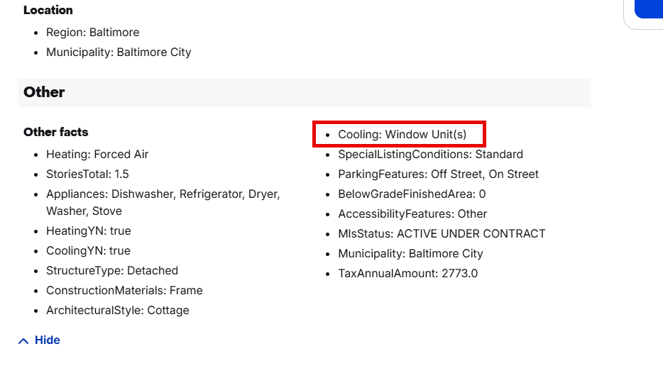
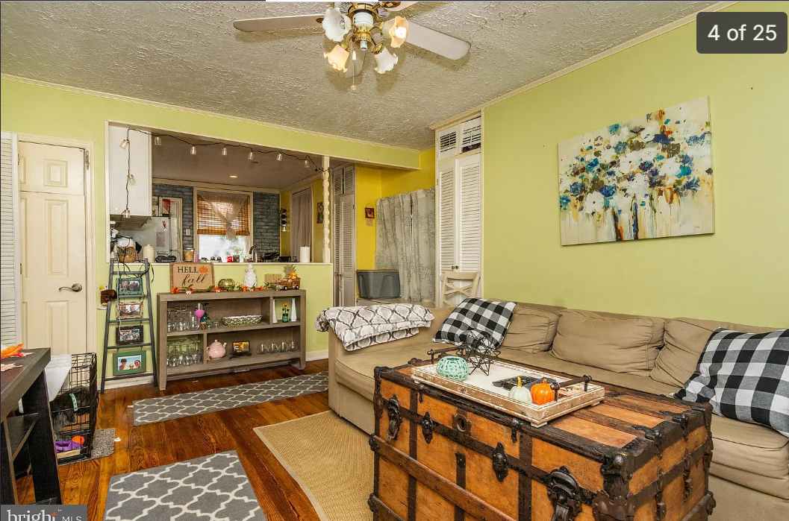
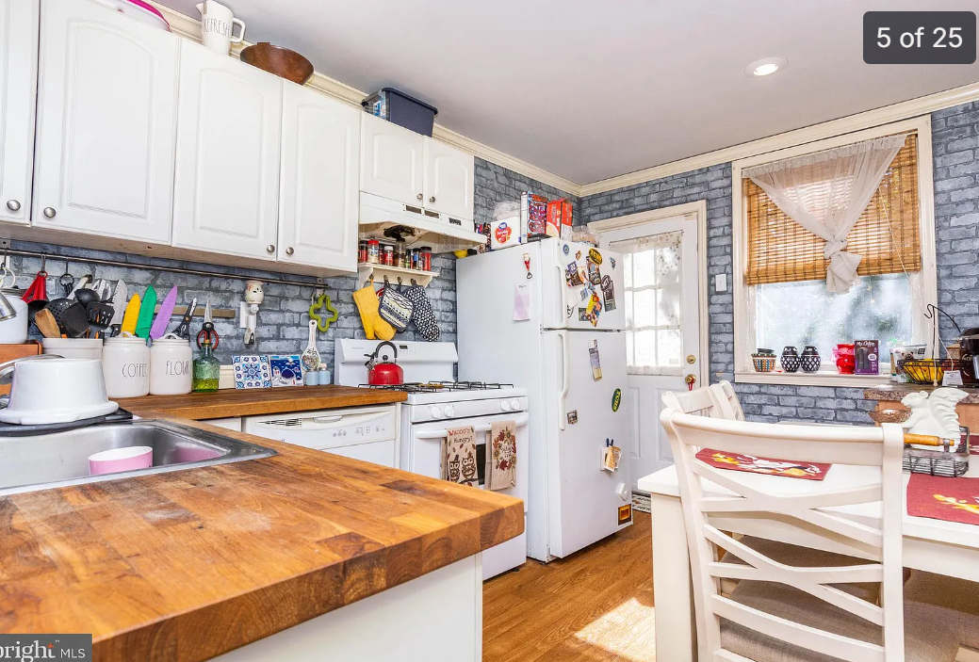

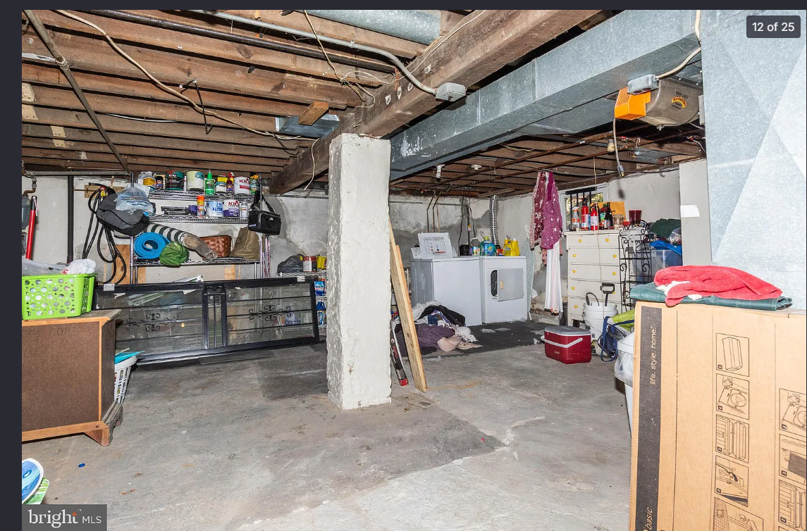

- When asked for permits or a valid U&O permit, the listing agent provided an architect letter that only addresses cosmetic work. (See Exhibit 4.)

Address Change Concealment
- 2024 listing under “3801 Overlea Ave”
- 2026 listing under “3801 W Overlea Ave”
- SDAT confirms same property

Reference to Additional Exhibits
- Permit search results (Exhibit 3)
- Architect letter (Exhibit 4)
- Inspection findings (Exhibit 5)

This exhibit documents the advertising claims and the renovation work performed, which requires permits under Baltimore City law. No permits exist for this work.

