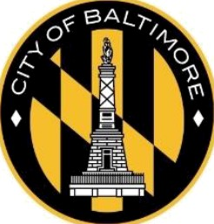
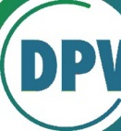
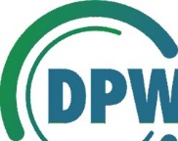

City of Baltimore Department of Public Works Bureau of Solid Waste
DPW
Missing Trash Can or Recycling Cart Replacement Request

Every single-family household is entitled to receive one trash can or recycling cart replacement at no charge. If the can or cart assigned to your household is missing, lost, or stolen, please complete and return this form within five (5) business days of receipt to dpw.trashcans@baltimorecity .gov or mail to Baltimore City Department of Public Works, Attn: Municipal Trash Can Program, 3311 Eastbourne Ave, Baltimore, MD, 21224. Failure to provide a completed Replacement Request form within five (5) business days will result in the closure of your service request.

P/ease note: Trash cans and recycling carts belong to the City of Baltimore and are associated with a specific address. Both cans and carts are to remain at the assigned address, even if the homeowner moves.

Customer Information
Date:
Applicant Name: Service Address: Email Address: Phone Number: Special delivery instructions:

Missing Trash Can or Recycling Cart Information
311 Service Request #: Cart Serial #: Cart Type: O Trash Can (Green Can) O Recycling Cart (Blue Cart)
Cart Size:0 35-gallon 0 65-gallon
Please note any details, such as date cart was last seen or used, whether you looked along your street for your
cart, etc.

I hereby declare that the trash can or recycling cart assigned to the above service address and owned by the City of Baltimore has been stolen or is missing from my property. To the best of my knowledge, the details I provided are true and accurate, and if found to be false will result in forfeiture of a City of Baltimore owned and issued trash can and/or recycling cart.

Applicant Signature Date

