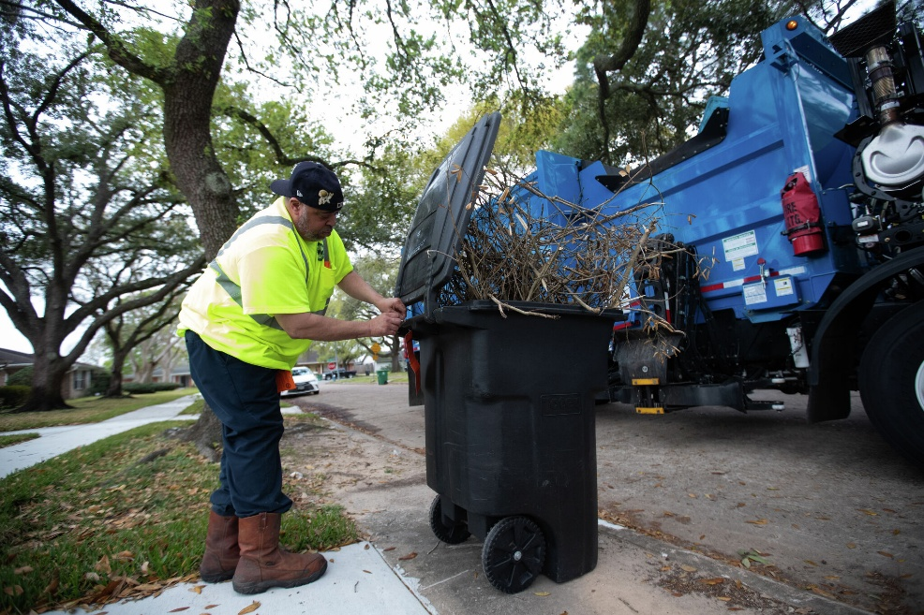

Curbside Instructions
Place all recycling materials (Plastic and glass bottles and jars, paper and cans) in recycle bins, cardboard boxes, paper bags or a clearly marked "recycle" at the same location as your regular trash.
Set out recycling items at the same location as your regular trash pick-up by 6 a.m. for collection.
If your collection day falls on a holiday, please hold your recycling items until the makeup collection day, which will be the following Saturday.
Please DO NOT USE PLASTIC BAGS. With single stream recycling, we send our materials to a processing facility using an automated system to sort and bale recyclables. Plastic bags jam the automated machinery. Most retailers now collect used plastic shopping bags for recycling (you can even take your used dry-cleaning bags to these collection points).
For additional information, please dial 311, contact the office at (410) 396-4511, or tune in to Baltimore City’s Cable channel 25.
Acceptable Recycling Material:
Aerosol Cans (empty)
Aluminum: cans, beverage and food containers, foil (clean), and pie pans
Books: hardbound, paperback and textbooks
Bottles: narrow-neck bottles used for food liquids, soap, soda or water - (lightly clean if heavily soiled)
Cardboard and paperboard boxes corrugated boxes, egg containers, food boxes (including cereal boxes and pizza boxes), frozen food packaging, mailing boxes and shoe boxes
Please remove plastic or Styrofoam packaging material from inside
Cartons (waxed): used for a liquid such as juices, milk or soups
Glass containers such as bottles and jars (brown, clear or green - please rinse)
Juice Boxes (clean)
Mail: envelopes with plastic windows
Metal: beverage and food containers
Paper (all colors and types): catalogs, folders, junk mail, magazines, mixed paper, newsprint (all types), non-metallic wrapping paper, office papers, printer paper, school papers and shredded paper
Plastic: bottles and jars (narrow neck and screw top – lightly clean if heavily soiled) -e.g., detergent/bleach bottles, juice bottles, milk jugs, soda bottles, water bottles. Containers (wide-mouthed – lightly clean if heavily soiled) -e.g., cottage cheese, margarine, mayonnaise, sour cream and yogurt (caps and labels o.k.). Drinking cups and prescription bottles, including lids and caps.
Steel: beverage containers and food
Tin: cans and foil
Rigid Plastics
(to be taken to the citizen drop-off center locations 1 – 5 only and placed in container marked "rigid plastics):
Rigid plastics which include milk/soda crates, buckets, laundry baskets, lawn furniture, totes, plastic drums, coolers, flowerpots, water bottles, pallets, pet carriers, shelving, closet organizers, empty garbage/recycling bins.

*Please note that many grocery stores will recycle your plastic bags.

Unacceptable Recycling Material Examples:
Carry out or deli food containers
Cat litter
Chemicals
Cookware and plates (plastic)
Containers of toxic substances -e.g., bottles, cans motor oil, pesticides, etc.
Contaminated paper products -e.g., napkins, paper towels, waxed paper, paper plates and tissue
Contaminated plastic products -e.g., plates, utensils, cookware, to-go cartons
Dry cleaning bags
Food Waste
Furniture of any kind
Glass (window and mirror)
Paint and paint cans
Plastic bags including grocery and newspaper covers
Utensils (plastic)
Waxed paper
Styrofoam

