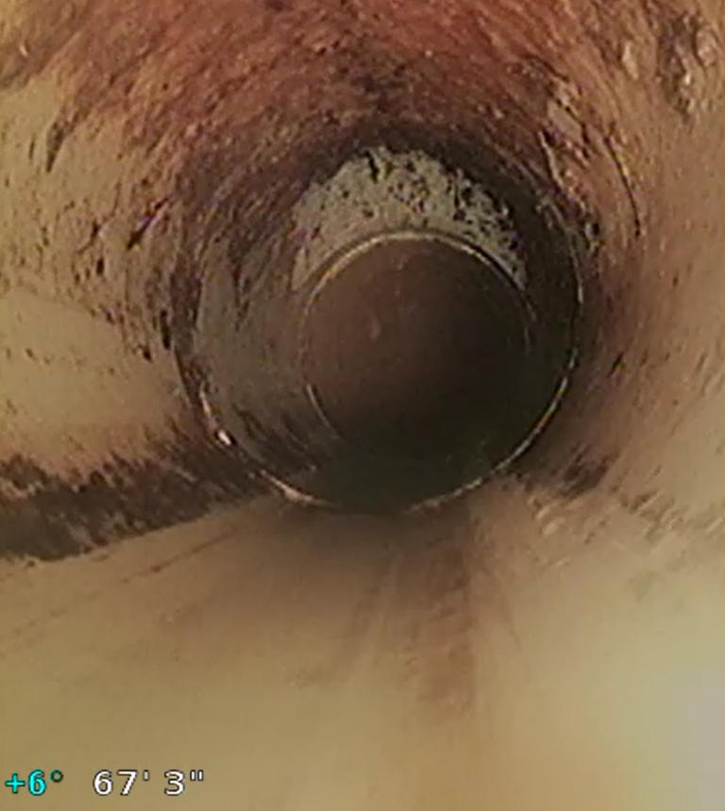
Figure 1 Tee up to front yard clean out

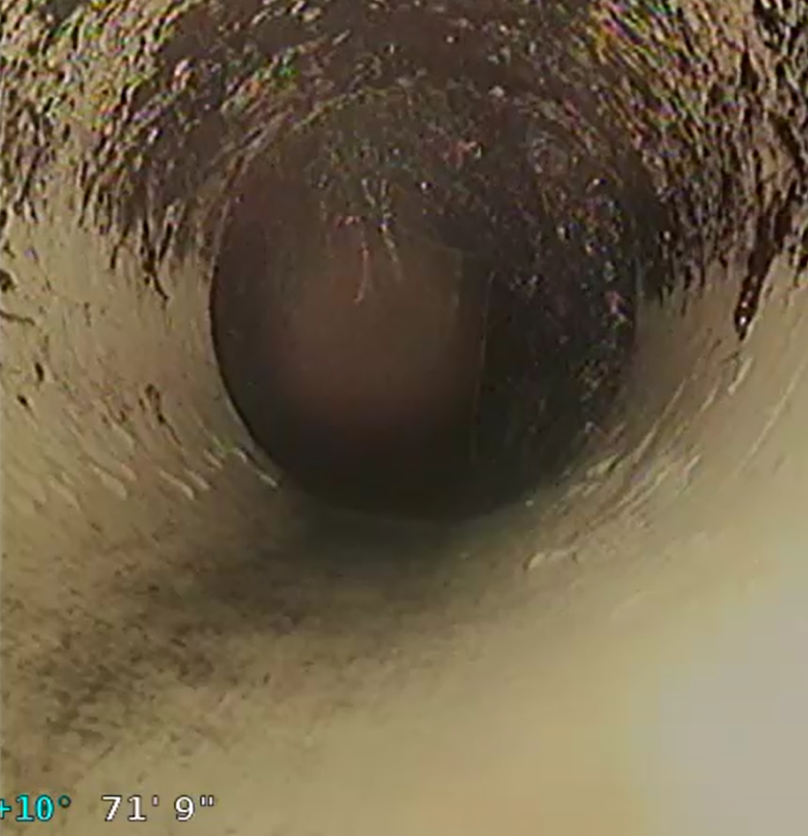
Figure 2 Roots about 4'-0" downstream

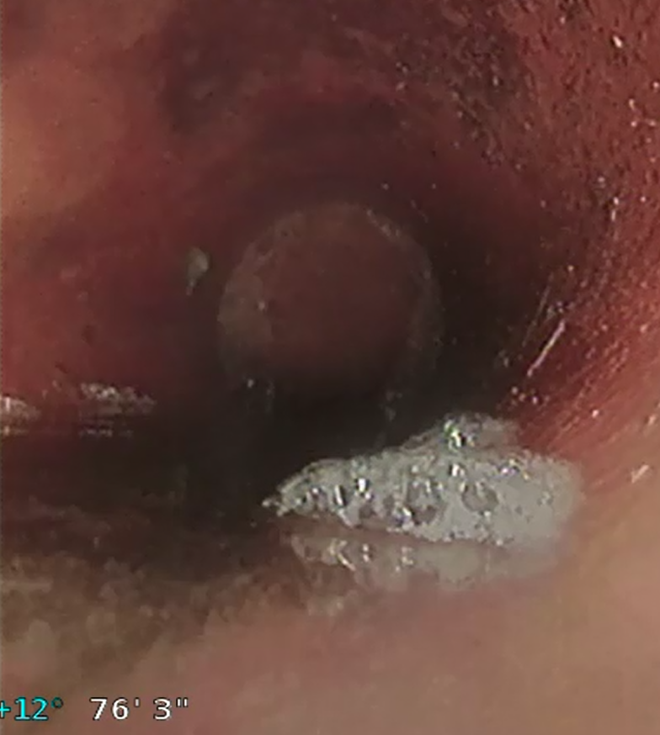
Figure 3 More Roots about 10'-0" downstream of front yard clean out and slight belly

