300 BLOCK DAVIS STREET EARLY MORNING AROUND 7:30 AM
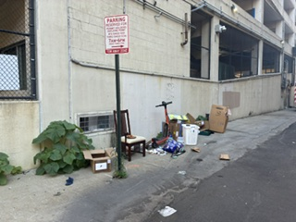
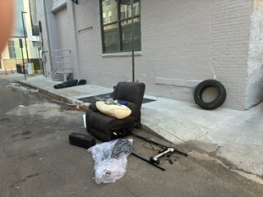
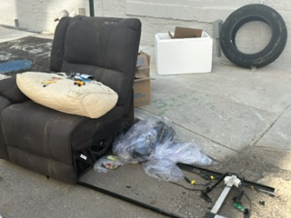

200 BLOCK DAVIS STREET – PICS TAKEN JUNE 4, 2026, AFTER 4:30 PM
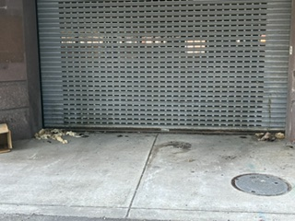 HUMAN FECIES
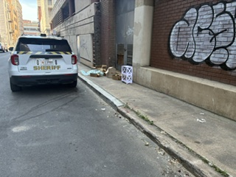TRASH NEXT TO A SHERIFF’S VEHICLE

