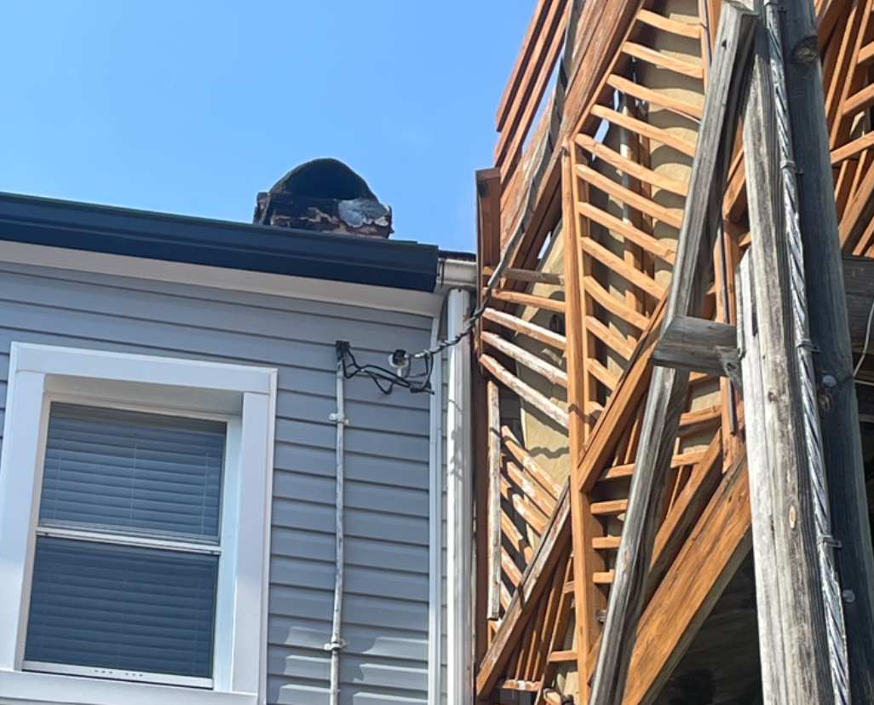

Decking overhanging utility power line that is connected to the top of a utility pole.

