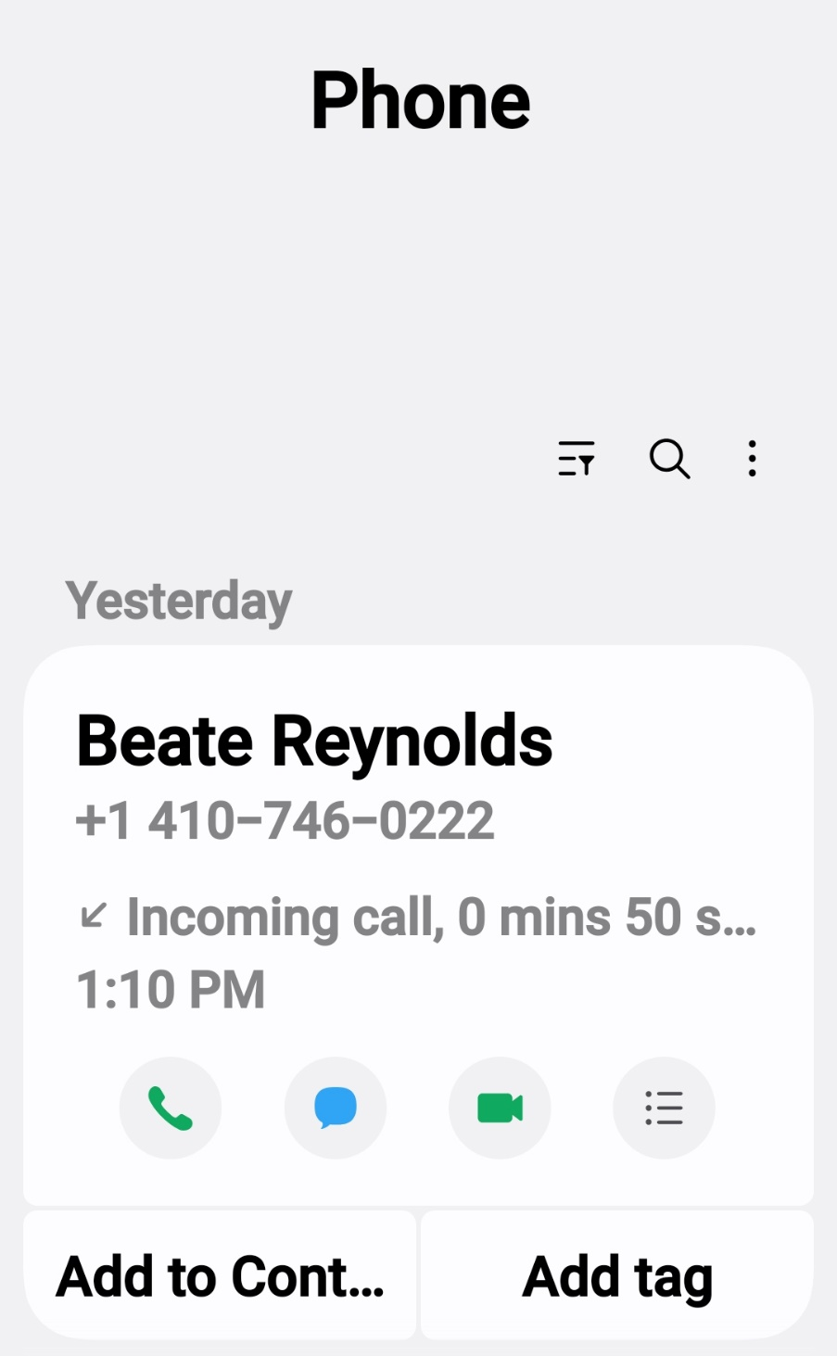

----- Forwarded Message -----
From: "Balt311.Admin" <balt311.admin@baltimorecity.gov>
To: "ccartertaylor@yahoo.com" <ccartertaylor@yahoo.com>

Sent: Tue, Sep 8, 2026 at 3:28 PM
Subject: City of Baltimore 3-1-1 Service Request Resolution - 26-00839378
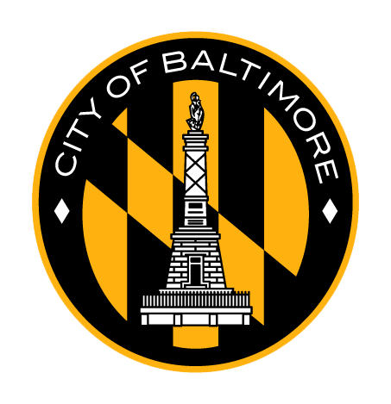
This is an automated E-mail notification from the City of Baltimore 3-1-1 contact center – PLEASE DO NOT REPLY.
Thank you for your recent request for a City service. Your service request number 26-00839378 for Street Light Pole Access Cover/Plate Missing (Exposed Wires) was recently completed with the outcome: We reviewed your issue and marked it closed.
Service Request details link
Thank you again for contacting the City of Baltimore.
When you submit a service request to 3-1-1, you are doing your part to make Baltimore cleaner, safer and stronger! City of Baltimore staff would truly appreciate your constructive feedback by your completing a very brief survey regarding your 3-1-1 experience. Thank you for your continued commitment to the City and allowing us to serve you!
Send us your feedback
