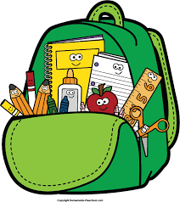**Pack My Bag Checklist**

|  |  |
| --- | --- |
| Backpack  (Collapsible) lunchbox  Water bottle  Oxford Maths Set  Calculator (suitable for up to GCSE. Check with school for specific model required)  Pencil case with 1 x blue and 1 x black pen, 2 x HB pencils, sharpener, eraser, glue stick, collapsible 30cm ruler, highlighters, colouring pencils, whiteboard marker & eraser if needed, post it notes  Keyring for locker and front door keys  Bus pass  Emergency cash  USB memory stick and portable charger  Sun lotion  Umbrella/raincoat  Map of school  Hand wipes/hand sanitiser  PE Kit  Charged mobile phone with Find my Friends’ or Life 360 |  |