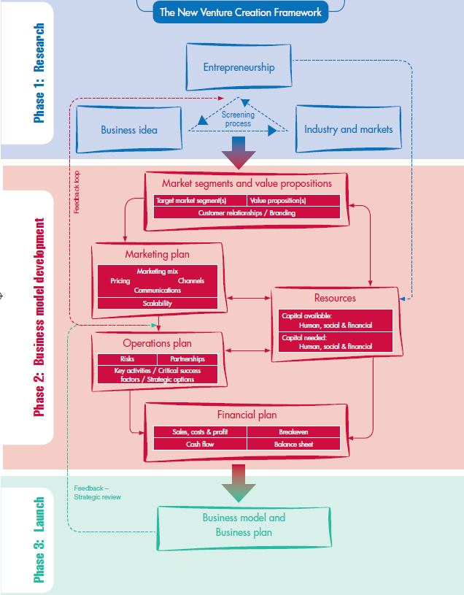

**Phase**

**2**

**Market segments and value propositions**

**Financial plan**

|  |  |
| --- | --- |
| Sales, costs & profit | Breakeven |
| Cash flow | Balance sheet |

**Market segments and value propositions**

|  |  |
| --- | --- |
| Target market segment(s) | Value proposition(s) |
| Customer relationships / Branding | |

**Marketing plan**

|  |
| --- |
| Marketing mix  Pricing Channels  Communications |
| Scalability |

**Operations plan**

|  |  |
| --- | --- |
| Risks | Partnerships |
| Key activities / Critical success factors / Strategic options | |

**Resources**

|  |
| --- |
| Capital available: Human, social & financial |
| Capital needed: Human, social & financial |