Chapter 8 Supplementary

**8.1 Age of menarche**

The complex combined effects of the in utero and early childhood environments on the age of menarche is illustrated by the work of Sloboda et al (2007) on a cohort of 776 Australian girls, 349 of whom had reached menarche. The authors found that both low birth weight and a higher than median BMI at the age of 8 were both associated with earlier menarche, and that, moreover, these effects were additive (Figure 8.1). Weight gain before birth and later weight gain up to age of 8 years had opposite effects on the age of menarche. Possibly then we see the effect of synergy between low birth weight and high BMI both of which from a life history perspective serve to reduce the age of menarche. The former (low birth weight) brings forward menarche in the expectation of harsh conditions ahead, and the latter (high BMI) also advances menarche since good nutrition signals the possibility of a longer reproductive life. Interestingly, this combination of low birth weight and later accelerated growth has been shown to be associated with life shortening diseases such as diabetes, hypertension and cardiovascular disorders (Hales and Ozanne, 2003), a phenomenon also pointing to the need to begin reproduction early.

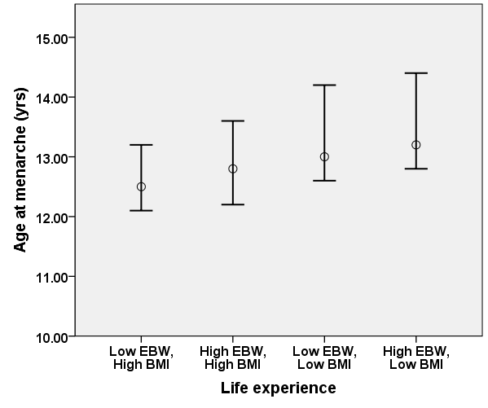

**Figure 8.1 Age of menarche in relation to early life experience for a cohort of 349 Australian girls**. EBW (Expected birth weight ratio) is defined as the ratio of observed birth weight divided by expected birth weight (corrected for size and weight of mother). Low EBW is when EBW<1, high EBW is when EBW>1. Circle represent median values. BMI was measured at age 8 years. Bars represent interquartile range. Data plotted from Sloboda, 2007, Table 1, p.47.

**References**

Hales, C. and S. Ozanne (2003). "The dangerous road of catch-up growth." The Journal of physiology 547(1): 5-10.

Sloboda, D. M., R. Hart, D. A. Doherty, C. E. Pennell and M. Hickey (2007). "Age at menarche: influences of prenatal and postnatal growth." Journal of Clinical Endocrinology & Metabolism 92(1): 46-50.