LEADERSHIP ACTION PLAN

Andrew Topping

* Total Word Count: Executive Summary: 3,860

(Excluding Title Page, Table of Contents, References, and Appendices)

**Table of Contents**

List of Figures 5

List of Tables 6

Introduction 7

Personal needs assessment 7

Values and Goals 15

Competency framework 17

Implementation plan 18

Conclusion 19

References 20

Appendix A 22

Appendix B 25

Appendix C 26

Appendix D 28

Appendix E 32

Appendix F 33

Appendix G 36

Appendix H 39

**List of Figures**

Figure 1: The Big Five**®** (FFM) personality trait assessment…………………………………….9

Figure 2: Strengths Finder 2.0 scoring matrix 10

Figure 3: Strengths Finder 2.0 scoring result 2012 10

Figure 4: Learning Styles 12

Figure 5: Personal values and goals 13

**List of Tables**

Table 1: Emotional Intelligence score 7

Table 2: FIRO-B 2015 results 8

Table 3: Tolerance for Ambiguity scoring matrix……………………………………………….11

Table 4: Goal: how/why matrix………………………………………………………………….14

Table 5: Competing values model of communication…………………………………………...16

Table 5: Pesonal implementation plan 18

# Introduction

This Leadership Action Plan documents my vision, career goals, and foundational values, and provides a blueprint for on-going personal and professional development to achieve success. Specifically, this paper is divided into three major sections: (1) a personal needs assessment that describes my leadership strengths and weaknesses via several self-evaluation tools; (2) a competency framework that evaluates my strengths and weaknesses of specific leadership competencies and principles, and; (3) an implementation plan for addressing developmental opportunities. The value of this plan is that it will serve as a long-term, adaptive career planning template to link my goals in an actionable way to encourage and facilitate sustained personal improvement, commitment and self-efficacy.

# Personal needs assessment

My personal needs assessment describes my perceived leadership strengths and weaknesses utilizing the following self-evaluation tools:

* Myers-Brigs**®** Personality Test;
* Emotional Intelligence self-assessment;
* Fundamental Interpersonal Relations Orientation (FIRO-B**®**);
* The Big Five**®** (FFM) personality trait assessment;
* Strengths Finder 2.0**®**;
* Tolerance for ambiguity self-assessment, and;
* Learning Style preference self-assessment.

The following section will summarize the results found in Appendices A through G and will highlight how my personal leadership style and personality characteristics will drive my career plan.

My personal definition of leadership is based on my normative preferences and my concrete operating environment (Van Wart, 2003, p. 221). For the based fifteen years I have been in various team leadership roles in the telecom sector. This private-sector operating environment is highly competitive and dynamic and has a robust set of performance management systems. Concurrently, for the last twelve years I have also been a public-sector elected representative to local government in the role of municipal councilor, mayor and board of education trustee. These dual operating environments have led to the following personal leadership definition:

**Leadership is a process involving a complex-adaptive composite of skills, competencies, values and insights that enable success in achieving a pre-determined goal in serving the common good.**

Peter Drucker, one of the world’s foremost authorities on management and leadership, stated that in today’s economy, people must be aware of their strengths, their values and how they best perform (Quinn et al, 2011, p.39). Accordingly, to better align my leadership developmental opportunities to my career goals, it is important to first gain a clear understanding of my personal strengths, weakness and personality characteristics.

**General disposition**

Leadership can be defined as a complex patterns of behaviors, likely explained, in part, by multiple leadership traits ( Yukl, 2006). Specifically, “leader traits can be defined as relatively coherent and integrated patterns of personal characteristics, reflecting a range of individual differences, that foster consistent leadership effectiveness across a variety of group and organizational situations” (Zaccaro, 2007, p. 7). The Myer-Brigs**®** personality test is an introspective self-evaluation tool designed to indicate personal psychological characteristic preferences. Completed in December of 2015, the Myers-Brigs**®** Type Indicator (MBTI) describes me as a **INTJ**: **Introversion – Intuition – Thinking – Judging** personality type. In summary, this personality type, “have original minds and great drive for implementing their ideas and achieving their goals. They have long-range vision and quickly find meaningful patterns in external events. They are independent, skeptical, and critical and have high standards of competence and performance for themselves and others”. The MBTI describes INTJ types as having the following characteristics:

* INTJs have a clear vision of future possibilities;
* Their faith in their inner vision can move mountains. Problems only stimulate them - the impossible takes a little longer, but not much;
* They quickly see patterns in external events and develop long-range plans;
* INTJs are relentless innovators; and;
* They make their decisions based on logic and analysis.

I found that this evaluation is accurate and the MBTI key words resonate with me.

**Emotional Intelligence**

Emotional intelligence involves recognizing your emotions and how they affect you and others, and also knowing what you feel and why (Quinn et al, 2011, p.39). Using Whetton’s and Cameron’s (2011) emotional intelligence self-evaluation assessment in December 2015, I scored the following:  
**Table 1: Emotional Intelligence score**

|  |  |  |
| --- | --- | --- |
| Mean score | 70 |  |
| Top quartile | 86 of higher |  |
| Second quartile | 71-85 |  |
| Third quartile | 55-70 | **Self-assessment = 65** |
| Bottom quartile | 54 or lower |  |

The above summary of results shows my score to be below the mean of 70. I found that this evaluation is accurate. It is also supported by the following Myers-Brigs MBTI characteristic observations of INTJs:

* They may find it difficult to engage in social conversation, preferring to talk about abstract ideas;
* Others may find them hard to get to know or even aloof;
* INTJs tend to respect only people who meet their high standards ofcompetence;
* Because they have high standards and because they are so good at analysis,they may appear critical of others; and
* Appreciating others may be hard for INTJs, and they may ignore other people’s values and feelings.

**Interpersonal relations**

Since its publication in 1958, the Fundamental Interpersonal Relationship Orientations-Behaviour (FIRO-B) has been actively used in organizations for a variety of purposes; including training, understanding senior management functioning, enhancing leadership effectiveness, coaching, and personnel selection and placement (Ahmetoglu, G., Chamorro-Premuzic, T., & Furnham, A., 2010, p. 220). Completed in December 2015, I scored the following:

**Table 2: FIRO-B result 2015**

|  |  |  |  |  |
| --- | --- | --- | --- | --- |
|  | **Inclusion** | **Control** | **Affection** |  |
| **Expressed** **Behavior** | 5 | 9 | 1 | 15  Total Expressed |
| **Wanted** **Behavior** | 8 | 2 | 1 | 11  Total Wanted |
|  | 13  Total Inclusion | 11  Total Control | 2  Total Affection | **26**  **Social** **Interaction Index** |

The above summary of results show medium scores for including others; a very high score for seeking situations that involve controlling and influencing; and a very low score for forming close relationships with others. I found this evaluation accurate as it is supported by the other self-assessment tools described above.

**Personality traits**

The FFM is generally regarded as the most widely accepted taxonomy for studying personality (Quinn et al, 2011, p. 40). The FFM taxonomy uses five factors or basic behavioral tendencies. The five tendencies can act as predictors for leadership performance and it is important for managerial leaders to be aware of their tendencies as they perform work (Quinn et al, 2011, p. 41). Completed in December 2015, I scored the following:

**Figure 1: The Big Five personality factors 2015**

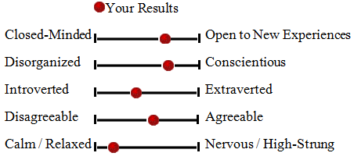

The above summary of results shows my score to be in the 70th percentile in the Openness to Experience/Intellect tendency; 74th percentile in the Conscientious tendency; 37th percentile in the Extraversion tendency; 57th percentile in the Agreeable tendency; and in the 11th percentile in the Neuroticism tendency. I found this evaluation accurate as it is supported by the other self-assessment tools described above. I am aware of my introverted tendencies as well as my ability to stay calm, even in tense situations, per my MBTI personality characteristic which states that I, “often present a calm, decisive, and assured face to others”.

**Strengths**

Leadership strengths can be defined as, “a preexisting capacity for a particular way of behaving, thinking, or feeling that is authentic and energizing to the user, and enables optimal functioning, development and performance” (Linley, p. 9). Research is showing that the more leaders use their unique strengths, the higher their performance will be in the workplace (Linley, Woolston & Biswas-Diener, 2009), and their levels of happiness, fulfillment, authenticity, goal accomplishment, and optimal functioning will increase (Linley, Nielsen, Wood, Gillett & Biswar-Diener, 2011).

Tom Rath’s Strengths Finder 2.0 methodology was used in 2012 to evaluate the telecommunications operational leadership team for the purposes of a team builder exercise. The framework categorizes leadership traits within five themes that reside within four general leadership styles (see figure 2).

**Figure 2: Strengths Finder 2.0 leadership styles**

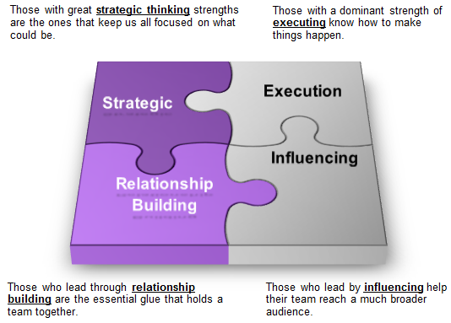  
**Source**: Strengths Finder personal assessment 2012.

My 2012 result showed the following five themes:

* **Futuristic** - are inspired by what could be. They inspire others with their visions of the future;
* **Input** - Often like to collect and archive all kinds of information.
* **Intellection** - Are introspective and appreciate intellectual discussions.
* **Strategic** - have a great desire to learn and want to continuously improve
* **Learner** - quickly spot the relevant patterns and issues.

**Figure 3: Strengths Finder 2.0 result 2012**

|  |  |  |  |  |  |
| --- | --- | --- | --- | --- | --- |
| **Team Member** | **Theme #1** | **Theme #2** | **Theme #3** | **Theme #4** | **Theme #5** |
| Andrew | Futuristic | Input | Intellection | Strategic | Learner |

All five themes from my score belong in the strategic leadership style quadrant. I found this evaluation accurate as it is supported by my MBTI personality characteristic which states that the INTJ type are, “Excellent long-range planners and often rise to positions of leadership in groups or organizations”.

**Tolerance for Ambiguity**

Tolerance of ambiguity has been defined as an individual’s range of reactions to stimuli that are considered unfamiliar, complex, uncertain, or subject to multiple interpretations (Tsirikas,A., Katsaros, K., Nicolaidis, C., 2012, p. 346). Ambiguity stems from three primary sources: novelty, complexity and insolubility. The scoring key for this self-evaluation tool is the higher one scores, the more one may perceive situations as threatening, rather than promising. Completed in December 2015, my results are as follows:

**Table 3: Tolerance for Ambiguity scoring matrix**

|  |  |  |
| --- | --- | --- |
| (N) | Novelty Score | 22 |
| (C) | Complexity Score | 28 |
| (I) | Insolubility Score | 05 |
| Mean score | | 56.47 |  |
| Top quartile | | 63 of higher |  |
| Third quartile | | 57-62 |  |
| Second quartile | | 50-56 | **Self-assessment = 55** |
| Bottom quartile | | 59 or lower |  |

I was surprised at this evaluation result. Due to my very dynamic work environment and my comfort level in changing direction based on new information, I expected my tolerance for ambiguity to be in the top percentile. This result did bring to light my preference for routine for efficiency purposes and a tendency to regards certain changes in my environment in an initial negative light.

**Learning Style preference**

Kolb’s (1984) learning style inventory is a popular assessment tool in measuring learning preferences and can be a strong indicator of performance (Armstrong, S., Ming, L., 2013). Kolb’s model consists of a four-stage cycle of learning where immediate concrete experience (CE) serves as the basis for observation and reflection (RO), in which the experience is subsequently assimilated into abstract conceptualization (AC), and then formed into active experimentation (AE) with the world. Active experimentation both completes the cycle of learning and ensures that it begins anew by assisting the creation of new experiences Kolb, 1984). Completed in December 2015, my results are as follows:

**Figure 4: Learning Style preference** **scoring matrix**

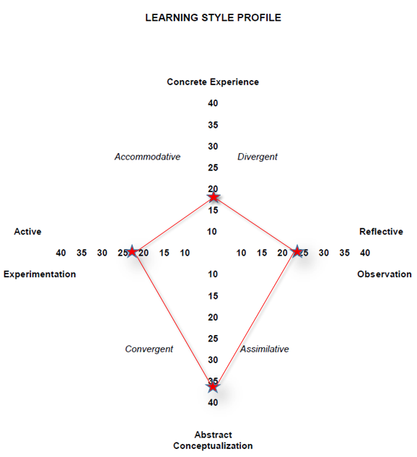

The above results show that I have a learning style that is underdeveloped in the Concrete Experience (CE) orientation, which focuses on being involved in experiences and dealing with immediate human situations in a personal way. CE learning emphasizes feeling more than thinking; a concern with the uniqueness and complexity of present reality over theories and generalizations; and intuitive, "artistic" approach over a systematic, scientific approach to problems. It is not surprising that I am deficient in this domain given the consistency of the personality traits documented above.

# Values and Goals

This section provides additional direction for my career plan as setting and aligning career goals and objectives to one’s personal values can be viewed as a way of energizing one to work towards goal-related activities (Cunningham, B., 2015). My future success begins with a set of values that inform my career goals, which in turn enable me to reach my vision. They are the following:

1. **Vision statement:** to achieve contentment and emotional well-being by constantly striving to do my best in job performance, health and fitness, and relationships with family and friends.
2. **Career goal:** to lead with humility, respect and gratitude in creating a better future for myself, and my family, by serving others to create opportunity for betterment, in a just society
3. **Personal values**: truth, justice, compassion, forgiveness, love, respect and honour.

**Figure 5: personal values and goals alignment**

To maximize the effectiveness of goal setting, short-term goals must be connected in a

causal way to higher-level goals defining an overall purpose (Cunningham, B., 2015). The table below illustrates how learning goals that focus on task learning and skill development support the achievement of my higher outcome centric performance goals.

**Table 4: Goal “how/why” matrix**

|  |  |
| --- | --- |
| **Why**  **How** | **Elected MLA** |
| **PERFORMANCE GOALS** |
| *Performance goals focus on the end result, outcomes (solving the problem; getting a job, degree, good*  *grade; making money):*   1. Riding nomination 2. Work on election campaign 3. MPA completion 4. Join political party 5. Build key competencies:    1. Communicating honestly & effectively    2. Using power & influence ethically & effectively    3. Champion & sell new ideas    4. Negotiating agreement & commitment    5. Implementing & sustaining change |
| **LEARNING GOALS** |
| *Learning goals relate to task learning or improvement, skill development or competence (learning a new competency or skill such as becoming competent at problem-solving).*   1. Communicating 2. Consulting 3. Relationship management 4. Conflict management 5. Strategic thinking 6. Critical evaluation 7. Leadership |

Adapted from Cunningham, B. “Developing and Engaging Employees” (2015).

The above table identifies my ideal and ultimate career goal as the elected Member of the Legislative Assembly for British Columbia for my local constituency riding. I consider this an ambitious goal, and definitely outside my comfort level given the current employment security offered by my current private-sector employer and introverted personality traits described above. Table 4 describes how I plan to continuously improve on specific skills, via learning goals, that become more complex competencies to reach higher objective or performance goals.

# Competency framework

This section explores five key competencies and guiding principles that are amenable to development and are necessary performance goals in order to succeed in my chosen career path. A competency suggests both the possession of knowledge and the behavioral capacity to act appropriately using that knowledge (Quinn et al, p. 22). Utilizing the Competing Values Approach (see Appendix H) provided by Quinn et al (2011), the following five competencies included in my developmental plan are the following:

1. **Communicating honestly & effectively**

Communication is the exchange of information, facts, ideas and meaning and is at arguably at the heart of many leadership competencies (Quinn et al, p. 48). As an elected representative, it is perhaps the most important competency to acquire as it is both enables reaching the career goal of being elected, and is also the main core competency in the practice of the politician’s role. Communicating, especially in the verbal form, is one of my most proficient competencies and I find addressing large groups stimulating. Developmental opportunities are largely in communicating one-on-one on a personal level, as indicated by my personal needs assessment.

**Principles:**

1. Whenever we attempt to communicate, the information exchanged may take a variety of forms, including ideas, facts and feelings (Quinn et al, p. 49).
2. Of the skills associated with good communication perhaps the most important is reflective listening, which requires the dual process of both concentration and collaboration (Quinn et al, p. 55).
3. **Using power & influence ethically & effectively**

In an organizational context, the term “power” is most often defined as, “the capacity to mobilize people and resources to get things done” (Kanter, 1983). Effective leaders sustain their influence by building and maintaining trust and helping perform at a higher level (Quinn et al, p. 256). Influencing effectively is a competency I have had success in, which is in part attributable to my verbal communication skills and experience. Developmental opportunities are largely in the development of interpersonal relationships skills and seeking out experiences and dealing with immediate human situations in a personal way.

**Principles:**

1. There are three levels from which to study power:
   1. Organizational – can be viewed as the ability to influence the flow of available energy and resources towards a certain goal, such as legislating policies (Quinn et al, p. 257).
   2. Team – can be seen as the ability to influence your peers through one’s personal strengths of expertise and experience (Quinn et al, p. 257).
   3. Individual – can be seen as one’s capacity to influence another person’s behavior that they would not do otherwise (Quinn et al, p. 257).
2. The development of this competency should stress interpersonal relationships and the resources we bring to bear in those relationships (Quinn et al, p. 257).
3. **Champion & sell new ideas**

Championing and selling new ideas can be analyzed through a competing values model framework to facilitate the appropriate delivery of intended objectives:

**Table 5: Competing values model of communication**

|  |  |
| --- | --- |
| **Relational messages build trust**   * Open, candid, honest * Credible, believable, plausible | **Transformation messages bring change**   * Emphatic, forceful, powerful * Insightful, visionary |
| **Information messages provide facts**   * Rigorous, precise, controlled * Focused, logical, organized | **Promotional messages direct action**   * Interesting, stimulating, engaging * Conclusive, decisive, action-oriented |

**Source**: Adapted from Quinn, Hildebrandt, Rogers & Thompson 1991; and Rogers and Hildebrandt, 1993

Championing and selling new ideas is a competency I have had success in, which again, is in part attributable to my verbal communication skills and experience. My personal developmental opportunities reside in the Relational quadrant of the above table in developing open and candid communication skills that build my comfort in expressing my feelings to others, and my comfort with having others acting warmly and sharing their feelings with me.

**Principles:**

1. All communications can be evaluated in terms of substance (content) and style (how) (Quinn et al, p. 270).
2. One needs to communicate in different ways, depending on the purpose and content of the message (Quinn et al, p. 271).
3. People frequently want to accomplish more than one objective with a single message and can have competing goals (Quinn et al, p. 271).
4. **Negotiating agreement & commitment**

William Ury, an associate at Harvard Law School’s Program on Negotiation, stated that most of the important decisions we make in life are not made unilaterally, but rather through negotiating (Ury, 1993, p.5). It is important to note that, successful negotiators know that trying to use real power to force into an agreement rarely results in optimal outcomes and can seriously damage relationships in the long run (Quinn et al, p. 299). Much of my public-sector experience has been that of an elected official where I hold some degree of formal power in the form of voting to either support or reject agreements. My personal developmental opportunity is to involve myself in negotiations that utilize the conditions of dialogue, mutual purpose, meaning and respect (Quinn et al, p. 300).

**Principles:**

1. Separate the people from the problem
2. Focus on interests, not positions
3. Generate a variety of possibilities before deciding what to do
4. Insist that the result be based on some objective standard

(Fisher, R., Ury, W., 2002)

1. **Implementing and sustaining change**

Change is a social-emotional process, and people must willingly be persuaded and engage in the effort (Quinn et al, p. 314). Persuasion is important to implementing and sustaining change as it promotes understanding; understanding breeds acceptance; acceptance leads to action” (Garvin, D., Roberto, M., p. 33). As an elected representative, my personal developmental opportunity is to focus on active listening and allow for each person to express their truth.

**Principles**:

There are four approaches to implementing change:

* 1. Telling – is most effective for simple situations and assumes that people are guided by reason
  2. Forcing - relies on formal power such as political or economic sanctions, and is not likely to result in healthy and enthusiastic change that will endure.
  3. Participating - is a collaborative change process that incorporates the meanings, habits, norms, and institutional policies of human culture.
  4. Transforming - assumes that deeply held belief or core values drive a leader’s behavior to alter the external environment, rather than to change it

(Quinn et al, p. 319).

# Implementation plan

This section describes a developmental plan for achieving my performance goals and to further enhance and capitalize on personal competency strengths, as well as addressing competency weaknesses per table 4: Goal “how/why” matrix.

**Table 6: personal implementation plan**

|  |  |  |  |
| --- | --- | --- | --- |
| **Performance Goals** | **Initiatives** | **Achievement Measures** | **Time Period** |
| 1. **Riding nomination** | 1. Win provincial seat in BC Legislature | 1. Elected MLA | 7 years |
| 1. **Riding nomination** | 1. Win party nomination to run as a local candidate | 1. Win nomination | 6 years |
| 1. **Work on election campaign** | 1. Learn provincial election campaign strategy and operations for existing MLA | 1. Actively participate in 2017 election campaign | 2 years |
| 1. **MPA completion** | 1. Develop expertise in public sector governance | 1. Completion of MPA degree from UVic | 3 years |
| 1. **Join political party** | 1. Acquire support network for participation in BC politics | 1. Obtain political party membership | 6 months |
| **Competencies** | **Initiatives** | **Achievement Measures** | **Time Period** |
| 1. **Communicating honestly & effectively** | 1. Develop skills in active and reflective listening 2. Develop skills to increase comfort in listening to and sharing in personal feelings. | 1. Read material and practice reflective listening skills 2. Complete formal workshop on empathetic communication skills. | 3 years |
| 1. **Using power & influence ethically & effectively** | 1. Develop greater comfort and competency in interpersonal relationships | 1. Volunteer in a front-line capacity with recipients of social/public services in region 2. Visit schools in district to develop 1:1 relationships with front-line staff | 5 months |
| 1. **Champion & sell new ideas** | 1. Develop a greater inventory of communication styles | 1. Utilize the Competing Values Model of Communication | 3 months |
| 1. **Negotiating agreement & commitment** | 1. Increase negotiating skills | 1. Seek negotiating activities that do not rely on formal power 2. Take formal training in negotiation | 3 years |
| 1. **Implementing and sustaining change** | 1. Increase skills to influence sustainable change | 1. Utilize the four strategies for Changing Human Systems | 1 year |
| **Learning Goals** | **Initiatives** | **Achievement Measures** | **Time Period** |
| 1. **Consulting** | 1. Develop consulting skills | 1. Volunteer consulting expertise for small non-profit organizations to gain experience | 3 years |
| 1. **Relationship management** | 1. Increase relationship management skills | 1. Research relationship management strategies and processes 2. Purchase Client Relationship Management software to create inventory of contacts | 1 year |
| 1. **Conflict management** | 1. Increase skills in conflict management | 1. Research conflict management strategies 2. Take formal training in conflict management | 2 years |
| 1. **Strategic thinking** | 1. Increase skills in strategic thinking | 1. Research strategic thinking processes 2. Take formal training in strategic thinking | 3 years |
| 1. **Critical evaluation** | 1. Increase skills in critical evaluation | 1. Research critical thinking evaluation 2. Take formal training in critical evaluation | 3 years |
| 1. **Leadership** | 1. Enhance leadership capabilities | 1. Research leadership theory 2. Take formal training in leadership to address deficiencies identified in this LAP | 3 years |

# 

# Conclusion

The development of my personal Leadership Action Plan was an unexpected and insightful learning journey about my own strengths, weaknesses and opportunities for development. It also served as a deeply contemplative process that allowed me to become clear about my own personal values, vision and career goals. As a result, I feel empowered, energized and more aware of the world around me, and my unique place in it. This document will continue to expand as I assert more personal leadership in addressing development opportunities not yet discovered in my implementation plan. Through the process of a personal needs assessment, and the alignment of vision, values, performance goals and learning goals, and the specific action strategies described in the implementation plan, I have developed a clear roadmap for the advancement of my career goal; to lead with humility, respect and gratitude in creating a better future for myself, and my family, by serving others to create opportunity for betterment, in a just society.

# References

Ahmetoglu, G., Chamorro-Premuzic, T., & Furnham, A., (2010). Interpersonal Relationship Orientations, Leadership, and Managerial Level: Assessing the practical usefulness of the FIRO-B in organizations. *International Journal of Selection and Assessment,* 18(2), 220-225

Armstrong, S., Ming, L., (2013). The relationship between Kolb's experiential learning styles and Big Five personality traits in international managers. *Personality and Individual Difference,* 86 (2015) 422–426

Cunningham, B. (2015). “Developing and Engaging Employees” Not yet published.

Fischer, R., Ury, W., (2002). *Getting to yes: Negotiating agreement without giving in*. New York: Penguin

Garvin, D., Roberto, M., (2005). Change through persuasion. On Change Management. Boston: Harvard Business Review Press

*Key Leadership Competencies* (2006). Government of Canada. Published by the Canada Public Service Agency and the Public Service Commission. Retrieved from http:// //www.tbs-sct.gc.ca/tal/kcl/dwnld/klc-eng.pdf

Kanter, R. (1983). *The change masters: Innovation for productivity in the American corporation*. New York: Simon & Schuster

Kolb, D.A. (1984). *Experiential learning: Experience as the resource of learning and development.* Englewood Cliffs, NJ: Prentice Hall

Linley, A. (2008). *Average to A: Realizing strengths in yourself and others*. Coventry, UK: CAPP Press

Linley, A., Nielsen, K., Wood, A., Gillett, R., & Biswar-Diener, R. (2011). Using signature strengths in pursuit of goals: Effects on goal progress*. International Coaching Psychology Review*, 5, 6 –15

Linley, A., Woolston, L., & Biswas-Diener, R. (2009). Strengths coaching with leaders. *International Coaching Psychology Review*, 4, 20 –31. Retrieved from http://positiveacorn.com/wp-content/uploads/2012/01/ Linley_2009.pdf

Quinn, R.E., Faerman, S. R., Thompson, M.P., McGrath, M. R., & St. Clair, L.S. (2011). *Improving Productivity and Increasing Profitability, In Becoming a Master Manager: A Competing Values Approach* (5th ed.). New York: John Wiley & Sons

Rath, T. (2007). *Strengths Finder 2.0*. New York: Gallop Press

Tsirikas,A., Katsaros, K., Nicolaidis, C., (2012),"Knowledge management, tolerance of ambiguity and productivity", *Employee Relations*, 34(4), p. 344 – 359

Ury, W. (1993). *Getting past no: Negotiating your way from confrontation to cooperation*. New York: Bantam Books.

Van Wart, M. (2003). "Public Sector Leadership Theory: An Assessment", *Public Administration Review*, 63(2)

Whetton, David A., Cameron, Kim S. *Developing Management Skills*, 5th Edition. New Jersey: Pearson Education Inc., 2002

Yukl, G. A. (2006). *Leadership in organizations* (6th ed.). Upper Saddle River, NJ: Pearson Prentice Hall

Zaccaro, S.J. (2007). Trait-Based Perspectives of Leadership. *American Psychologist*, 62, 1, 6-16

# Appendix A

Myers-Brigs

*The following personal self-evaluation results are from the Myers-Brigs personality test completed in December 2015:*

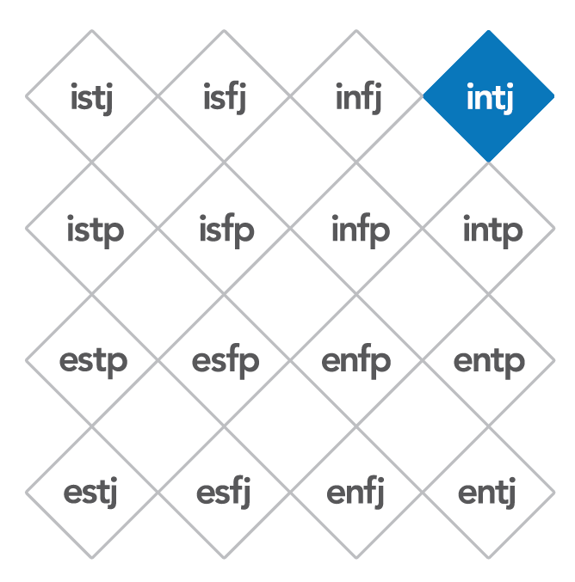

**Introversion | Intuition | Thinking | Judging**

INTJs have original minds and great drive for implementing their ideas and achieving their goals. They have long-range vision and quickly find meaningful patterns in external events. They are independent, skeptical, and critical and have high standards of competence and performance for themselves and others.

They value health, home, family, and achievement.

**Characteristics of INTJs:**

* INTJs have a clear vision of future possibilities.
* Their faith in their inner vision can move mountains. Problems only stimulate them - the impossible takes a little longer, but not much.
* They quickly see patterns in external events and develop long-range plans.
* INTJs are relentless innovators.
* They make their decisions based on logic and analysis.

**INTJs with Others:**

* INTJs often present a calm, decisive, and assured face to others.
* They may find it difficult to engage in social conversation, preferring to talk about abstract ideas.
* Others may find them hard to get to know or even aloof.
* INTJs tend to respect only people who meet their high standards ofcompetence.
* Because they have high standards and because they are so good at analysis,they may appear critical of others.
* They value others who think and act as independently as they do.

**INTJs at Work:**

* The boldness of INTJs’ Intuition preference may be of immense value in many fields.
* They are excellent long-range planners and often rise to positions of leadership in groups or organizations.
* They want to see their inspirations worked out in practice, applied, and accepted by the rest of the world.
* INTJs drive others almost as hard as they drive themselves.
* When necessary, they can focus on the details of a project in order to realize their vision.
* They will take charge, organize a job, and carry it through.
* INTJs often value and use confidently their intuitive insights in fields such as science, engineering, invention, politics, and philosophy.
* They are less satisfied in any job that limits or restricts their vision and innovation.

**Potential Blind Spots for INTJs**

* If INTJs have not developed their Intuition, they may not take in enough information or may take in only information that fits their inner vision and make poor decisions as a result.
* Also, they may concentrate so hard on their goal that they fail to look for other information that might conflict with the goal
* If they have not developed their Thinking preference, INTJs may not have reliable ways of translating their valuable insights into real-world applications.
* Also, if their Thinking preference is undeveloped, they will be unable to criticize their inner vision and may not listen to the opinions of others. They will therefore be unable to shape their inspirations into effective action
* Appreciating others may be hard for INTJs, and they may ignore other people’s values and feelings.

# Appendix B

Fundamental Interpersonal Relations Orientation-Behavior (FIRO-B)

FIRO-B result – Andrew (2015)

*The following personal self-evaluation results are from the FIRDO-B personality test completed in December 2015:*

|  |  |  |  |  |  |  |  |
| --- | --- | --- | --- | --- | --- | --- | --- |
| **Expressed Inclusion** | | **Expressed Control** | | **Expressed Affection** | | **Total expressed** | |
| **5** | **medium** | **9** | **high** | **1** | **low** | **15** | **medium** |
| You often include others in your activities, join and belong to groups, and interact with people most of the time  *(Range: 0-9)* | | You actively seek situations that involve controlling and influencing, organizing and directing others, and assuming responsibility  *(Range: 0-9)* | | You typically avoid getting close to people and are not comfortable expressing feelings and supporting others  *(Range: 0-9)* | | You initiate activities with others, but it clearly depends on the people and the situation  *(Range: 0-27)* | |
| **Wanted Inclusion** | | **Wanted Control** | | **Wanted Affection** | | **Total expressed** | |
| **8** | **high** | **2** | **low** | **1** | **low** | **11** | **medium-low** |
| Most often you want others to include you in their activities and groups, and you like being noticed  *(Range: 0-9)* | | You are most comfortable in ambiguous situations and can formulate structure  *(Range: 0-9)* | | Most of the time you are not comfortable with others acting warmly, or sharing their feelings with you  *(Range: 0-9)* | | You are most comfortable initiating activities, rather than waiting on others  *(Range: 0-27)* | |
| **Total Inclusion** | | **Total Control** | | **Total Affection** | | **Social Interaction Index** | |
| **13** | **medium-high** | **11** | **medium-low** | **2** | **low** | **26** | **medium-low** |
| You have a strong preference for being involved in social situations most of the time  *(Range: 0-18)* | | You prefer a moderate amount of structure and clarity concerning authority and responsibility  *(Range: 0-18)* | | Typically you dislike a lot of warmth and closeness in your one-on-one relationships  *(Range: 0-18)* | | Involvement with others is often satisfying for you. You probably prefer to work in smaller groups and regular contacts and tend to have a smaller group of friends and associates  *(Range: 0-54)* | |

# Appendix C

The Big Five personality factors 2015

*The following personal self-evaluation results are from The Big Five personality test completed in December 2015:*

|  |  |  |
| --- | --- | --- |
|  | http://www.outofservice.com/bigfive/images/red-ball.gifYour Results |  |
| Closed-Minded | http://www.outofservice.com/bigfive/images/black-end.gifhttp://www.outofservice.com/bigfive/images/black-line.gifhttp://www.outofservice.com/bigfive/images/red-ball.gifhttp://www.outofservice.com/bigfive/images/black-line.gifhttp://www.outofservice.com/bigfive/images/black-end.gif | Open to New Experiences |
| Disorganized | http://www.outofservice.com/bigfive/images/black-end.gifhttp://www.outofservice.com/bigfive/images/black-line.gifhttp://www.outofservice.com/bigfive/images/red-ball.gifhttp://www.outofservice.com/bigfive/images/black-line.gifhttp://www.outofservice.com/bigfive/images/black-end.gif | Conscientious |
| Introverted | http://www.outofservice.com/bigfive/images/black-end.gifhttp://www.outofservice.com/bigfive/images/black-line.gifhttp://www.outofservice.com/bigfive/images/red-ball.gifhttp://www.outofservice.com/bigfive/images/black-line.gifhttp://www.outofservice.com/bigfive/images/black-end.gif | Extraverted |
| Disagreeable | http://www.outofservice.com/bigfive/images/black-end.gifhttp://www.outofservice.com/bigfive/images/black-line.gifhttp://www.outofservice.com/bigfive/images/red-ball.gifhttp://www.outofservice.com/bigfive/images/black-line.gifhttp://www.outofservice.com/bigfive/images/black-end.gif | Agreeable |
| Calm / Relaxed | http://www.outofservice.com/bigfive/images/black-end.gifhttp://www.outofservice.com/bigfive/images/black-line.gifhttp://www.outofservice.com/bigfive/images/red-ball.gifhttp://www.outofservice.com/bigfive/images/black-line.gifhttp://www.outofservice.com/bigfive/images/black-end.gif | Nervous / High-Strung |

**What aspects of personality does this tell me about?**

There has been much research on how people describe others, and five major dimensions of human personality have been found. They are often referred to as the OCEAN model of personality, because of the acronym from the names of the five dimensions.

|  |  |  |  |
| --- | --- | --- | --- |
| **Openness to Experience/Intellect** | | | |
|  | High scorers tend to be original, creative, curious, complex; Low scorers tend to be conventional, down to earth, narrow interests, uncreative. | | |
|  | http://www.outofservice.com/bigfive/images/black-end.gifhttp://www.outofservice.com/bigfive/images/black-line.gifhttp://www.outofservice.com/bigfive/images/red-ball.gifhttp://www.outofservice.com/bigfive/images/black-line.gifhttp://www.outofservice.com/bigfive/images/black-end.gif | You are relatively open to new experiences. | (Your percentile: 70) |
|  |  |  |  |
| **Conscientiousness** | | | |
|  | High scorers tend to be reliable, well-organized, self-disciplined, careful; Low scorers tend to be disorganized, undependable, negligent. | | |
|  | http://www.outofservice.com/bigfive/images/black-end.gifhttp://www.outofservice.com/bigfive/images/black-line.gifhttp://www.outofservice.com/bigfive/images/red-ball.gifhttp://www.outofservice.com/bigfive/images/black-line.gifhttp://www.outofservice.com/bigfive/images/black-end.gif | You are well-organized, and are reliable. | (Your percentile: 74) |
|  |  |  |  |
| **Extraversion** | | | |
|  | High scorers tend to be sociable, friendly, fun loving, talkative; Low scorers tend to be introverted, reserved, inhibited, quiet. | | |
|  | http://www.outofservice.com/bigfive/images/black-end.gifhttp://www.outofservice.com/bigfive/images/black-line.gifhttp://www.outofservice.com/bigfive/images/red-ball.gifhttp://www.outofservice.com/bigfive/images/black-line.gifhttp://www.outofservice.com/bigfive/images/black-end.gif | You tend to shy away from social situations. | (Your percentile: 37) |
|  |  |  |  |
| **Agreeableness** | | | |
|  | High scorers tend to be good natured, sympathetic, forgiving, courteous; Low scorers tend to be critical, rude, harsh, callous. | | |
|  | http://www.outofservice.com/bigfive/images/black-end.gifhttp://www.outofservice.com/bigfive/images/black-line.gifhttp://www.outofservice.com/bigfive/images/red-ball.gifhttp://www.outofservice.com/bigfive/images/black-line.gifhttp://www.outofservice.com/bigfive/images/black-end.gif | You are neither extremely forgiving nor irritable. | (Your percentile: 57) |
|  |  |  |  |
| **Neuroticism** | | | |
|  | High scorers tend to be nervous, high-strung, insecure, worrying; Low scorers tend to be calm, relaxed, secure, hardy. | | |
|  | http://www.outofservice.com/bigfive/images/black-end.gifhttp://www.outofservice.com/bigfive/images/black-line.gifhttp://www.outofservice.com/bigfive/images/red-ball.gifhttp://www.outofservice.com/bigfive/images/black-line.gifhttp://www.outofservice.com/bigfive/images/black-end.gif | You probably remain calm, even in tense situations. | (Your percentile: 11) |
|  |  |  |  |

**What do the scores tell me?**

In order to provide you with a meaningful comparison, the scores you received have been converted to "percentile scores." This means that your personality score can be directly compared to another group of people who have also taken this personality test.

The percentile scores show you where you score on the five personality dimensions relative to the comparison sample of other people who have taken this test on-line. In other words, your percentile scores indicate the percentage of people who score less than you on each dimension. For example, your Extraversion percentile score is 37, which means that about 37 percent of the people in our comparison sample are less extraverted than you -- in other words, you are rather introverted. Keep in mind that these percentile scores are relative to our particular sample of people. Thus, your percentile scores may differ if you were compared to another sample.

# Appendix D

Strengths Finder 2.0**®** Themes

*The following information is reproduced from Strength Finder 2.0 (Rath, T. 2007):*

|  |  |
| --- | --- |
| **Achiever®** | People strong in the Achiever theme have a great deal of stamina and work hard. They take great satisfaction from being busy and productive. |
| **Activator®** | People strong in the Activator theme can make things happen by turning thoughts into action. They are often impatient. |
| **Adaptability®** | People strong in the Adaptability theme prefer to "go with the flow." They tend to be "now" people who take things as they come and discover the future one day at a time. |
| **Analytical®** | People strong in the Analytical theme search for reasons and causes. They have the ability to think about all the factors that might affect a situation. |
| **ArrangerTM** | People strong in the Arranger theme can organize, but they also have a flexibility that complements this ability. They like to figure out how all of the pieces and resources can be arranged for maximum productivity. |
| **Belief®** | People strong in the Belief theme have certain core values that are unchanging. Out of these values emerges a defined purpose for their life. |
| **Command®** | People strong in the Command theme have presence. They can take control of a situation and make decisions. |
| **Communication®** | People strong in the Communication theme generally find it easy to put their thoughts into words. They are good conversationalists and presenters. |
| **Competition®** | People strong in the Competition theme measure their progress against the performance of others. They strive to win first place and revel in contests. |
| **Connectedness®** | People strong in the Connectedness theme have faith in the links between all things. They believe there are few coincidences and that almost every event has a reason. |
| **Consistency®** / **FairnessTM** | People strong in the Consistency theme (also called Fairness in the first StrengthsFinder assessment) are keenly aware of the need to treat people the same. They try to treat everyone in the world fairly by setting up clear rules and adhering to them. |
| **Context®** | People strong in the Context theme enjoy thinking about the past. They understand the present by researching its history. |
| **Deliberative®** | People strong in the Deliberative theme are best described by the serious care they take in making decisions or choices. They anticipate the obstacles. |
| **Developer®** | People strong in the Developer theme recognize and cultivate the potential in others. They spot the signs of each small improvement and derive satisfaction from these improvements. |
| **DisciplineTM** | People strong in the Discipline theme enjoy routine and structure. Their world is best described by the order they create. |
| **EmpathyTM** | People strong in the Empathy theme can sense the feelings of other people by imagining themselves in others' lives or others' situations. |
| **FocusTM** | People strong in the Focus theme can take a direction, follow through, and make the corrections necessary to stay on track. They prioritize, then act. |
| **Futuristic®** | People strong in the Futuristic theme are inspired by the future and what could be. They inspire others with their visions of the future. |
| **Harmony®** | People strong in the Harmony theme look for consensus. They don't enjoy conflict; rather, they seek areas of agreement. |
| **Ideation®** | People strong in the Ideation theme are fascinated by ideas. They are able to find connections between seemingly disparate phenomena. |
| **Inclusiveness®** / **Includer®** | People strong in the Inclusiveness theme are accepting of others. They show awareness of those who feel left out, and make an effort to include them. |
| **Individualization®** | People strong in the Individualization theme are intrigued with the unique qualities of each person. They have a gift for figuring out how people who are different can work together productively. |
| **Input®** | People strong in the Input theme have a craving to know more. Often they like to collect and archive all kinds of information. |
| **Intellection®** | People in the Intellection theme are characterized by their intellectual activity. They are introspective and appreciate intellectual discussions. |
| **Learner®** | People strong in the Learner theme have a great desire to learn and want to continuously improve. In particular, the process of learning, rather than the outcome, excites them. |
| **Maximizer®** | People strong in the Maximizer theme focus on strengths as a way to stimulate personal and group excellence. They seek to transform something strong into something superb. |
| **Positivity®** | People strong in the Positivity theme have an enthusiasm that is contagious. They are upbeat and can get others excited about what they are going to do. |
| **Relator®** | People who are strong in the Relator theme enjoy close relationships with others. They find deep satisfaction in working hard with friends to achieve a goal. |
| **Responsibility®** | People strong in the Responsibility theme take psychological ownership of what they say they will do. They are committed to stable values such as honesty and loyalty. |
| **Restorative®** | People strong in the Restorative theme are adept at dealing with problems. They are good at figuring out what is wrong and resolving it. |
| **Self-Assurance®** | People strong in the Self-assurance theme feel confident in their ability to manage their own lives. They possess an inner compass that gives them confidence that their decisions are right. |
| **Significance®** | People strong in the Significance theme want to be very important in the eyes of others. They are independent and want to be recognized. |
| **StrategicTM** | People strong in the Strategic theme create alternative ways to proceed. Faced with any given scenario, they can quickly spot the relevant patterns and issues. |
| **Woo®** | People strong in the Woo theme love the challenge of meeting new people and winning them over. They derive satisfaction from breaking the ice and making a connection with another person. |

# Appendix E

Strengths Finder 2.0**®** scoring result – Andrew (2012)

C:\Users\t071679\AppData\Local\Microsoft\Windows\Temporary Internet Files\Content.IE5\ET9OKOPL\news-blue-bracket-r[1].gif *The following personal self-evaluation results are from the Strengths Finder 2.0 personality test completed in January 2012:*



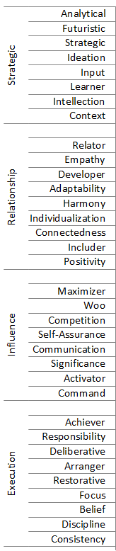

All themes results reside in “strategic” leadership style

# Appendix F

Tolerance for Ambiguity – Andrew (2015)

*The following personal self-evaluation results are from the Tolerance of Ambiguity Scale personality test completed in December 2015:*

Please respond to the following statements by indicating the extent to which you agree or disagree with them. Fill in the blanks with the number from the rating scale that best represents your evaluation of the item.

**Rating Scale:**  
1 - Strongly disagree  
2 - Moderately disagree  
3 - Slightly disagree  
4 - Neither agree nor disagree  
5 - Slightly agree  
6 - Moderately agree  
7 - Strongly agree

* 1. __1__ An expert who doesn’t come up with a definite answer probably doesn’t know much
  2. __2_ I would like to live in a foreign country for a while
  3. __2_ There is really no such thing as a problem that can’t be solved.
  4. __6_ People who fit their lives to a schedule probably miss most of the joy of living
  5. __2_ A good job is one where what is to be done and how it is to be done are always clear
  6. __2_ It is more fun to tackle a complicated problem than to solve a simple one
  7. __4_ In the long run it is possible to get more done by tackling small, simple problems rather than large and complicated ones
  8. __2_ Often the most interesting and stimulating people are those who don’t mind being different and original
  9. __3_ What we are used to is always preferable to what is unfamiliar.
  10. __1_ People who insist upon a yes or no answer just don’t know how complicated things really are.
  11. __4_ A person who leads an even, regular life in which few surprises or unexpected happenings arise really has a lot to be grateful for.
  12. __3_ Many of our most important decisions are based upon insufficient information.
  13. __6_ I like parties where I know most of the people more than ones where all or most of the people are complete strangers.
  14. _ 3_ Teachers and supervisors who hand out vague assignments give one a chance to show initiative and originality
  15. __7_ The sooner we all acquire similar values and ideals the better
  16. __1_ A good teacher is one who makes you wonder about your way of looking at things

**Scoring Key**

Having intolerance for ambiguity means that an individual tends to perceive situations as threatening rather than promising. Lack of information or uncertainty, for example, would make such a person uncomfortable. Ambiguity arises from three main sources: novelty, complexity and insolubility. These three subscales exist within this instrument.

High scores indicate a greater INTOLERANCE of ambiguity. To score the instrument, the even numbered items must be reverse-scored. That is, the 7s become 1s; 6s become 2s etc. After reversing the even-numbered items, sum the scores for all 16 items to get your total score.

The 3 subscales also can be computed to reveal the major source of intolerance of ambiguity. Here are the items associated with each subscale.

Item Subscale Item Subscale Item Subscale Item Subscale

1 I 5 C 9 N 13 N

2 N 6 C 10 C 14 C

3 I 7 C 11 N 15 C

4 C 8 C 12 I 16 C

(N) Novelty Score (2,9,11,13) __22__

(C) Complexity Score (4,5,6,7,8,10,14,15,16) __28__

(I) Insolubility Score (1, 3, 12) __05__

**TOTAL SCORE** __55__

Novelty indicates the extent to which you are (in)tolerant of new, unfamiliar information or situations.

Complexity score indicates the extent to which you are (in)tolerant of multiple, distinctive or unrelated information.

Insolubility indicates the extent to which you are in(tolerant) of problems that are very difficult to solve because, for example, alternative solutions are not evident, information is not available, or the problem components seem unrelated to each other.

Remember, the higher the score(s) the more intolerant of ambiguity you scored.

Source: Budner, 1962.

# Appendix G

*The following personal self-evaluation results are from the Learning Style personality test completed in December 2015:*

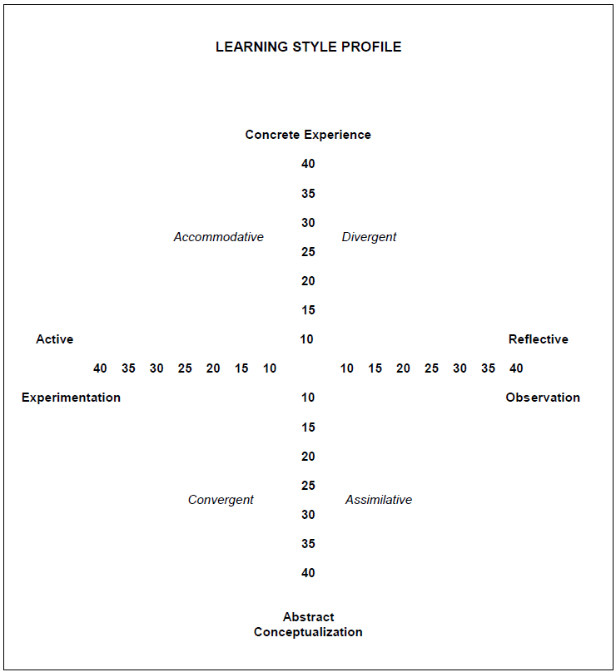

**Learning style profile:**

**Concrete Experience (CE)** -- A CE orientation focuses on being involved in experiences and dealing with immediate human situations in a personal way. It emphasizes feeling more than thinking; a concern with the uniqueness and complexity of present reality over theories and generalizations; and intuitive, "artistic" approach over a systematic, scientific approach to problems.

**Reflective Observation (RO)** -- An RO orientation focuses on understanding the meaning of ideas and situations by carefully observing and describing them. It emphasizes reflection and

understanding over action and practical application; a concern with what is true or how things happen over what will work.

**Abstract Conceptualization (AC**) -- An AC orientation focuses on using logic, ideas, and concepts. It emphasizes thinking rather than feeling; a concern with building general theories rather than intuitively understanding unique, specific areas; a scientific more than an artistic approach to problems.

**Active Experimentation (AE)** -- An AE orientation focuses on actively influencing people and

changing situations. It emphasizes practical applications as distinct from reflective understanding; a pragmatic concern with what works rather than with what is absolute truth; an emphasis on doing, more than observing.

**Dominate learning style profile:**

**Convergent** -- The convergent learning style relies primarily on the dominant learning abilities of abstract conceptualization and active experimentation. The greatest strength of this approach lies in problem solving, decision-making, and the practical application of ideas. The style works best in situations where there is a single correct answer or solution to a question or problem. The style suggests a preference for task accomplishment or productivity rather than for more socio-emotional experiences.

**Divergent** -- The divergent learning style has the opposite learning strengths from the convergent. It emphasizes concrete experience and reflective observation. Its greatest strength lies in imaginative ability and awareness of meaning and values. The primary adaptive ability of divergence is to view concrete situations from many perspectives and to organize many relationships into a meaningful "gestalt." The emphasis in this orientation is on adaptation by observation rather than action. It is called divergent because it works best in situations that call for generation of alternative ideas and implications, such as a "brainstorming" idea session. The style suggests a preference for socioemotional experiences over task accomplishment.

**Assimilative** -- In assimilation, the dominant learning abilities are abstract conceptualization and reflective observation. The greatest strength of this orientation lies in inductive reasoning and the ability to create theoretical models, in assimilating disparate observations into an integrated explanation. As in convergence, this orientation is focused less on socio-emotional interactions and more on ideas and abstract concepts. Ideas are valued more for being logically sound and precise than for their practical values. It is more important that the theory be logically sound and precise.

**Accommodative** -- The accommodative learning style has the opposite strengths from assimilation, emphasizing concrete experience and active experimentation. The greatest strength of this orientation lies in doing things, in carrying out plans and tasks and getting involved in new experiences. The adaptive emphasis of this orientation is on opportunity seeking, risk taking and action. This style is called accommodative because it is best suited for those situations where one must adapt oneself to changing immediate circumstances. In situations where the theory or plans do not fit the facts, those with an accommodative style will most likely discard the plan or theory.

# Appendix H

*The following figure describes the Competing Values Approach.*

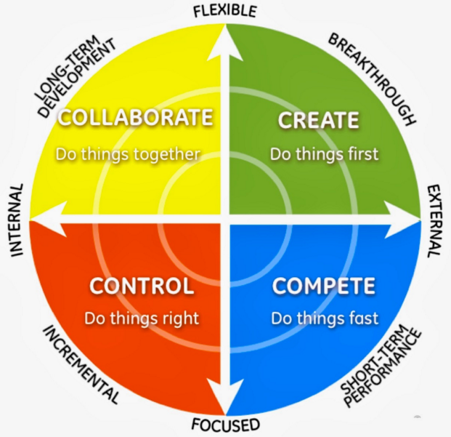

**Source**: Quinn, R.E., Faerman, S. R., Thompson, M.P., McGrath, M. R., & St. Clair, L.S. (2011). Improving Productivity and Increasing Profitability, In Becoming a Master Manager: A Competing Values Approach (5th ed.). New York: John Wiley & Sons