Guidance for Chapter 6, Extra Exercise 3

‘Recoding’ a variable in Excel
This exercise is based on data on the anxiety levels of men and women. The data looks like this:
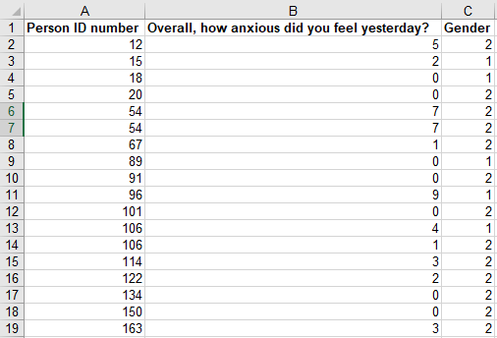
The question involves identifying what proportion of people have anxiety scores of 8 or more. In order to do this we are going to create a new variable (column) called ‘Anxious’ which will be equal to 0 if the person has an anxiety score of less than 8 and will be equal to 1 if they have an anxiety score of 8 or higher.
Note: Because we are taking information from the ‘anxiety’ variable and coding it differently (0/1 rather than 0–10), this process is called ‘recoding’.
In the second row of the new column, type the following formula:
=if(b2>7,1,0)
Typing a formula like this into Excel is a sort of ‘command’: you are telling Excel that you want it to do something. In this case you are telling it that you want it to look in cell B2 (the first row of the ‘Overall, how anxious did you feel…’ column) and see if the number in that cell is higher than 7 (the > symbol means ‘greater than’). If it is, Excel should return the value ‘1’ (the number after the first comma). If it isn’t, Excel should return the value ‘0’ (the number after the second comma).
After you’ve typed in the formula, hit enter. You should then see that the formula disappears and is replaced by a number (in this case a 0). Excel has gone away and done what we asked: it has looked in cell b2 and seen that the number in that cell is a 5. The number 5 is not more than 7, so Excel has returned the value 0.
Now we need to do the same thing for the rest of the rows, all the way down to row 2,049. But we don’t need to type the formula out 2,048 times. Instead, simply select cell D2 (where you’ve just typed the formula) and double-click the green box in the lower right corner of the cell:
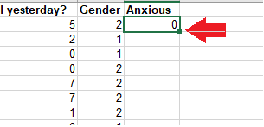
This will fill out the same formula for all the rows of data (changing ‘b2’ to ‘b3’, then ‘b4’, etc.).

Calculating the percentage of men and women who have high anxiety
Calculating percentages in Excel is covered in the guidance for Chapter 3, Extra Exercise 1.

Calculating a relative risk
To calculate the relative risk of having high anxiety for women, simply divide the percentage of women who are anxious by the percentage of men who are anxious. Chapter 6 of the book explains how to interpret this number.

