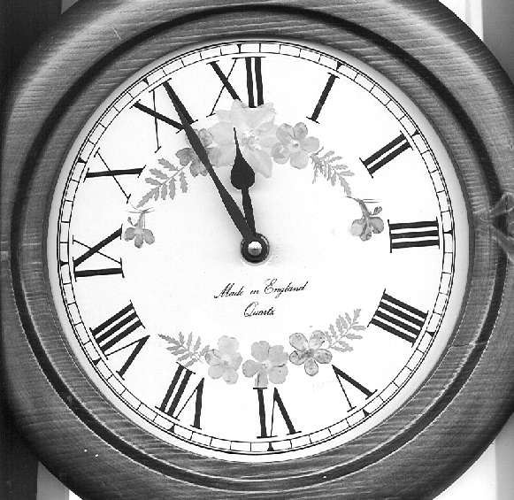 THE CHANGING PERSONA OF THE PLANNER
Marxists
Scientist
PostWar
Rebuilder
Soldier
Economist
Geographer
Urban
Designer
Communicator
EO Rights
Advocate
Businessman
Manager
Environmentalist
The Clock of the
Twentieth Century Clock
ACROSS THE TWENTIETH CENTURY

Marxist

N.B. 12.00 is both 1900 and the year 2000

