# **Startup Navigator Case Study – TRAVIS**

In spring 2019, Philip Grossmann is on his way to a session at the international executive education program at the University of St. Gallen. He is invited to listen to students’ analyses of Travis, his and his co-founder’s start-up. Travis is an online travel booking tool for event organizers and event visitors. Philip founded the start-up with Alexander Porsche during their bachelor studies at the University of St.Gallen in 2015. In a pre-seed phase, Travis raised investments of 500.000 Euro, underwent multiple pivots during its journey and reached a product-market-fit in the highly competitive “business to the consumer travel market.” With over 200 clients such as International Motor Show Germany (IAA), Pioneers Festival, and Web Summit, the solution reached more than 1.5 million event visitors and a monthly booking volume of over 100.000 EUR. Within the executive education program, the student’s case analyses focus on how a start-up can enter and compete in a market that is dominated by large players investing millions in advertisements while being exposed to consumers who are highly priced sensitive when it comes to online travel booking.

Given the nature of his case and the complexity of events, Philip is asked to provide critical insights, his learnings, and be available for question and answers after the students’ case presentations. Philip is excited to listen to the presentations and to find out how the students interpret his business model. What will be the outcomes of the students’ analyses? Will he gain new inspiration or exciting ideas? Will someone figure out the reasoning behind his specific approach and eventually his failure?

The venue is located just on the hills in St.Gallen, Switzerland, with a beautiful landscape view. Inside the venue, there is a conference room with a little stage and a large screen behind. About 30 people are participating in the entrepreneurship module of the executive program. All participants are C-level people working in corporate firms. Regardless, the atmosphere is quite tense due to the upcoming presentation about their analyses and findings of Philips’ start-up. After a short introduction, Philip is seated in the front row and listens to the students’ presentations. He has a chuckle to himself because none of the students found out about why Travis was so successful in the first place and short after failed. After the students’ presentations, Philip takes the stage and starts talking about how everything started, which problem Travis solved, his learnings and about his and his co-founder journey.

# **How to start a start-up for the first time without tech know-how**

Philip picks up by reflecting on their motivation within the first months. He reflects: “Start with your idea before you feel ready. Everything comes into place and starts to make sense once you have started. If you start with the motivation to earn much money through your start-up, that is also okay. However, within the first months, you should start to feel motivated by solving a problem and building a product that amazes customers. This is the only way you will be able to put in enough work and stay motivated long-term.” The starting point for Travis was a little bit different than what it is for many other start-ups. The founders did not identify a specific problem they wanted to fix. The starting point was the motivation to start a start-up company and the passion for making an impact in the travel sector.

Alexander and Philip’s initial idea was to develop a smartphone app that suggests users the best hotel and flight offers from the thousands of travel offers based on their personal preferences. The core of the application was an algorithm that uses, on the one hand, personal information about the user’s preferred airlines and price sensitivity and the other hand calendar information in order to determine the departure and arrival airport as well as optimal flight times. At the end of the process, the user should receive the three most relevant hotel and flight offers.

After developing the idea into a business plan, the founders moved on to building a minimum viable product (“MVP”) in order to get first customer and investor feedback. As there was no technical co-founder in the team, and due to the founder’s lack of programming skills, they had to outsource the programming to a software development company. Most of the approached developer companies, however, priced an MVP extremely high with a demand of more than 100.000 EUR. Through the start-up network at the University after three months the founders finally found a development company that was based in Switzerland with developers in Pakistan, who were willing to develop an MVP for less money but in return for shares.

Having finally someone building Travis’s first MVP, one of the founders made a first investment and development of Travis began. During this time the business concept of Travis evolved from a simple filter algorithm to a personalized travel app that should not only book flights and hotels but also restaurants and Uber cabs and include additional features such as an automated check-in. After three months the user interface was finished as well as a first programmed version of the algorithm. However, building the backend of a travel app that enabled users to book Hotels and Flights was more difficult than expected. Integrating such an “application programming interface” (API; an API is a “set of functions and procedures allowing the creation of applications that access the features or data of an operating system, application, or other service”) is a very complicated and time-consuming process that requires a very good organization of the development process.

As this process took longer than expected, Alexander and Philip started to collect feedback by applying for pitching competitions and going to start-up events with a demo version that contained linked screenshots of the user interfaces. As the scheduled end of the MVP, development came close, and there was still no working MVP insight the money run out. Just in time, the networking paid off. Through personal contacts, the founders got into contact with Business Angels who were willing to pay 250.000 EUR.

Philip remembers: “Luck plays a major role in every investment in an early stage company. However, the main driver is consistent action by the founding team: Talking to people, asking around family and friends, making the first step, and asking for an introduction. Everybody has somewhere in there 1st, 2nd or 3rd degree of his contacts at least one person who is willing and able to provide a seed investment. In the end, it comes down to always being excellently prepared and then meeting the right opportunity.”

**The small way between successes and failures and the first pivot**

With financial backing, the development was expected to gain speed. However, after three more months, there were still no significant improvements. Although the backend made improvements, the developers still struggled, and as Travis had no technical co-founder, there was no way for the founders to support the process.

In hindsight, the lesson learned is obvious to Philip: “Start small with your MVP and only focus on the features that add real value to your customers, and that can make revenue. It is easy to fall into the trap to build a product that created values because it combines a large number of features, but for a start-up company, this is not realistic. You need a small MVP with only a few features that you can launch quickly to evaluate client interest and ideally revenue.”

Additionally, negative feedback from potential investors and clients started to increase. The reasoning was always the same:

* The travel market is too competitive with shallow margins
* Building a trustworthy brand is very time and cost consuming, but an absolute necessity in the travel market as customers usually spend many hundreds of euros at once and want to have the assurance that the supplier is trustworthy.
* The market is very centralized on a few big players who push the prices down
* There is no apparent problem the app solves for its customer as people most of the times are only interested in the cheapest option
* The complexity of the app is too high as multiple API’s from different suppliers need to be integrated

The slow development process proved that the feedback was not wrong. Even integrating one API took months, how long would it take to implement multiple AP I’s?

As a consequence, Alexander and Philip decided that they needed to make a pivot in order to not waste the remaining funds on building a product that would not be able to get a product-market-fit. So, they decided to start tackling the most critical issue: How to build a booking volume without massive spending is on advertisement or a long brand building process. An interview with the Eventbrite founders provided a new idea: Building a travel booking solution targeted for event organizers. The idea would enable access to the thousands of event visitors that attended each event by only acquiring one client. At the same time, the event organizer already built a trusted brand which Travis could use to gain trust for its travel booking solution.

In order to validate the idea, Alexander and Philip started approaching event organizers and tried to sell the idea. The results proved that there is a market for such a product since event organizers were keen on having such a tool but struggled with providing a travel solution for their attendees. Out of these conversations, Philip’ and Alexander’s conclusion was:

* Event organizers want to offer essential travel services for attendees and
* they do not want to spend money on integrating the travel services as it is not their core business, and they cannot generate revenue with these services.

Even more surprising were the high booking numbers of the travel services provided by the organizer, independently how badly the user’s experience was or how different the prices compared to other websites such as Booking.com or Expedia were. At some events, the organizer provides a link to a hotel chain; at some events, users need to fill out PDF documents by hand and return scanned copies of them. Even small events with only 2000 to 3000 attendees completely booked out their 250 rooms. It seemed that event visitors trusted the event organizers for their hotel and airline recommendation and therefore are ready to accept higher prices and bad user experience.

During these first discussions with event organizers, Alexander and Philip realized that many of them declared interest in Travis’ solution since it presented a solution to all their problems. Based on this feedback, the founders decided to make a pivot and redesign the platform. The entire Travis travel booking process was now targeted on event visitors, showing, for example, the event location and dates throughout the booking process as helpful information to the event visitor. Besides, Travis stayed true to its original idea: Providing a simple, transparent way to book a full trip including hotel and mean of transportation without overloading the websites with useless information such as Booking.com and Expedia show.

{PICTURES OF DESIGN}

**Turning the wheel around**

Alexander and Philip soon realized, that as an early-stage founder, one does not need to have a functioning product to get feedback from the market or to get first clients. A pitch deck that includes first user interfaces is enough to sell the product, explain the business model, and provide a good understanding of how the product will look. The first 15-month Travis had no working product due to the long and complicated development process. The first clients, the acceptance into Startupbootcamp, the investors and the advisors Travis got was all achieved with a good pitch deck that included user interface screenshots.

More essentially than having a functioning product, is to never lose focus on the most critical priority in an early stage start-up – generating revenue. Everything else is much less important, especially when founders have enough funds to not worry about the next months. Time should not be wasted by going to too many start-up events. More importantly, is to build a great product that adds value for the client and pushes it as fast as possible in the market.

The new design was done by the same company that programmed the platform. However, while the new user interface was ready soon after the pivot, the problems on developing a functioning backend continued. The missing know-how and management control that comes with a Tech Co-Founder was starting to endanger Travis seriously.

Nevertheless, Travis onboarding new partners, first clients that were signed already on even though the product was not ready and new advisors joined the company. With these positive developments, the pressure to launch quickly started to increase, and as the development process still was not making significant progress, the founders decided it was necessary to make some serious operational changes. They called in a joint investor and advisor meeting where the following problems were summarized:

* There was not enough experience in the team to control and manage the development process.
* The time management in the business development focused too much on visiting start-up events or participating in start-up competitions instead of selling the solution, preparing the market launch and building Travis as a recognized brand with event organizers.

Transparency is a must for an early stage start-up. Philip explains: “Always be transparent with your mentors, advisors and especially investors and customers. While it is necessary to sell the company and the product with a great vision, it always fires back when you cannot deliver on your promised features of deadlines. This also means keeping promises and commitments. They are great tools to build trust with investors and clients and always pay off in the long term.”

Based on this meeting and feedback, the founders finally – after more than a year -let go of the old developer company from Pakistan and hired a new development company from Serbia. The CTO of the company was a close friend of an advisor. At the same time, Travis hired a part-time CTO, who was a friend of an advisor. He was willing to support Travis in exchange for shares. On the business development side, regular advisor and investors meeting helped to keep the priorities right.

Out of these challenges, Alexander and Philip learned a valuable lesson: Fire fast and hire slow. Travis hired the development company way to fast without making any due diligence. Once they discovered that it did not work out with this company, Travis still stuck too long to them, wasting much money. Firing a company or an employee will cost time, but not doing so will cost even more time and more importantly, much money. The second development company and the first employees took Travis much longer to hire, but in the end, it paid off, as Alexander and Philip were sure that it was the right choice because this time they made enough due diligence.

The changes started to show success quickly. While the first MVP took more than nine months, the second try to develop an MVP only took two months even though the entire code had to be rewritten. Travis transformed into an online travel booking platform backed by a real booking API. Further clients were signed, and Travis also got accepted into Startupbootcamp, a global accelerator program.

**Reaching the product-market-fit**

When Travis was ready for market launch, multiple event organizers had already agreed to implement the platform which exposed the platform immediately to thousands of event visitors. Travis was solving a problem now and had a scalable business model:

* With Travis, the event organizer could implement a full online travel booking solution with a simple button for free
* Travis, on the other hand, got free access to all his attendees and earned a commission on the booking volume
* In order to further incentivize the organizer to promote Travis, he received a 20% of the commission

Even with this robust business model and Travis being implemented on more and more event websites, weeks passed by, and there were still no bookings nor traffic. Philip and his co-founder figured while Travis had a clear value proposition for the event organizer, they did not have one for event attendees.

To solve the future problem, the founders initiated interviews with event organizers, attendees, advisors, and the Startupbootcamp team. Then the next step was to evaluate the information received from the interviews, the A/B testing, the conjoint analysis, and the lead user analysis, which took one and a half weeks. Alexander and Philip could highlight the following core issues out of the evaluation:

* **The brand was still an issue.** Even though Travis was implemented with a “Book your trip” button on the event website, the online travel booking process still had its branding and was running on an external link. Event visitors did not trust Travis.
* **The whole booking process was way too long**. While Travis was designed to split the booking process into as many simple steps as possible for the user, it created too much friction at the same time. Event visitors want to book their trip with as fewer clicks as possible.
* **The content from the Hotel API was of low quality** (especially the pictures). Event visitors did not trust this, and even though a hotel might have excellent quality, the wicked pictures did not communicate that.

**TRAVIS BOOKING PROCESS STEPS**

At this stage, the focused and energetic environment of the Startupbootcamp came into play. The daily exchanges with experienced start-up founders and other early-stage companies helped to stay motivated and focused. In workshop sessions, the founder defined with the advisors and mentors’ multiple changes to the User Interface in order to test and validate if they increase the bookings (A/B Testing). The core changes were the following:

1. The button on the event website became a widget that included more content and promoted Travis as an official event partner with discounted prices. While this increased clicks on the Widget, it still not solves the branding issue and the long booking process.
2. It followed a complete redesign of the platform with a professional UX and UI Designer. The booking process was cut down from 10 to 3 steps.
3. The Travis brand was removed entirely and white labeled. The colors of the platform were always adapted to the core brand colors of the event in order to communicate to the event visitor that the event organizer itself organizes this booking process.
4. Travis became directly implemented into the website of the event organizer with an I-Frame, which further increased the trusted brand and removed the risk to click on an external link for the user.
5. Travis implemented new API such as Google Pictures and an external Hotel Database to provide high level, attractive Pictures, and quality content for the user.
6. 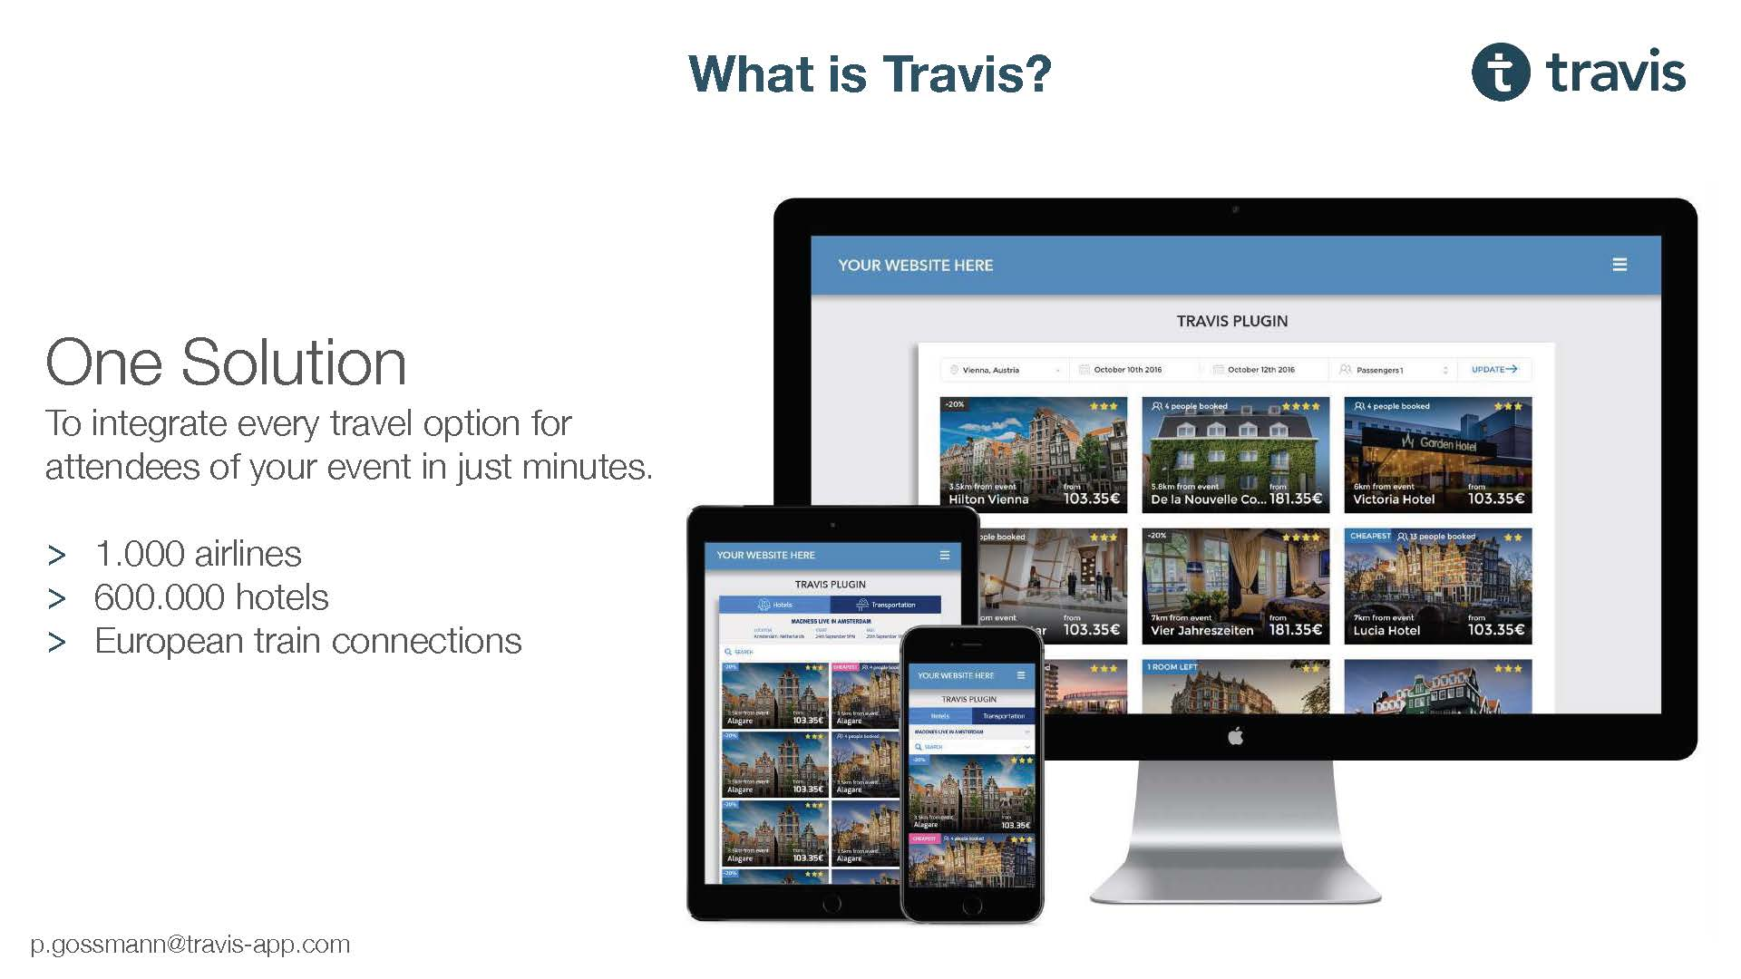Event Organizers usually received discounted rates from Hotels for a selected number of rooms. The booking API was extended by a feature to enter theses discount codes in order to transfer them to the event visitors and provide an additional value.

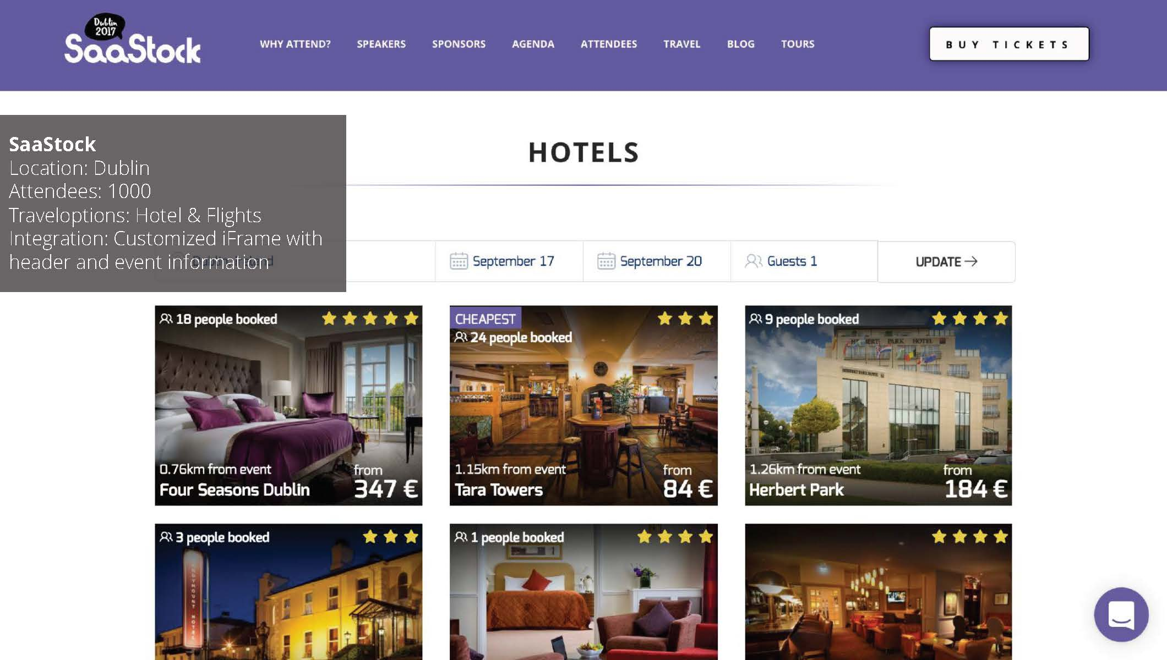

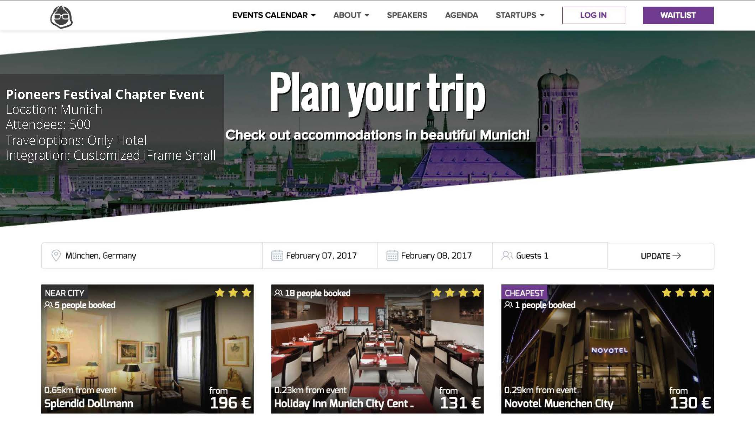

Suddenly everything happened faster. Until then, the founders worked already over two years on Travis. Now, these six steps were tried out and implemented within six weeks. The development of the six steps is on past experiences, priority driven project management, and a great team of advisors and mentors. Out of this, Philip learned: “You need to solve a TIER 1 problem for your end customer (Save Money, Earn More money, reach new clients, Extend Brand Reach). Everything else such as a nice user interface or additional information can be hard to generate revenue from as users might be interested in using it but not to pay for it.”

**Finally, Travis could be scaled**

With the new design, the traffic and booking numbers started to increase consistently. Travis entered the growth phase and hired a project manager as well as a full-time sales executive. While the small and midsized event organizers received Travis for free, larger event organizers with more than 10.000 event attendees were required to pay a monthly fee.

At its peak time, Travis reached a monthly booking volume of more than 100.000 EUR and had signed more than 200 event organizers including events such as Web Summit or IAA, reaching more than 1.5 million event attendees worldwide. Single booking volumes started to exceed 1.000 EUR.

**A bad foundation collapses**

Just when Travis reached a new high in booking volume, the mistakes from beginning cached up. The API Travis had implemented managed by a Rumanian company. While it was certainly cheaper and quicker to integrate than a more professional solution such as Amadeus, it also had negative aspects such as harmful content.

Without any note, the API got shut down by the Rumanian company. From one day to another, Travis had no content to sell anymore, and existing bookings got canceled.

Even though Alexander and Philip immediately started to implement the Amadeus API, the full development process would take months. In order to bridge this time, flights were removed from the platform and limiting the hotels to a maximum of 9 recommendations. Besides, the hotel content was managed manually, which meant updating the prices daily for more than 200 events. As the hotel prices increased faster than manually could be updated even when taking into account of 20% mark-up, Travis started to lose money on each booking.

As all bookings also needed to be handled manually, Travis was no longer to support bigger events as there were too many bookings to handle manually. For this reason, bigger events dropped Travis, even though they were still excited to use the platform in the future once the solution worked again.

With the old investors being bound in personal matters and unable to invest further money, Travis had no clients, no revenue and no money left.

Philip finally quotes: “Especially when nothing seems to work out, it is important to let go of the start-up and spend time on something else for a while. There is the saying that when you build a start-up, you can choose two activities out of these five: Having worked too much at many occasions when deadlines come up, or money was short, it helps much more when you take off for a few hours, get enough sleep and start fresh in the morning.”

**Reflecting on the start-up journey**

The C-Level students from the international executive education program are amazed by the 24-year-old Philip and about what he already achieved in his young age. Now they are interested in more private insights about Philips journey and his feelings.

The students asked Philip if he regrets having started Travis or if he regrets having quit Travis or if he thinks, he quit Travis too early. The answer is no. Philip spends much time reflecting on the last two years. There have been many successes and many losses. Building a start-up means sacrifice – the sacrifice of time, of opportunities and emotional health. In Philips case, he sacrificed to spend time with his family, the opportunity to have a relationship, to go out and party with his friends, to travel, and his emotional health. Philip states: “Closing your company that you worked for more than two years and that you invested so much time into is never easy. However, in the end, building a start-up is what excites me, what motivates me to get up in the morning and to stay up late in the evening. My long-term goal is to build a product that amazes customers, and that has a positive impact on my environment. I might fail at that, but I want to have at least tried it. Moreover, I do not regret having tried it because of the experience and new perspective I gained. One thing I learned that despite my relatively young age is that time is too short to do something you do not like. Time flies by so quickly that everything could be over tomorrow. I do not regret sacrificing this time in order to do something that makes me happy, and that helps me to try to reach my long-term goal.”

The only thing Philip regrets is that he did not enjoy the time while he founded Travis. When he started to have their first successes with Travis Alexander and Philip already looked for the next success. When things did not work out as they wanted it to be, they looked for the next success to regain motivation. Alexander and Philip were always looking in the future when building Travis and did not enjoy the moments enough they had. Philip remembers: “In retrospect, the hardest moments of building Travis were also the best ones. They were the moments that taught me the most.”

People should be encouraged to try to pursue their happiness. If their happiness is building a start-up a company, then they should start working on it today. Many people are afraid of starting their own company because they are afraid of what other people will think of them when they fail. However, it is a legitimate fear. Failing and taking responsibility for it, especially in front of the people who are essential to one, make it hard to start, which takes courage, but, Philip is sure, it is worth it. “For me, the failure of Travis is the beginning of my journey. I will not stop with Travis. I will come back and try again. Most importantly, without making the same mistakes again.” Philip recommends that if one would like to start a company, they should do so and start it today. On the start-up journey, founders have to be focused, consistent, and able to let go of negative feedback and the fear of failure. Philip says: “In the end, you cannot lose, you can only gain experience. Moreover, pursuing your happiness – in the end, it is the best thing one can spend their time on.”

**Questions:**

1a) Describe and visualize Travis Business Model development and identify its KPIs and their evolvement/development with respect to Travis’s strategic decision.

1b) How did Travis manage to gain a higher look to book ratio (L2BR)?

2) Explain how the Unit Economic evolved with Travis’s business model evolvement.

3) Reflecting on the failure of Travis, what circumstances were curtal and how could the failure be avoided?

4) Describe the emotion distress of Philip when he decided to close Travis?