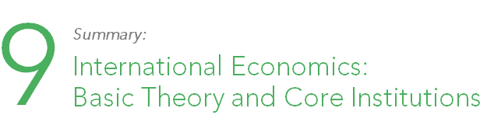

Enduring question:
How do politics shape the global economy?

- The doctrine of comparative advantage has allowed countries to make considerable gains from trade, with both states benefiting from the exchange even if one state has an absolute advantage in production.

- Nonetheless, many countries protect themselves from trade (protectionism), in the hopes of developing domestic industry and becoming self-sufficient, using techniques like infant-industry protection, high tariffs, and non-tariff barriers.

- Foreign direct investment, portfolio investments, and bank deposits and lending make up three basic elements of international money, allowing individuals and firms to invest abroad.

- Different countries opt to use either fixed or flexible exchange rate systems, depending on which they think will benefit their domestic economies more. Each system comes with its benefits and drawbacks to host countries and other countries.

- Multinational enterprises have a major impact on international political economy, both positive and negative.
  - Intra-firm trade and other financial flows can bring money into developing countries. Scholars also argue that MNEs strengthen bonds between nations, increasing international peace.
  - However, the drive to attract investment from MNEs can damage the environment and workers’ rights (i.e. ‘race to the bottom’ and ‘pollution havens)

- A variety of international institutions have arisen to foster and regulate international trade, including the ITO, GATT, and WTO.
  - Some of these institutions, such as the IMF and the World Bank, have sought to accelerate development, but these have created controversy.
  - Recent years have seen the rise of populist movements that question the costs and benefits of global trade.

- Nations debate over whom should have the reigns of the world economy (G-7, G-8, G-20)

