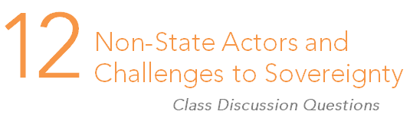

Enduring question:
Can the state continue to overcome challenges to its authority?

- Consider the other actors/technologies that people once thought might dominate the new international order such as nuclear weapons or multinational organizations. What would the international order be like if these predictions had come true?

- What is the greatest danger to the international community arising from failed states?

- Do terrorists pose a legitimate threat to the stability of individual states and/or to the international community as a whole?

- Which poses the greatest threat to states and to the international community as whole: warlords, criminal gangs, pirates, or terrorists? (Consider whether there are two different answers: one to individual states and another to the international community as a whole).

- Consider technologies that have enabled globalization and trade liberalization like global communications, and others like cyber warfare and UAVs. How might these technologies help or hurt states in their efforts to combat non-state actors?

- Does the international community have the right to violate the sovereignty of a state to intervene and protect that state’s citizens from harm, either at the hands of the government or at the hands of non-state actors that the government cannot control? Does the international community have a responsibility to do so?

- Do you think the state will be surpassed as the primary actor in the global system? What might surpass it?

