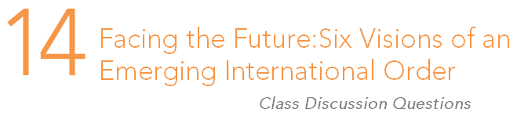

Enduring question:
Will the international system undergo fundamental change in the future?

- Do you believe the Westphalian system will endure in its current form?

- Do you believe the idea that economic security will replace military security is a compelling one?

- Do you believe the world will most likely be unipolar, bipolar, or multipolar in twenty years?

- What role do you think non-state actors will play in determining the world order of the near future?

- Consider the challenges China faces on its path to becoming a superpower. Do they appear surmountable? Did the US pass similar hurdles?

- Do you think the idea that the world will eventually be a community of democratic states living in peace is plausible?

- Do you believe a clash of civilizations is likely? If so, what form do you think it will take?

- Could the world potentially fracture into pre-modern, modern, and post-modern zones? If so, what would be the primary factors characterizing the divides? Explain your answer.

- Which of the six models outlined in this chapter do you find most compelling? Why?

- What form do you think the international order will take in the future? Explain the key components of your vision in detail. Why will it take this form? What are the primary drives leading to this new order?

