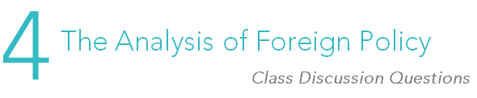

Enduring question:
Which factors most influence the foreign policies of states?

- Generally, a state attempts to bring about its foreign policy objectives using persuasive policy instruments and only turns to coercive means if persuasive means fail. Is a state ever justified in turning to coercive policy instruments? If so, when?

- Do you think that domestic pressures outside of elections, such as interest groups and NGOs, should have a strong influence on foreign policy? If so, what sorts of pressures ought to have influence? If not, why not?

- Do you think covert operations are inherently an act of war? Was the United States justified in entering Pakistan to kill Osama bin Laden without alerting the Pakistani government? If these operations can be justified, what constitutes a just covert operation?

- How much influence do you think the media has on your perception of foreign policy? How much do you think state-run media changes an individual’s perception compared to free and independent media?

- To what extent do you believe geography affects the foreign policy of your country? Discuss some examples of both real and potential cases in which geography had an impact on your country’s foreign policy.

- Thinking in terms of the levels-of-analysis framework, explain some possible reasons why Iran continues to pursue its nuclear program.

- Do you think the United Nations has a considerable impact on the foreign policy of most individual states? If so, what sort of impact? Do you think international institutions should have more of a role in determining foreign policy?

- Which of the policy instruments discussed in this chapter do you think are the most useful and the least useful?

