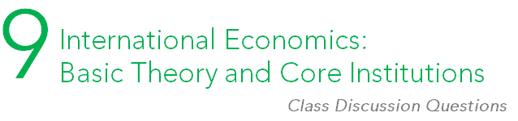

Enduring question:
How do politics shape the global economy?

- In US trade with China today, do you think the US might care more about relative gains or absolute gains? Do you think different sectors of the US might have differing views?

- Why might a state pursue a protectionist strategy? Do you think a state might ever pursue protectionism against its own best interests?

- Do you think the international community should have any role in limiting tariffs or non-tariff barriers? Why or why not? If so, how much of a role should they have?

- What are the main benefits and drawbacks of both fixed-rate and flexible-rate exchange systems? If you were responsible for choosing the system for a wealthy, powerful country, what would you choose? What about for a developing country? Explain why your answer differed or stayed the same.

- What are the primary effects of multinational enterprises on the global economy? What are the benefits and drawbacks of MNEs?

- What good do organizations like GATT or the WTO do? Do they cause harm? If so, how?

- Do regional blocs and regional free trade agreements help or hurt the global economy?

- Do you think bilateral and regional agreements will take precedence over large multinational agreements like the WTO?

- How do the IMF and World Bank help developing countries progress? How might they harm developing countries? Do you think these organizations have a net positive or negative effect on development?

