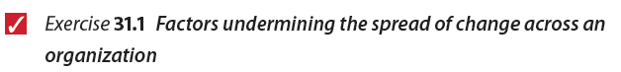
Reflect on your experience of successful change efforts and identify examples where the new methods and processes were not spread to other locations. List below some of the factors you think have limited spread and fostered containment.
 | Factors limiting spread | Reason
1 | Click here to enter text. | Click here to enter text.
2 | Click here to enter text. | Click here to enter text.
3 | Click here to enter text. | Click here to enter text.
When you have read this chapter, reflect on the notes you have made here and consider whether your list needs to be amended in any way.

